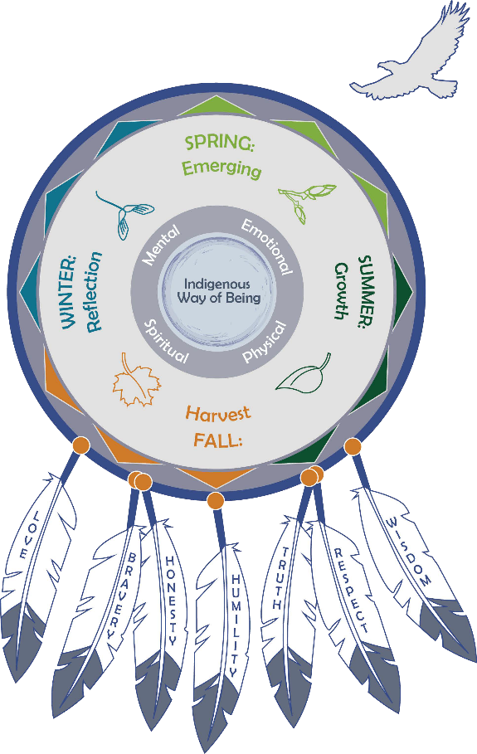

**CERTIFICATE**

**OF ATTENDANCE & COMPLETION**

**THIS CERTIFICATE IS AWARDED TO:**

***First***

***Last***

TRIBAL CHILD WELFARE  
LEADERSHIP ACADEMY

 DATE