
Tribal Child Welfare Leadership Academy
Participant Workbook
Fall

This product was developed by the National Capacity Building Center for Tribes, which is funded by the Children’s Bureau through cooperative agreement number FAIN #90CZ0028.


Table of Contents
Fall Agenda 3
Fall Learning Outcomes 4
Indigenous Circles of Leading 5
Intergenerational Protective Circles of Care 6
Indigenous Circles of Leading: An Eagle’s View 7
The Honorable Harvest 8
Sample Ecomap 9
Eagle Mapping: Identify Shared Purpose and Connections 10
Indigenous Adaptive Leadership in Practice 12
Immunity to Change 14
Shared Learning Activity: Your Immunity to Change 15
Identifying Resistance in the Workplace 16
Margaret’s Story: Your Case Study 17
Adaptive Leadership 18

Fall Agenda
- Indigenous Circles of Leading – An Eagle’s View
- The Honorable Harvest
- Harvesting Through Adaptive Change
- Eaglemapping
- Your Eaglemap Activity
- Indigenous Adaptive Leadership in Practice
- Mobilizing People: Leadership Moments
- Immunity to Change
- Identifying Resistance in the Workplace
- Mindfulness in Adaptive Leadership
- Margaret's Story
- Closing

Fall Learning Outcomes
- Explore how to mobilize people and resources for adaptive change.
- Recognize the impact of immunity to change.
- Recognize how the Indigenous way of being supports leaders when facing immunity to change.
- Review and further explore concepts of Indigenous adaptive leadership in your work setting.



Indigenous Circles of Leading
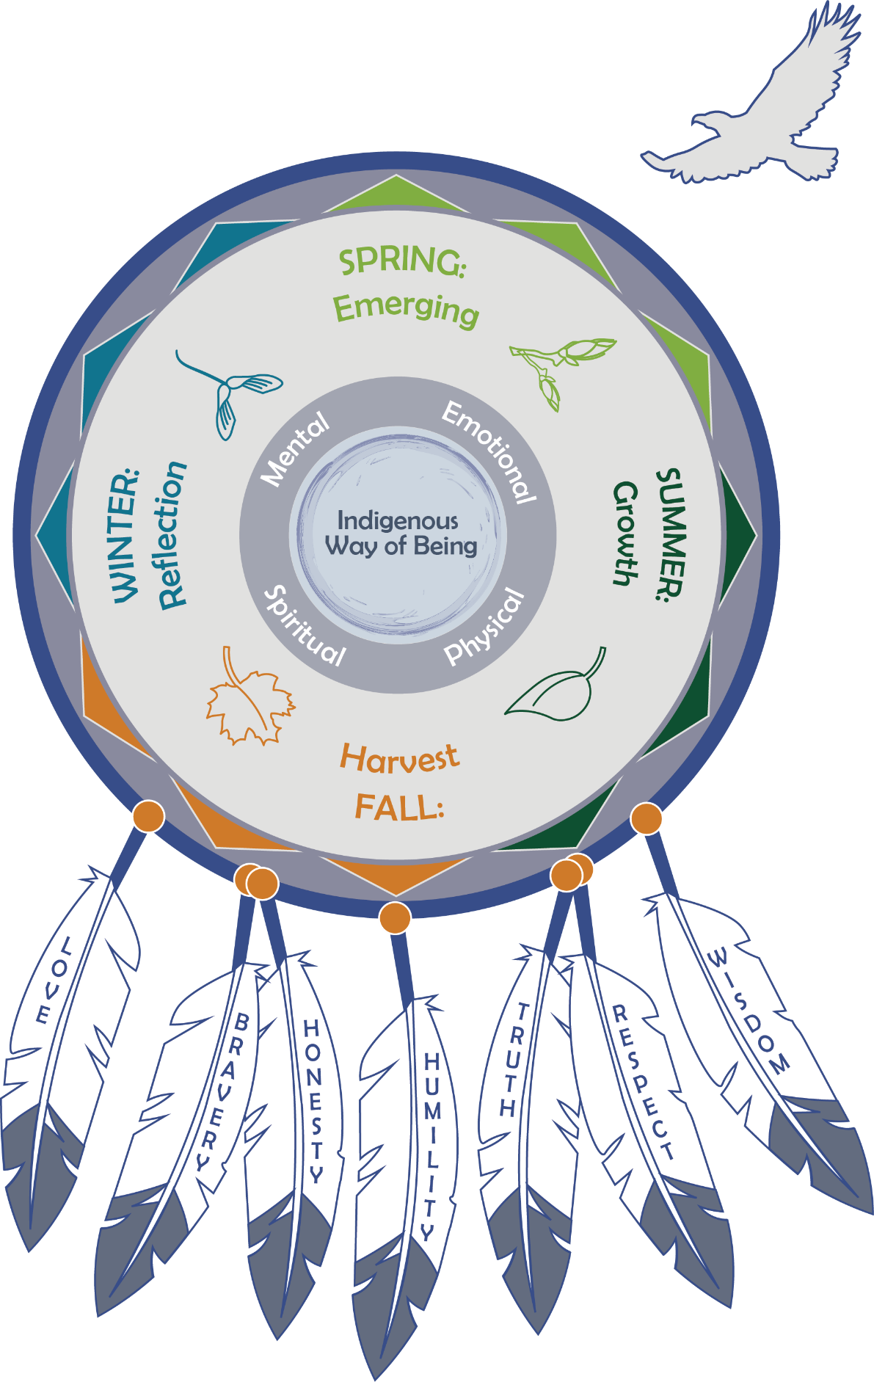

Intergenerational Protective Circles of Care

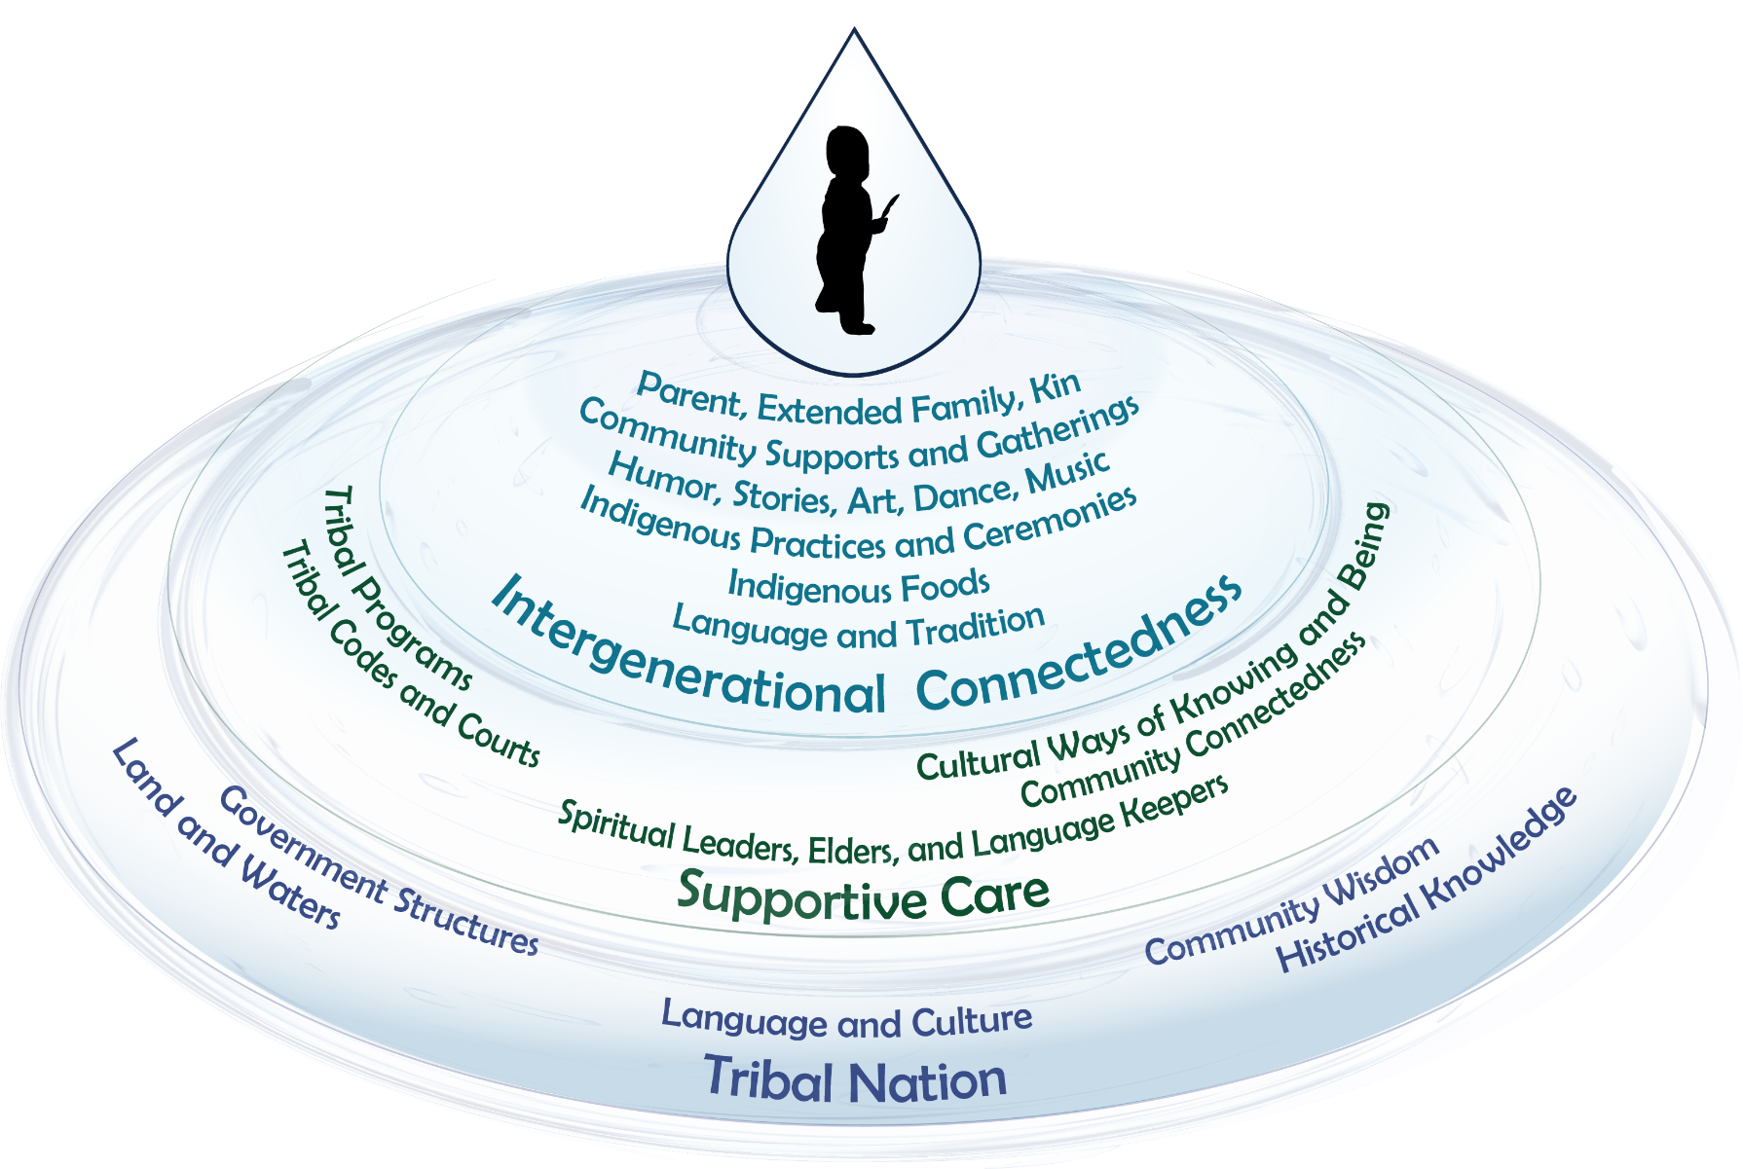

Indigenous Circles of Leading: An Eagle’s View
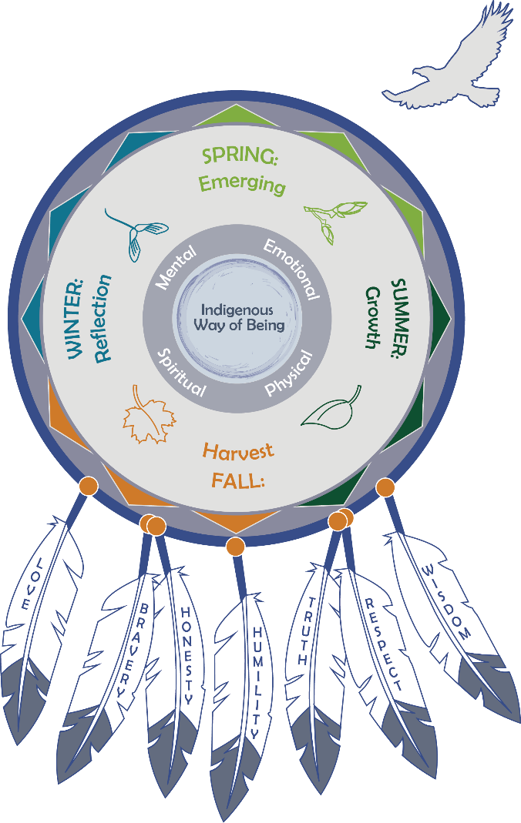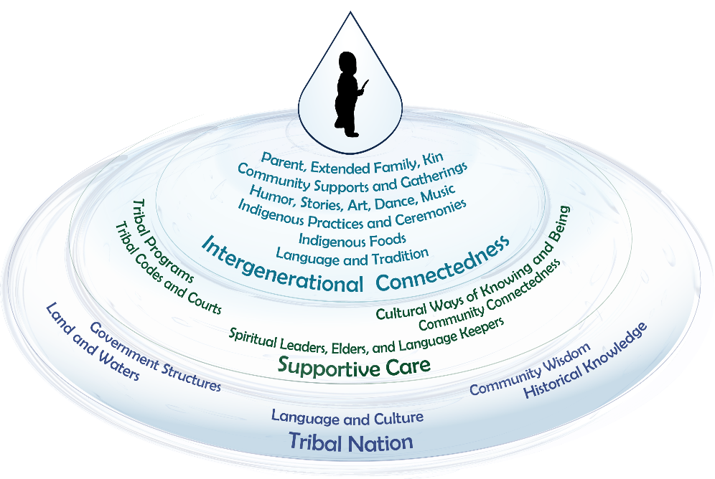

The Honorable Harvest
The video is available at: https://youtu.be/cEm7gbIax0o.

- Know the ways of the ones who take care of you, so that you may take care of them.
- Introduce yourself. Be accountable as the one who comes asking for life.
- Ask permission before taking. Abide by the answer.
- Never take the first. Never take the last.
- Take only what you need.
- Take only that which is given.
- Never take more than half. Leave some for others.
- Harvest in a way that minimizes harm.
- Use it respectfully. Never waste what you have taken.
- Share.
- Give thanks for what you have been given.
- Give a gift, in reciprocity for what you have taken.
- Sustain the ones who sustain you, and the earth will last forever.
Robin Wall Kimmerer, Braiding Sweetgrass
https://youtu.be/cEm7gbIax0o
Consider how these ideas apply to child welfare interconnectedness and the seasonal cycles.

Sample Ecomap
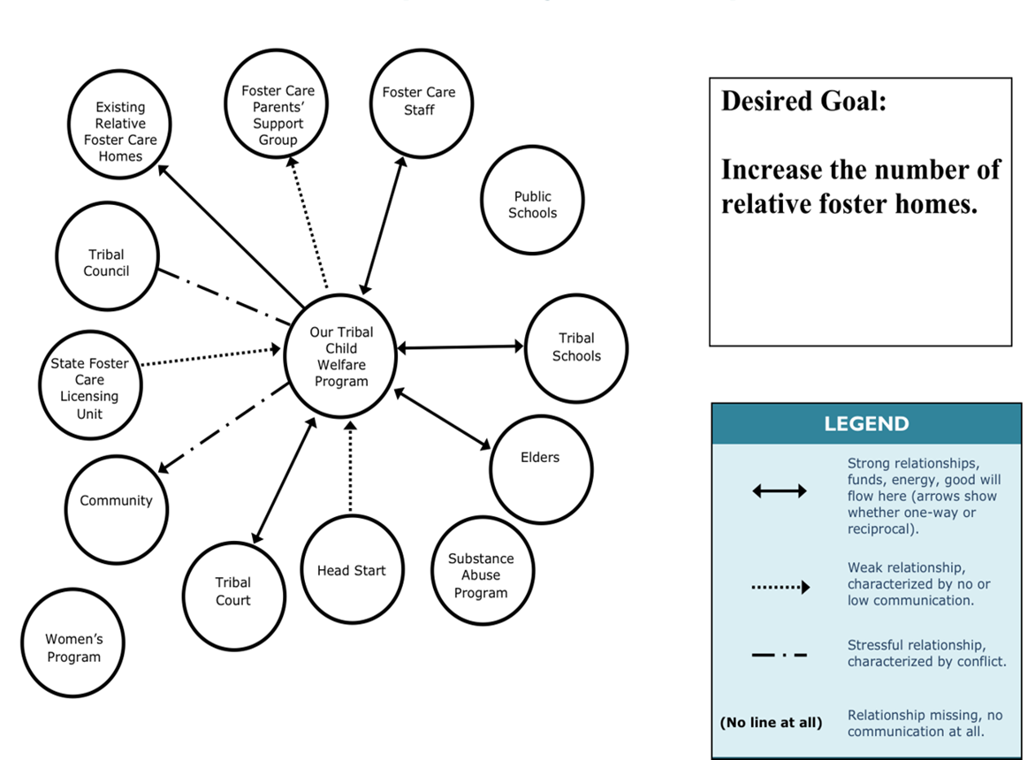The video is available at: https://youtu.be/d5iK3ly6bpM.

Source: Ecomapping was originally cited in Hartman, A. (1978). Diagrammatic assessment of family relationships. Social Casework, 59(8), 465–476

Eagle Mapping: Identify Shared Purpose and Connections
This blank page is provided for you to draft your own ecomap. When complete, you will draw your group’s ecomap on a piece of flipchart paper so that you can share with the larger group.

Another way to complete an ecomap is to draw it on the blank Intergenerational Protective Circles of Care. We are providing this blank image for you if it helps you to draw your connections in relationship to the circles.

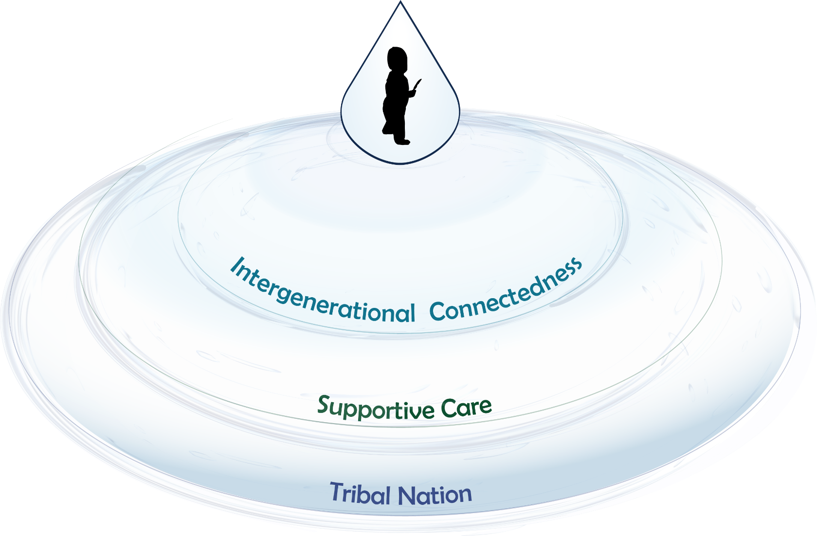

Indigenous Adaptive Leadership in Practice
The video is available at: https://youtu.be/xa3IXzh0dnM.

From our pre-discussion and as you listen to Eric Martin’s next video, jot down a few traits that come to mind in the appropriate column. If you need some refreshers, there are some technical and adaptive traits on the next page.
Technical | Adaptive

Leadership | Authority
Possible Topics for Technical and Adaptive Leadership

Debate is encouraged.
Environment is open, restless, and changing.
Participants engage in dialogue.
Knowledge is held by a few.
Language includes all.
Information is shared.
Process is rigidly structured, ordered.
Action by staff is punished.
Debate is stifled.
Expertise is limitless.
Environment is stagnant.
Pronouncements are made (no dialogue).
Information is hoarded.
Process is flowing, creative, noisy.
Action for self is defined by self.
Expertise is limited.
Diversity is recognized and appreciated.
Language includes some.
Knowledge is within us all.
Diversity is ignored.

Immunity to Change
The video is available at: https://youtu.be/d29eA9FUeO8 .
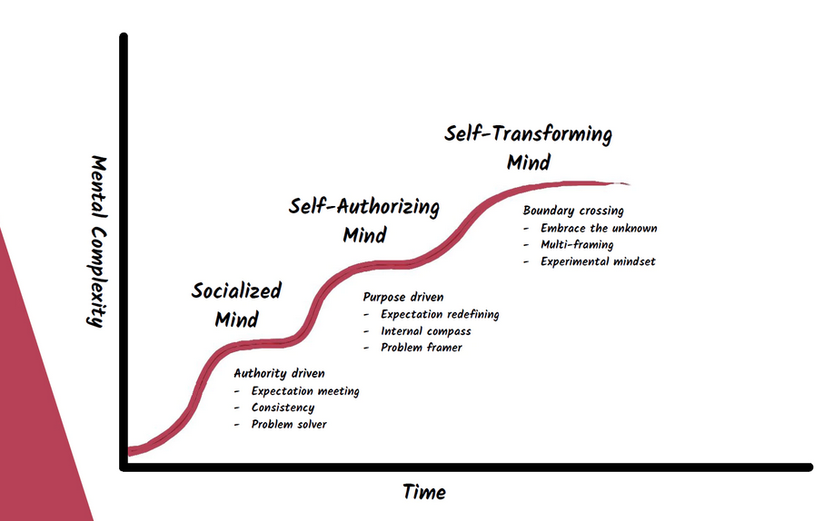
Source: Eric Martin, Managing Director, Adaptive Change Advisors

Shared Learning Activity: Your Immunity to Change

- What kind of things would help you perform at your best if they happened more often, or less often, in your work?

- I am committed to the value or importance of ________.

- What do I do, or not do, that gets in the way of my values?

- What might I be ready to let go of in service to my purpose?

Identifying Resistance in the Workplace
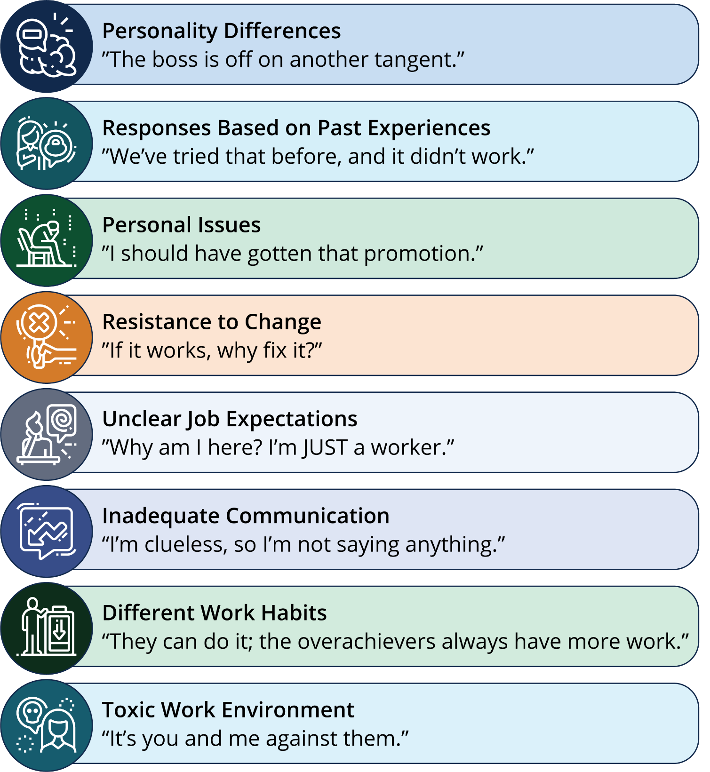

Margaret’s Story: Your Case Study
The video is available at: https://youtu.be/7mCB9VzYXas.
Feel free to use your creativity when building your case plan. You don’t get to see all the interactions in the video, so you can make some inferences to fill any gaps you have!
New funding streams gave Margaret the ability to grow the number of families that her organization could serve.
- What is one thing you need to make your vision a reality?

- What kind of ripple effects could that have for your program?

Adaptive Leadership

As you have learned about adaptive leadership over the first two days, we are providing a space here for you to start writing down what challenges you are currently facing in your program.
Challenges you are currently facing:
________________________________________________________________________________________________
________________________________________________________________________________________________
________________________________________________________________________________________________
________________________________________________________________________________________________
________________________________________________________________________________________________
________________________________________________________________________________________________
________________________________________________________________________________________________
________________________________________________________________________________________________
Now that you have listed out some of your current challenges, put them into columns of “technical” and “adaptive.” This can allow you to begin determining how you might want to address these challenges as you learn more about adaptive leadership in the next two days.
Technical | Adaptive

