Tribal Child Welfare Leadership Academy

Session 3

Fall

This product was developed by the National Capacity Building Center for Tribes, which is funded by the Children’s Bureau through cooperative agreement number FAIN #90CZ0028

# Acknowledgment

Welcome to the Tribal Child Welfare Leadership Academy (TCWLA). This curriculum was adapted from the National Child Welfare Workforce Institute’s (NCWWI) Leadership Academy for Middle Managers (LAMM) using federal dollars. You will see the curriculum has been divided into 4 modules reflecting a seasonal approach. Module 1 begins in the spring, and module 4 ends in the winter. The examples provided throughout the curriculum reflect specific tribal values for some tribes, but we respect that all tribes are not the same and each unique community has values, customs, and practices of their own. The full curriculum is free to the public and can be adapted by your tribal child welfare organization to meet the needs of your staff and your own cultural values.

We are grateful to the Children’s Bureau for funding this project and hope you will find it relevant to your own tribal child welfare leadership needs. When using the curriculum or its materials, we ask that you make attributions to the Capacity Building Center for Tribes and the Children’s Bureau.

***Recommended citation:***

Capacity Building Center for Tribes. (2024). *Tribal Child Welfare Leadership Academy*. Denver, CO: Author.

© 2024, Capacity Building Center for Tribes, Butler Institute for Families, Graduate School of Social Work, University of Denver

This document may be reproduced in whole or part without restriction as long as the Capacity Building Center for Tribes is credited for the work.

The contents of this document are solely the responsibility of the Capacity Building Center for Tribes and do not necessarily represent the official views of the Children’s Bureau.

# Table of Contents

Acknowledgment 2

Table of Contents 3

Training Materials 4

Room Setup 4

Training Design 4

Welcome and Introductions 5

Open in a Good Way 5

Tribal Child Welfare Leadership Academy: Fall 6

Respecting Our Time Together 6

Note of Caution 7

Foundation of the Tribal Child Welfare Leadership Training 7

Today’s Agenda 8

Storytelling Bingo Activity 9

Indigenous Circles of Leading: An Eagle’s View 9

Fall – Taking Stock and Harvesting 10

The Honorable Harvest 11

A Shared Learning Activity: Identify Shared Purpose and Connections 14

Eaglemap Walkabout 14

Indigenous Adaptive Leadership in Practice 15

Mobilizing People: Leadership Moments 16

Immunity to Change 17

Shared Learning Activity: Your Immunity to Change 18

Listening in on Change 19

Identifying Resistance in the Workplace 19

Underlying Causes of Resistance 20

Mindfulness in Adaptive Leadership 21

Our Indigenous Way of Being and Doing 22

Margaret’s Story: Fall 23

Applying Margaret’s Story 23

An Eagle’s View 24

It’s Been a Good Day! 25

Tribal Child Welfare Leadership Academy Curriculum Team 26

# Training Materials

For the in-person training days, you will need the following materials:

* Printed participant workbooks, which are also emailed to participants ahead of time
* Flip chart paper
* Markers
* Paper
* Pens
* Post-Its

# Room Setup

When setting up the in-person classroom, these configurations are best for open discussion:

* Circle tables
* Four to six chairs per table
* Tables set up in a circle
* Drink/snack station in the back of the room

# Training Design

This complete training is 24 hours of training. The breaks are not included in this time frame because those will be tailored to the participants’ needs and the length of each day of training.

**Facilitator Note:** While this training is broken out into 4, 6-hour training days, the delivery of the training can be changed to accommodate program needs—for example, 6, 4-hour days. Depending on the size and engagement of the participants, some sections can take longer than others, so you will want to adjust your timing and breaks accordingly. You will want to work several breaks into the day, such as a 10-minute break at the end of each hour. You can find timers to share on screen that will keep track of the time left in breaks on YouTube. Search the internet for “YouTube” timers for timers, like this 10-minute example: <https://youtu.be/yxu0qHbG_2c>.

**Facilitator Note:** As people come into the room, you can play gentle music. The PowerPoint slides don’t start until after the “Welcome,” “Introductions,” and “Open in a Good Way.”

Welcome and Introductions

10 minutes

Virtual Delivery: You can adapt all the activities in this curriculum for virtual delivery, and we have found that the discussions and engagement can be successful in an online environment through using chat, creating breakout groups, and asking people to come off mute.

Do:

* Acknowledge any dignitaries, leadership, and elders who have joined the group.
* Recognize Children’s Bureau and the Capacity Building Center for Tribes for creating this training.
* Introduce the facilitators, including relevant info that you are comfortable sharing, and then provide detailed intro after blessing.
* Offer a land acknowledgment—if in person, for land of the venue, and if virtual, then each facilitator for land they are joining from.

Open in a Good Way

15 minutes

**Facilitator Note:** Make sure you have arranged blessing ahead of time with tribal programs and considered cultural protocols. Try to bring in a tribal elder of the tribes you are training. Find out what the protocol is for gifts and blessing supplies and provide culturally relevant introductions. If virtual, determine if the blessing will be on screen or just audio.

Say:

* As we begin this time together, we want to start our time together in a good way.

Do:

* Introduce blessing provider.

Offer thanks.

* Once blessing is done, bring the PowerPoint slide deck up after the “Welcome” and “Open in a Good Way.”

Virtual Delivery: When using Zoom as your sharing platform, make sure you click the two radio buttons in bottom left to share sound and optimize video for clips. The person who shares their screen will need to have good bandwidth and the ability to play videos without lagging.

Slide 1:

Tribal Child Welfare Leadership Academy: Fall

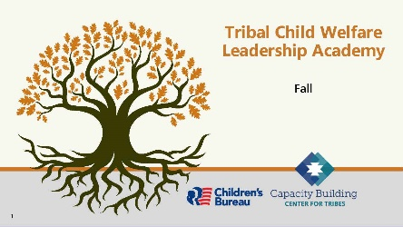

5 minutes

Say:

* That was such a meaningful way to start our third day of training. Thank you. We are now venturing into the next step in our leadership journey.

Do:

Reintroduce tech support, so they know who to send questions to if they have any issues; if any issues came up the day before, let the participants know the solutions.

**Tech Help:** When you introduce yourself, discuss all the housekeeping pieces that you need participants to discuss. Inform them that you will be present to help with things like printing handouts or accessibility issues. Be prepared to keep track of time for the breaks for participants.

Slide 2:

Respecting Our Time Together

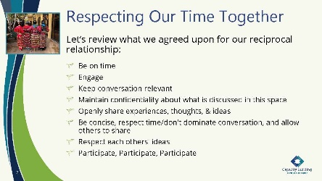

5 minutes

**Facilitator Note:**

If new participants have joined the group, allow for them to contribute to the agreements as you see fit. Also, remind participants about the break schedule for the day, which can be adjusted to fit the participants recommendations. For virtual, we recommend a short break each hour; for in-person trainings, two longer breaks during the day may work better.

Say:

* Let’s revisit how we will respect our time together.

Do:

Read the content on the slide.

Ask:

Does anyone have anything they want to add?

Say:

* Thank you to everyone for reciprocating this respect for our time together.

Slide 3:

Note of Caution

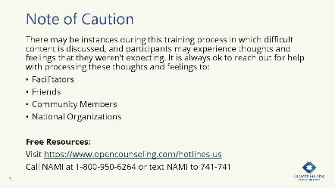

5 minutes

Say:

* We want to remind you to take care of yourself and reach out for help if needed. This slide notes some available resources, and we are always here to talk if needed.

Slide 4:

Foundation of the Tribal Child Welfare Leadership Training

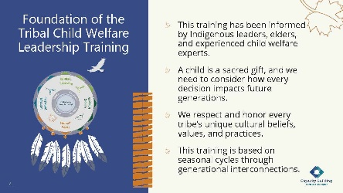

5 minutes

Say:

* Here is an opportunity to revisit the foundation of this training. Review what is on the slide and let me know if you have any questions.

**Facilitator Note:** This is what is on the slide. You can pick a topic from below to discuss:

How you lead and the choices you make can have ripple effects. Success in tribal child welfare programs is achieved when tribal child welfare leaders, tribal leaders, and the community work together and know children are sacred gifts who need to be connected to kin, community, and their environment. These collaborations provide a collective vision to honor the rights of Indigenous children for the next seven generations.

The intention of this training is to help you build upon your Indigenous leadership skills to create more strength and resiliency for your program. Our hope is that you will find universal connections to your own nation’s cultural beliefs and that you will bring your unique perspective to our conversations, so we can all work together to build upon tribal sovereignty.

Tribes who want to implement the training locally can use their own cultural beliefs, practices, and values. No landscape is the same, and all seeds need special conditions to successfully grow. What you can grow may be limited by the resources you have available. Or you may need to change your environment to grow what is needed to serve your people. We honor and respect all the landscapes you are bringing together in this room, and we hope you can find universal truths in the materials we provide.

Throughout this training, we will explore the historical events that shaped our current realities and consider the future of our tribal nations for the next seven generations.

Slide 5:

Today’s Agenda

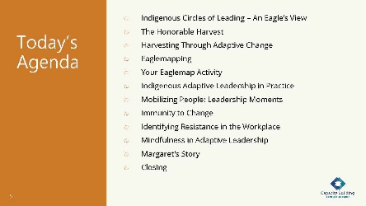

5 minutes

Do:

Review the day’s agenda:

* + Indigenous Circles of Leading – An Eagle’s View
  + The Honorable Harvest
  + Harvesting Through Adaptive Change
  + Eaglemapping
  + Your Eaglemap Activity
  + Indigenous Adaptive Leadership in Practice
  + Mobilizing People: Leadership Moments
  + Immunity to Change
  + Identifying Resistance in the Workplace
  + Mindfulness in Adaptive Leadership
  + Margaret’s Story
  + Closing

Do:

Remind everyone that they received a participant workbook that they will be using for the training day.

Slide 6:

Storytelling Bingo Activity

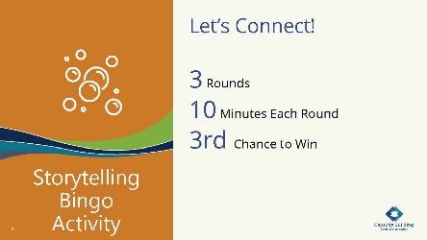

35 minutes

Say:

We continue to feel that this gathering space is such a blessing. We are ready to continue the bingo game that we started during our first session. Let’s see how many more squares you can fill this morning!

**Facilitator Note:** Here are the bingo instructions to refresh your memory from the summer training session.

Tell your story and ask others for their story. Break into a group of three for 10 minutes and choose a topic in a square; then each of you share a story. Write in **their** answers below the topic on your card. We will do three rounds of interaction each morning. Throughout the next few days of training, you will have additional opportunities to fill in your squares. The object of “Storytelling Bingo” is to fill in each square for “Blackout Bingo” (every square to be filled).

Virtual Delivery: This mingle can be done via Zoom by using breakout rooms.

**Tech Help:** Keep track of time and rotate groups every 10 minutes.

Slide 7:

Indigenous Circles of Leading: An Eagle’s View

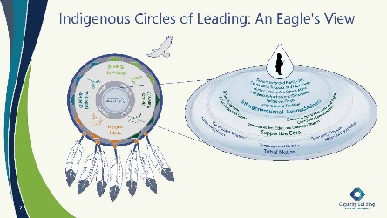

10 minutes

Say:

* Each session we take a quick review of the Indigenous Circles of Leading model from an eagle’s view as we move into another season.
* The Indigenous Circles of Leading and the Intergenerational Protective Circles of Care are our guide. Consider a parallel to the workplace and the time and purpose for all things. The fall season is the time for recognition and celebration of personal mastery and reviewing and adapting strategic plans. As we begin preparing for the next steps in organizational planning, we consider our continuous quality improvement through returning to our shared vision and purpose by interviewing staff, community, key stakeholders, and others for feedback. This process is much like in the fall when we are removing dead leaves, cutting things back, and planting new bulb flowers for the spring. The fall comes to us with a flurry of color, whose beauty we can absorb while taking an eagle’s view of our organization.
* As a general overview, the Indigenous Circles of Leading illustrates an eagle’s view of the interconnectedness we have with all relations. Whether we are Native or non-Native, we are serving Native children and families, and understanding this way of leading for finding healing, reconciliation, and resiliency within the communities promotes better outcomes for our future. You will remember some of this information from the Indigenous Circles of Leading video that you watched as part of your time with your coaches before our training sessions began.
* Understanding our interconnectedness as a tribal child welfare leader is the foundation to building upon the Indigenous Circles of Leading.
* We spent time in the second session in summer learning about that time of growth, which mobilizes and grounds resources. Growth continues through practice, energy, team building, focusing, and modeling self-care while recognizing trauma. We bring this model back to you this morning as a review. Now, we move into the fall season.

Slide 8:

Fall – Taking Stock and Harvesting

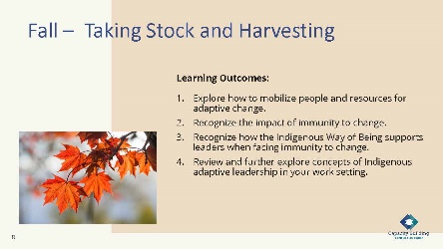

10 minutes

Say:

* We are continuing our training journey through the seasons. For day three, we’re entering the fall.
* The learning outcomes for today’s session are listed here and in your workbook. Please take a moment to read the outcomes [or have participants read them out loud].
* The weather is cooler, and animals are beginning to prepare for the winter. Many of our tribal celebrations and harvests are in the fall season.
* To everything there is a season and time for every purpose. It’s a time to take stock in what we have and prepare for winter. Squirrels and other animals are gathering and storing food. Some tribal ceremonies are being held to honor the harvest through reciprocity. In this session, we begin to review and explore concepts in Indigenous adaptive leadership to consider changes for enhancing leadership practice.

Slide 9:

The Honorable Harvest

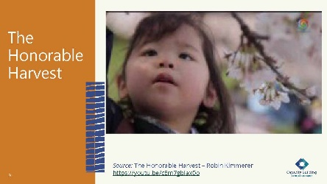

10 minutes

**Facilitator Note:** You will play this video, “The Honorable Harvest,” which is 3:31 minutes. It’s available through YouTube at <https://youtu.be/cEm7gbIax0o>.

Virtual Training: When sharing a video by Zoom or another online platform, you will need to make sure that you have selected the option to share sound so that participants can hear the video’s sound.

Say:

* Native author, Robin Wall Kimmerer, created this video to explain our interconnectedness with all our relatives, including our plant relatives.
* In her book *Braiding Sweetgrass*, Robin Kimmerer provided this list of small acts in daily life. This reminds us of reciprocity, a relationship-focused, Indigenous way of being in which we give and receive. In our work, we continually seek balance and consider changes to keep in focus the interconnectedness of all things. We engage our communities through “sharing and caring” toward a common purpose.
* As you watch this, consider how this applies to child welfare interconnectedness and the seasonal perspective.

Do:

Play YouTube video.

Ask:

What did you hear in this video that applies to child welfare interconnectedness and the seasonal cycles?

Do:

Give participants space to talk about their ideas.

**Facilitator Note:** Here are items from the video that you can share if needed:

**•** Reciprocity between humans and the living world is essential to healthy, resilient relationships.

**•** To care for the plants and animals, we must know what they need – this transfers to children and families we serve.

**•** You don’t need written protocol to treat families in a good way.

**•** We need to introduce ourselves to the world around us and tell what we are here for.

**•** If you are going to ask, you must listen for the answer. Be pragmatic and intuitive.

**•** Taking without permission is stealing.

**•** We must share what we harvest.

**•** Sharing is a culture of resilience.

Say:

* Let’s now discuss how we can take the thoughts from the honorable harvest into mobilizing our resources to support adaptive change.

Slide 10:

Harvesting Through Adaptive Change

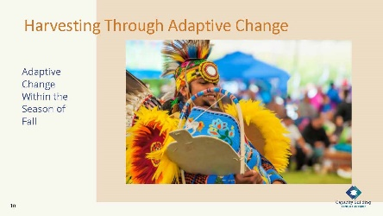

10 minutes

Say:

* The fall season is a time for celebration. Personal mastery is being recognized by those who practice their craft. At an organizational level, the path opens to an acceptance of the journey as we begin to understand adaptive change. Effective leadership involves embracing adaptive change and requires us to be open to leadership moments that connect us to a shared vision. In the summer season, we discussed this process of growth. Now we’ve entered fall and are able to see how changes made during the summer season are affecting the staff, organization, and communities we serve.
* In this session, we dive deeper to mobilize our resources and energy for continual progress. We are now going to look at how you can catalog resources for mobilization. It’s a tool to use when taking an eagle’s view for collaborative initiatives or projects and is intended to improve your program outcomes.

Slide 11:

Mobilizing Resources: Eaglemapping

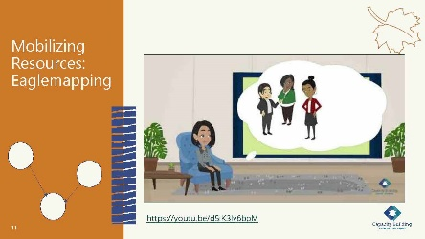

10 minutes

**Facilitator Note:** A. Hartman developed the ecomap in 1975 as a part of the Child Welfare Learning Laboratory, a project of the University of Michigan School of Social Work Program for Continuing Education in the Human Services. The project was supported in part by a grant from Region V, Social Rehabilitation Service, U.S. Department of Health, Education, and Welfare, Section 426, Title IV, part B of the Social Security Act. Ecomapping was originally cited in Hartman, A. (1978). Diagrammatic assessment of family relationships. *Social Casework*, *59*(8), 465–476.

**Tech Help:** You will play the video that is embedded in the slide, which is also available on YouTube at <https://youtu.be/d5iK3ly6bpM>.

Do:

Play the video embedded in the slide, which is also available at <https://youtu.be/d5iK3ly6bpM>.

After the video, lead a discussion on eaglemapping.

Say:

* Eaglemapping is adapted from ecomaps. Ecomaps are a tool to understand connections and supports to meet objectives of a shared purpose or goal. They are often used with families to understand their supports. They can, however, also be used at the organizational level by taking an eagle’s view to help to understand how a shared purpose in your organization can be supported and where you might need to repair or invite new external partners into your shared purpose.
* In the example shared in the video, the shared purpose (goal) of the organization is to increase the number of relative resource homes.

Ask:

What did you see in the video’s eaglemap?

Slide 12:

A Shared Learning Activity: Identify Shared Purpose and Connections

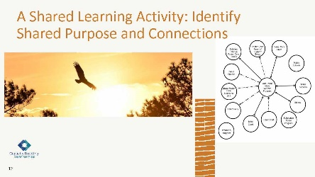

50 minutes

**Facilitator Note:** Pass out flip chart paper and markers for participants to draw their eaglemaps. There is also a page in their workbooks where they can sketch out their ideas.

* In pairs, take turns drawing your eaglemap with identifying shared purpose and connection to those in your communities. There are examples and space to draft your ideas your workbook, then you can create your eaglemap on the flipchart paper. Share any insight of the relationships and others to be included in the shared purpose. Review the Intergenerational Protective Circles of Care and the supports within each circle. Are there any that would contribute to your shared purpose and can be invited?

Do:

Break the groups into pairs for a shared learning activity.

Give them 45 minutes to draw their eaglemaps.

Provide a warning when there are five minutes remaining for the shared activity.

Bring the learners back together.

Slide 13:

Eaglemap Walkabout

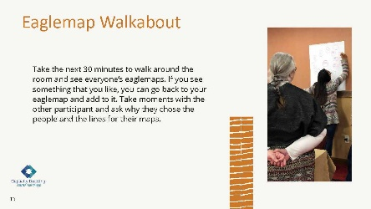

30 minutes

Say:

* Take the next 30 minutes to walk around the room and see everyone’s eaglemaps. If you see something that you like, you can go back to your eaglemap and add to it. Take moments with the other participants and ask why they chose the people and the lines for their maps.

**Slide 14:**

Indigenous Adaptive Leadership in Practice

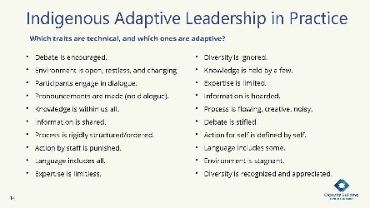

10 minutes

Say:

* In the spring, we looked at adaptive versus technical challenges that leaders can experience. On the screen we listed some of the traits discussed during the spring session. These are also in your workbook, where you’ll also find a blank table where you can write in more ideas.

Ask:

Are there any traits that stand out as being adaptive or technical? Did anyone want to name a trait and the type of challenge it is?

Do:

Allow a few participants to respond.

Say:

* We want you to continue to think about this as we watch the next video from Eric Martin. Continue to fill out your table with ideas that come to you as you watch.

**Facilitator Note:** Here are some additional ideas that you can bring forth as people discuss technical and adaptive challenges:

**• “**Indigenous Leadership in Practice” concepts are a shift in behaviors, being more of a shared authority in decision making.

**•** Recognizing a leadership moment where you or your organization needs Indigenous adaptive leadership can make all the difference in whether an issue is addressed in a way that results in change or remains the same or worsens.

**•** Dancing on the edge.

**•** The seven grandfather teachings—love, bravery, honesty, humility, truth, respect, and wisdom—guide our conduct and interaction with others.

Slide 15:

Mobilizing People: Leadership Moments

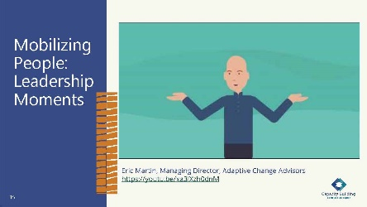

15 minutes

**Tech Help:** You will play Eric Martin’s video embedded in the PowerPoint slide. It is 6:35 minutes and available at <https://youtu.be/xa3IXzh0dnM>.

Say:

* In this video, Eric will explain how mobilizing people as a path to reconciliation requires reframing the work and seeing possibilities and how they may be in the way. It can be dangerous and risky with no guarantee it will be successful, so it’s like dancing on the edge of the limits of your authority.
* When you listen to this video, consider technical versus adaptive and the difference between leadership and authority. In the tables in your handout, fill in the moments you had recently where you needed to engage in leadership rather than authority.

**Facilitator Note:** Here are some additional ideas that can support participants’ understanding:

**•** Exercising leadership is risky, which is why we seldom see it from people at the top organizations.

**•** There’s no reason to exercise leadership unless it’s on behalf of a purpose that you hold.

**•** The single biggest mistake is conflating the exercise of leadership with the exercise of authority.

**•** Leadership definition v.1.0 includes mobilizing people to tackle challenges that have no known or easy answers.

**•** Leadership definition v.2.0 includes disappointing or disrupting your own people at a tolerable pace...for a purpose.

**•** Exercising authority requires the provision of direction, order, protection, and expertise. (See “Nature of Authority” graphic.)

**•** Leadership happens at the edges of the scope of authority.

**•** Authority tends to maintain the status quo; leadership creates more consequential change. Leadership is the way that we create the change that we see when we practice the eagle’s view.

Ask:

What thoughts do you have about the difference between leadership and authority? What leadership moments have you had recently where you needed to engage in leadership rather than authority?

Do:

Allow a few participants to respond.

Say:

* We want to share this quote with you: “New adaptations have the potential of significantly displacing, re-regulating, and rearranging old structure.” - Adel Panahi, adaptive leadership book summary

**Slide 16:**

Immunity to Change

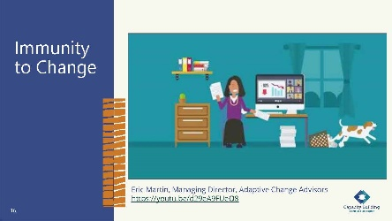

10 minutes

Ask:

What does it look like to you when you are faced with a big change? Does it look different if it is a change that you don’t really want?

Say:

* Adaptive change brings challenges, and we’ll begin discussing ways to engage others when they may be resistant for various reasons.
* As we discuss Indigenous adaptive leadership and supporting cultural practices, we need to recognize the change process and challenges you as a leader will face. In the fall, we continue to take stock and mobilize resources. In mobilizing people, Eric Martin shares that we are immune to change because of old habits, which he calls an immunity to change.
* In this next video, he will explore being mindful of adult learning techniques. As adults, we must unlearn old behaviors and habits to make progress toward our desired goals.
* While watching this video, consider these questions, as we will talk about them in our next breakout groups. There is a handout in your workbook with these questions in case you want to write down your thoughts as you listen to the video:

1. What kind of things would help you perform at your best if they happened more often, or less often, in your work?
2. I am committed to the value or importance of ________.
3. What do I do, or not do, that gets in the way of my values?
4. What might I be ready to let go of in service to my purpose?

Do:

Play the video embedded in the slide.

**Tech Help:** You will play Eric Martin’s video embedded in the PowerPoint slide. It is 3:21 minutes and available at <https://youtu.be/d29eA9FUeO8>.

Say:

* Let’s go into a shared learning activity to discuss the questions we asked you to consider from the video.

Slide 17:

Shared Learning Activity: Your Immunity to Change

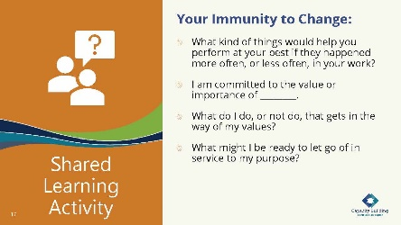

15 minutes

Say:

* We want you to engage in a shared learning activity now. We will break into pairs, and you will discuss the questions we presented earlier for the next 10 minutes. Considering the adult learning process and stages of growth Eric Martin presented, this exercise will allow you to identify how you may be getting in your own way.

Do:

Break participants into pairs.

Let participants know when there are just a couple minutes left in their discussion.

Bring the participants back together.

Virtual Delivery: Put participants into breakout groups as pairs. Place questions in the chat.

Say:

* Let’s talk more about resistance to change and being able to manage resistance.

Slide 18:

Listening in on Change

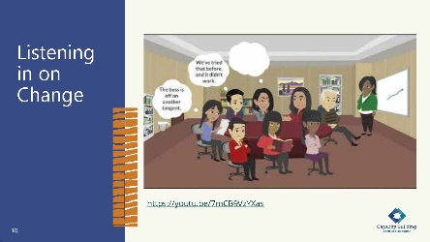

5 minutes

Say:

* Let’s take a look at this short clip.

**Tech Help:** Play the short video in the PPT deck, which is also available at: <https://youtu.be/7mCB9VzYXas>.

Do:

Play avatar video embedded in the PowerPoint slide.

Ask:

Does this situation look familiar to you? Do you recognize yourself or your coworkers?

Slide 19:

Identifying Resistance in the Workplace

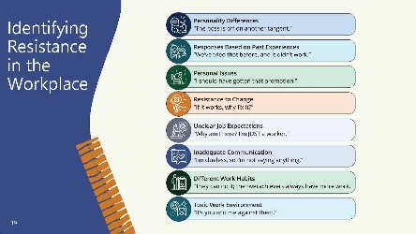

5 minutes

Say:

* As we saw in the video, change can affect everyone differently. How people respond to change can be intertwined with their past experiences, their current workload, or their fears about the future, just to name a few things that can spark resistance. When resistance shows up, it can sometimes be difficult to identify.

Ask:

When you look at the examples of resistance that are on this slide, can you identify how these responses have shown up in your day to day for either you or a coworker?

What are the most frequent resistance responses that you have noticed in your organization.

Do:

Provide a few minutes for responses.

If needed, provide some examples from your experiences with change.

Slide 20:

Underlying Causes of Resistance

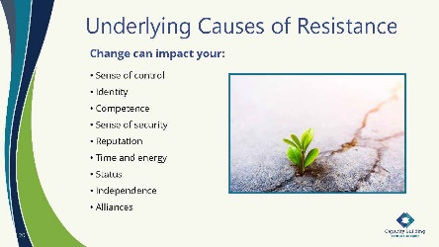

10 minutes

Say:

* We’ve talked about why we as individuals can be resistant to change.

Ask:

What do we need to consider in the workplace when others resist change?

Do:

Allow participants to provide answers for a few minutes.

After the discussion, press the mouse to advance on the slide. It will make each answer appear individually with each click. If they have covered the answer, you can say, “Look at that! We covered that!” If they haven’t covered it, you can say, “We haven’t talked about this one yet. What do you think about it?”

**Facilitator Note:** The answers below are animated on the slide. As you click your mouse, each one will fly in individually.

Change can impact:

**•** Sense of control

**•** Identity

**•** Competence

**•** Sense of security

**•** Reputation

**•** Time and energy

**•** Status

**•** Independence

**•** Alliances

Say:

* These are everyday challenges in working with people. Understanding the impact provides a way to begin discussions in a good way. Being mindful of our role as a leader and understanding the 4 Rs to being trauma informed allows each of us and our teams to remain balanced and in harmony.

Slide 21:

Mindfulness in Adaptive Leadership

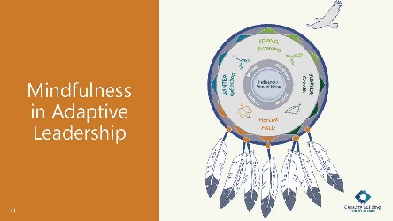

15 minutes

Say:

* From our discussions, we know adaptive leadership requires change. We’ve also talked about how this impacts our shared purpose and values. Here’s a quick reminder of how the Indigenous Circles of Leading model grounds us in our path to establish harmony and maintain balance.
* It’s not just for ourselves. Restoring harmony with others increases confidence and satisfaction with their work. Our ancestral teachings encourage us to remember that the cycle of life can affect anything that is growing. As we go through these cycles, we are mindful of the impact on the emotional, mental, physical, and spiritual growth not only of ourselves and our staff but also the organization. The feathers in the model, which represent the seven grandfather teachings, remind us also how we can care for ourselves and others as we engage in needed change.

Ask:

How can the Indigenous Circles of Leading model help ground you as you encounter resistance to change?

How can it help staff move past their resistance?

Do:

Provide time for participants to respond.

If possible, capture their responses on flip chart paper so that they can see other’s ideas for the rest of the day.

**Facilitator Note:** In case they are not mentioned, here are some ideas you can interject:

**•** Remain balanced and centered.

**•** Remember the activities of the season and how those translate to leading change.

Slide 22:

Our Indigenous Way of Being and Doing

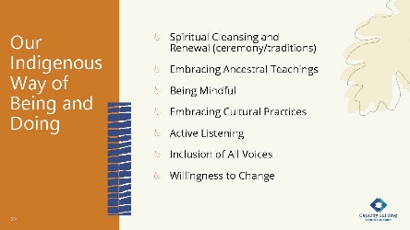

10 minutes

Say:

* Being mindful of our own Indigenous way of being provides a safe space to engage in discussion of resistance to change. These are examples of ways of being that can help you be in harmony and balance.

Ask:

What are other ways that you use to stay in harmony and balance?

How can you model those for staff?

Do:

As the participants provide answers, try to capture them on flip chart paper.

Say:

* We are in the season of fall, which is a time for harvesting. Consider how the seasons are interconnected and in balance. In the summer season, we talked about a “just society.” The just society in the cycle of seasons is not seen, but our mindfulness and action can ensure it is actively working. When we consider our cultural practices and spiritual ceremonies, these are the unseen.
* Remember that each of us can help to restore harmony, whether within ourselves or others.

Slide 23:

Margaret’s Story: Fall

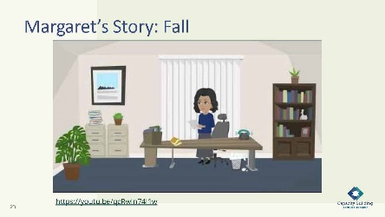

5 minutes

Say:

* We have heard from Margaret during each of our training seasons. Margaret was an early contributor to this curriculum, and we are honored to have her still involved by sharing her leadership story.
* After the hard work of summer’s growth, it’s time to take stock and begin the harvest. Margaret’s vision began to become a reality as she received funding and created needed services for permanency planning for the children. In this video, she begins to take stock of what she has developed in her program.

**Tech Help:** You will play the video embedded in the PowerPoint slide, which is 3:43 minutes. It is also available at: <https://youtu.be/qcRwJn74I1w>.

Slide 24:

Applying Margaret’s Story

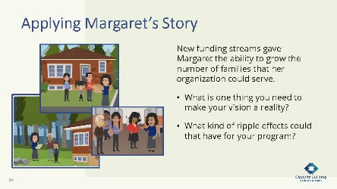

25 minutes

Say:

* We would like to give you some time to return to the case study you have been working through—Margaret’s Story.
* New funding streams gave Margaret the ability to grow the number of families that her organization could serve. She took an eagle’s view and used her vision to create a path for her organization.

Ask:

What is one thing you need to make your vision a reality?

What kind of ripple effects could that have for your program? Consider the Intergenerational Protective Circles of Care.

Virtual Delivery: Place questions in chat.

Say:

* Break into your groups and, using all the resources you have been given so far, pull together some answers for these questions. Feel free to use flip chart paper to write out your ideas. You can draw out your ideas, use eaglemaps, and/or write up a narrative—however you want to think about your vision.

Do:

Break participants into groups. Give them 20 minutes to discuss the questions.

Bring participants back together and give each group five minutes to debrief the larger group on what they covered.

Slide 25:

An Eagle’s View

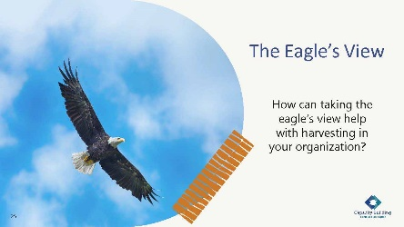

15 minutes

Say:

* As you think about the content of today, remember to always take an eagle’s view to remember that each of us can embrace a leadership moment. Sovereignty begins with each of us.
* When you take an eagle’s view, remember to consider everything that is going on because you are making decisions for the next seven generations.
* I also want to remind you that effective leadership is active and reflective. Taking a view from above the fray provides a holistic approach to see patterns, relationships, contexts, and visionary practices. In the fall, the eagle’s view takes a highly reflective nature, remembering to celebrate our successes from the year and look at where we go next.

Ask:

How are you feeling about today’s training session? Can you share some of what you have learned so far?

Do:

Provide a few minutes for participants to discuss the learning so far.

Virtual Delivery: Ask participants to come off mute or share in the chat.

Slide 26:

It’s Been a Good Day!

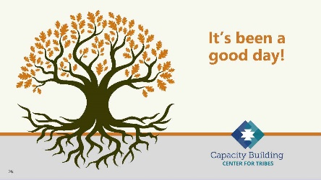

5 minutes

Say:

* As we close out our training day, we are always grateful for the sharing and engagement from this group. Each of us believe deeply in this training, and we are honored to be the ones to share it with you.
* Enjoy your evening, and we will see you at the next session!

# Tribal Child Welfare Leadership Academy Curriculum Team

This curriculum is the collaborative effort of many individuals and agencies working together to create the Tribal Child Welfare Leadership Academy training, an adaptation of the NCWWI Leadership Academy for Middle Managers. We acknowledge the many tribal leaders, formal, informal, and hereditary, who provided input and guidance to the process and outcome. The core curriculum team includes:

**Carolyn Benard**

Logistical Coordination. Butler Institute for Families, University of Denver. Grant and Project Coordinator for Capacity Building Center for Tribes. Denver, CO.

**Tabitha Carver-Roberts**

Curriculum Revision Editor. Senior Program Associate, Butler Institute for Families, University of Denver.

**Jackie Crowshoe,** Turtle Mountain Band of Chippewa

Resource Coordination and Culture Bearer. Capacity Building Center for Tribes, University of Southern Maine, Muskie School of Public Service. Tribal Child Welfare Policy Associate.

**Anne Comstock**

Project Management and Logistical Coordination. Tribal Law and Policy Institute/Center for Tribes Consultant.

**Emily Iron Cloud-Koenen,** Oglala Lakota

Lead Coaching Coordinator and Culture Bearer. Former Executive Director of Lakota Oyate Wakaneia Owicakiyapi, which is located on the Pine Ridge Reservation in South Dakota. Consultant for the Capacity Building Center for Tribes.

**Priscilla Day,** Anishinaabe and an enrolled tribal member of the Leech Lake Reservation

Lead Curriculum Writer and Culture Bearer. Director, Center for Regional and Tribal Child Welfare Studies and a tenured full professor at the Department of Social Work at the University of Minnesota Duluth, where she has taught since 1993. Advisory Board Member and Consultant for the Capacity Building Center for Tribes.

**Kathy Deserly**

Project Advisor and Co-Director, Tribal Law and Policy Institute/Center for Tribes. Worked in the field of child welfare for Native communities since 1974. Has provided extensive training and technical assistance to Native and non-Native programs. Became a founding board member of the Indian Child and Family Resource Center in Helena, MT. Served as the Associate Director for the National Child Welfare Resource Center for Tribes.

**Rachel Fore,** Cherokee

Curriculum Writer and Culture Bearer. Administrative Operations Leader with Cherokee Nation Indian Child Welfare in Oklahoma. Her work involves managing the administrative, financial, and support service programs for her agency. Rachel came to work for Cherokee Nation in 2009.

**Rita Hart,** Jicarilla Apache and Choctaw

Curriculum Writer and Culture Bearer, Project Senior Associate, Butler Institute/Center for Tribes. Extensive experience in the field of state child welfare, Indian child welfare, and Bureau of Indian Affairs.

**Robin Leake**

Principal Investigator and Co-Director, Capacity Building Center for Tribes. Research Associate Professor, Butler Institute for Families, University of Denver.

**Tom Lidot,** Chilkat Tlingit

Facilitator, Curriculum Writer and Culture Bearer. Tribal STAR Program Leader. Academy for Professional Excellence, San Diego State University, School of Social Work. Consultant Advisor Center for Tribes.

**Bob Lindecamp**

Project Advisor. ICF International. Senior Consultant to the Children’s Bureau for Capacity Building Center for Tribes and the National Child Welfare Workforce Institute. Selbyville, Delaware.

**Betty Nez,** Navajo

Coaching Advisor and Culture Bearer. Director of Zuni Tribal Social Services. Manages the Indian Child Welfare Act (ICWA) program, the Child Protective Services program, case management services, and the Foster Care and Family Preservation program. She has been working for Zuni Tribal Social Services for nine years.

**Rose-Margaret Orrantia,** Yaqui

Coaching Advisor and Culture Bearer. Previously worked at the Institute of American Indian Arts in Santa Fe, NM, for 18 years. Returning to San Diego, she served as the Executive Director of Indian Child and Family Services (ICFS), a state licensed foster family and adoption agency serving the American Indian population in San Diego and Riverside Counties.

**Deborah Reed**

Project Advisor. Assistant Professor of Practice/Project Leader. Leadership Academy for Middle Leaders, Center for Improvement of Child and Family Services-CWP. School of Social Work, Portland State University.

**Tribal Content Experts**

**Brenda Gilman Bagwill**

Tribal Patient/Liaison and ICWA Advocate  
Sycuan Band of Kumeyaay Nation

**Sunni Dominguez**

Council member  
Community Liaison for Tribal STAR  
Iipay Nation of Santa Ysabel

**Season Goodpasture**

Director of Social Services for Pala Band of Mission Indians  
Maidu and Paiute of the Susanville Rancheria

**Jahari Harrison**

Southern Indian Health Council  
Indian Child Social Services  
Carib-Kalinago

**Karan Kolb**

Indian Health Council  
Director of Social Services  
Rincon Band of Luiseno

**Melvin Lewis**

Director of Social Services  
Ft Mojave Indian Tribe

**Carolina Manzano**

CEO Southern Indian Health Council  
Alpine, CA

**Linda Ruis**

Director of Tribal Social Services  
Iipay Nation of Santa Ysabel