Tribal Child Welfare Leadership Academy

**Participant Workbook**

Spring

This product was developed by the National Capacity Building Center for Tribes, which is funded by the Children’s Bureau through cooperative agreement number FAIN #90CZ0028.



Table of Contents

Storytelling Bingo 3

Spring Agenda 4

Spring Learning Outcomes 5

Indigenous Circles of Leading 6

Indigenous Circles of Leading (Blank) 7

The Seven Grandfather Teachings 9

Shared Learning Activity: What Stands Out for You? 10

The 4 Rs Infographic 11

Self-Care Resources Offered by Capacity Building Center for Tribes 12

Maintaining Balance and Harmony Through the Cycle of Seasons 13

Intergenerational Protective Circles of Care 14

Bringing Together Circles of Leading and Intergenerational Protective Circles of Care 15

Shared Learning Activity: Intergenerational Protective Circles of Care 16

Eric Martin’s Definition of Leadership 18

Indigenous Leadership in Practice 19

Leadership from a Position of Authority 21

Indigenous Adaptive Leadership 22

Discovering Your Leadership Moment 24

Recognizing Leadership Moments 25

Technical vs. Adaptive Leadership 26

Margaret’s Story: Case Study 27

Adaptive Leadership 28

# Storytelling Bingo

Tell your story and ask others for their story. Break out in a group of three for 10 minutes and choose one topic in a square. Then each of you share a story. Write in ***their*** answers below the topic. The objective of Storytelling Bingo is to fill in each square for Blackout Bingo (every square to be filled out).

|  |  |  |  |  |
| --- | --- | --- | --- | --- |
| S | T | O | R | Y |
| An Unusual Talent | **Celebration of a Life Event** | **Giving Back to Others – Reciprocity** | **Playing a Sport or Favorite Sports Team** | **Favorite Childhood Memory** |
| Funny Event or Joke | **Your Career Choice** | **Favorite Song (please demonstrate!)** | **Favorite Movie or Book** | **Recent Success** |
| Pet or Favorite Animal | **Best Way for Rest and Relaxation** | **FREE** | **Driving During Rush Hour** | **Favorite Place Outdoors** |
| Meeting a Famous Person | **Favorite Food or Recipe** | **Smell That Brings Back a Memory** | **Caring for a House or Garden Plant** | **Growing up in Your Family** |
| Favorite School Teacher | **Dance Move (please demonstrate!)** | **Family Tradition** | **Favorite Season** | **Most Memorable Traveling Experience** |

# Spring Agenda

* Indigenous Circles of Leading
* Preparing Your Soil
* Indigenous Values: Seven Grandfather Teachings
* The Eagle’s View
* Recognizing Our Trauma in Our Work
* Tending to Your Growth: Self-Care
* Maintaining Balance and Harmony Through the Cycle of Seasons
* Intergenerational Protective Circles of Care
* Indigenous Adaptive Leadership
* Technical vs. Adaptive Leadership
* Margaret’s Story
* Case Study: Applying Margaret’s Story

# Spring Learning Outcomes

* Explore the seasons’ individual leadership built upon relationships and Indigenous intergenerational connectedness.
* Apply the “Indigenous Circles of Leading” model to your individual and organizational leadership.
* Explore how change happens through growing, nurturing, learning, practicing shared leadership, understanding context, and making choices for continued growth.
* Recognize that each of us has moments of leadership that we can choose to take and why we should do so, no matter our official role in the organization.
* Provide a framework based on the eagle’s view for Indigenous ways of leading and growing.



# Indigenous Circles of Leading

Overview video: <https://youtu.be/NXDceVVE56I>

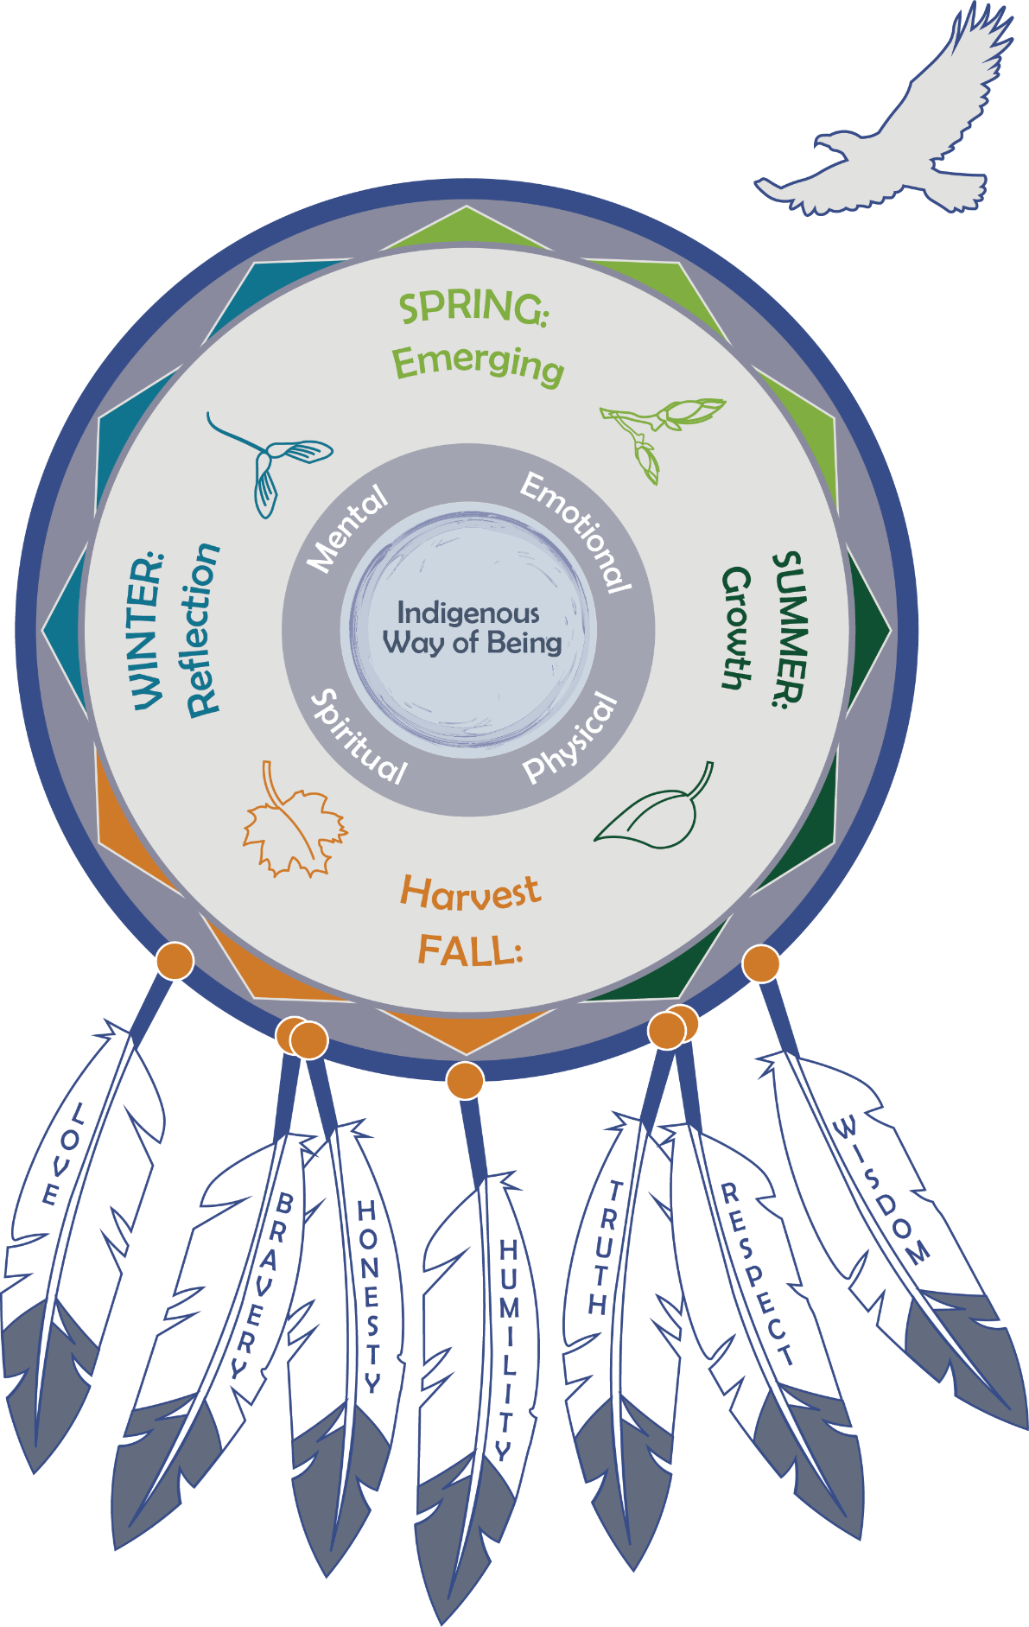

# Indigenous Circles of Leading (Blank)

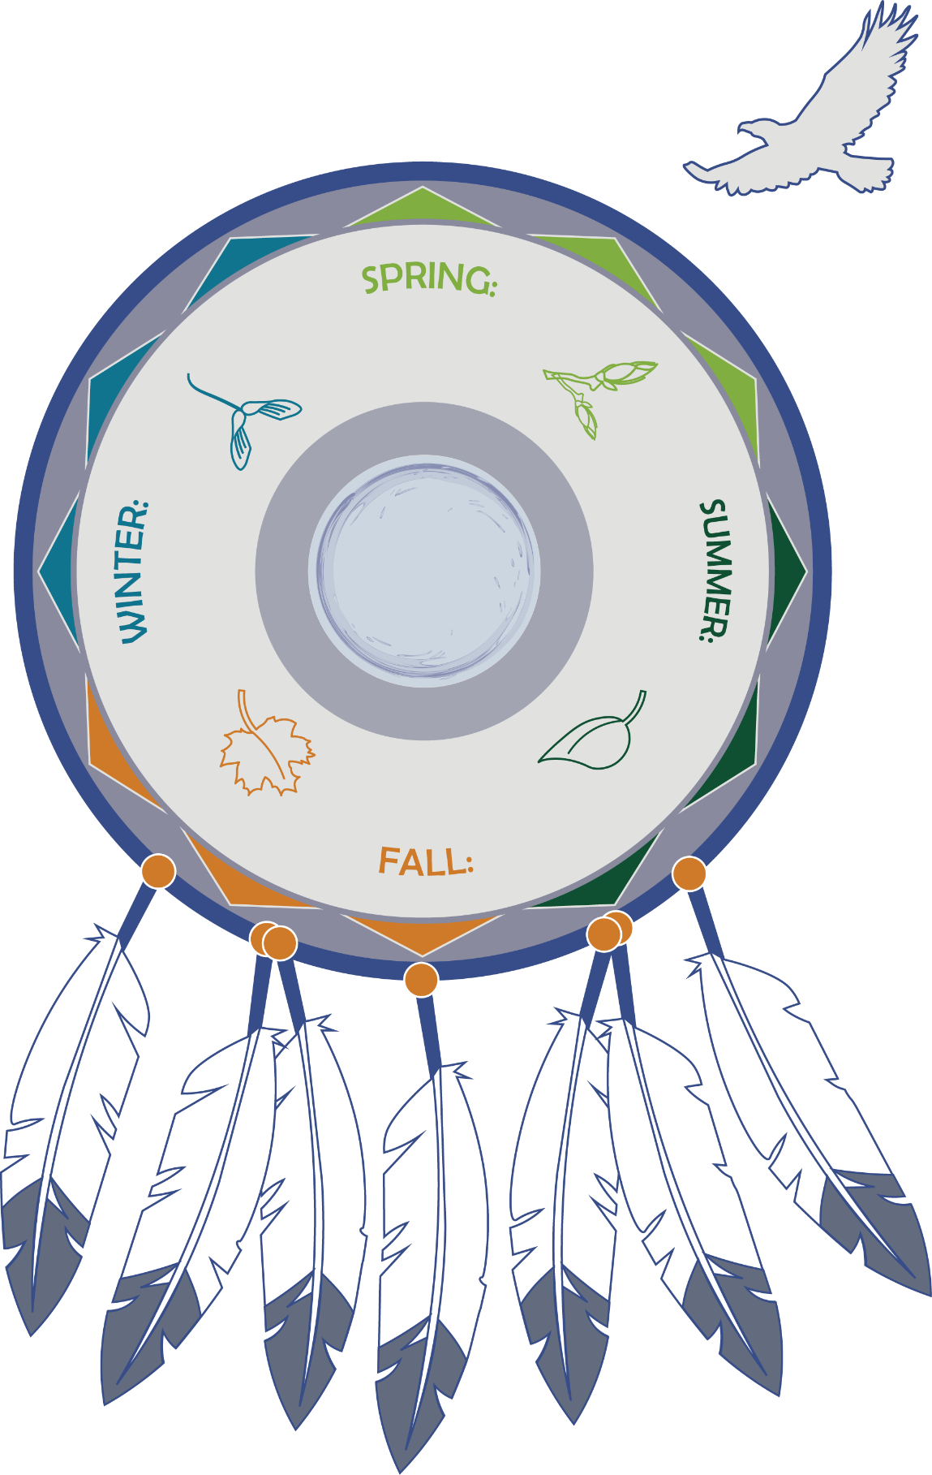

**Questions to Consider:**

* What do the seasons mean to you and your tribe?
* What are your tribal values?
* What does the eagle’s view mean to you?
* What about the model stands out most for you?

# The Seven Grandfather Teachings

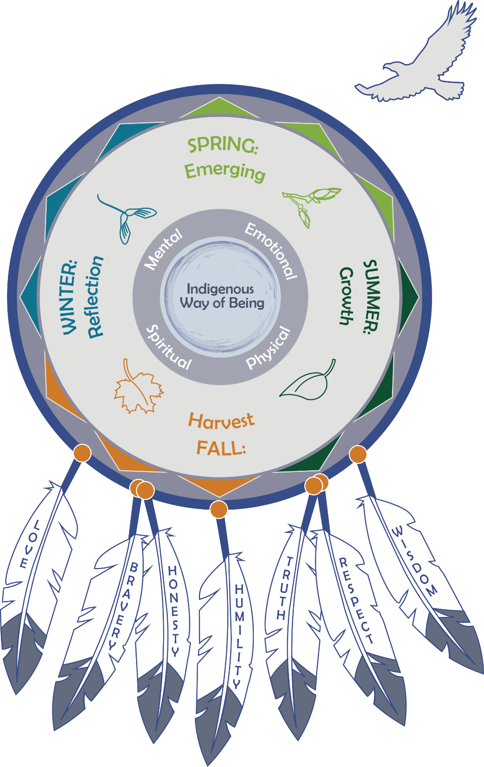

* What do these feathers mean to you?
* How are some values the same but expressed in different ways?
* Do you see shared values that transcend culture?

# Shared Learning Activity: What Stands Out for You?

Think about what stands out for you in the Indigenous Circles of Leading:

* Indigenous Way of Being
* Balance and Harmony
* A Time for Every Season
* Cultural Beliefs and Values

# The 4 Rs Infographic

  
**Note:** Double clicking on the image above will open a more readable PDF version of the document.

# Self-Care Resources Offered by Capacity Building Center for Tribes

**Self-Care in Leadership: Tom’s Story** is available at: <https://youtu.be/2tjtdfEg7QE>.

**Indigenous Trauma Lens to Support American Indian & Alaska Native Families Involved in Child Welfare** is on the TIE: <https://www.youtube.com/watch?v=LHNrDj2GWo0>

**Webinar:** [Self-Care Techniques for Tribal Child Welfare Professionals](https://www.youtube.com/watch?app=desktop&v=s8upZnDMXAE&t=11s)

<https://www.youtube.com/watch?app=desktop&v=s8upZnDMXAE&t=11s>

**Handout:** [Self-Care Resources to Help Address Burnout and Increase Wellness in Tribal Child Welfare](https://tribalinformationexchange.org/files/products/selfcareresourcelist.pdf)

<https://tribalinformationexchange.org/files/products/selfcareresourcelist.pdf>

# Maintaining Balance and Harmony Through the Cycle of Seasons

* What does it mean to prepare ourselves for the upcoming cycle of growth?
* How do we decide where we want to invest our energy and what we want our outcomes to be?
* How can we use the knowledge of the 4 Rs of trauma to guide our leadership during growth?

# Intergenerational Protective Circles of Care

The explanatory video for the IPCC is available at: <https://youtu.be/p0d4R3fIozU>.

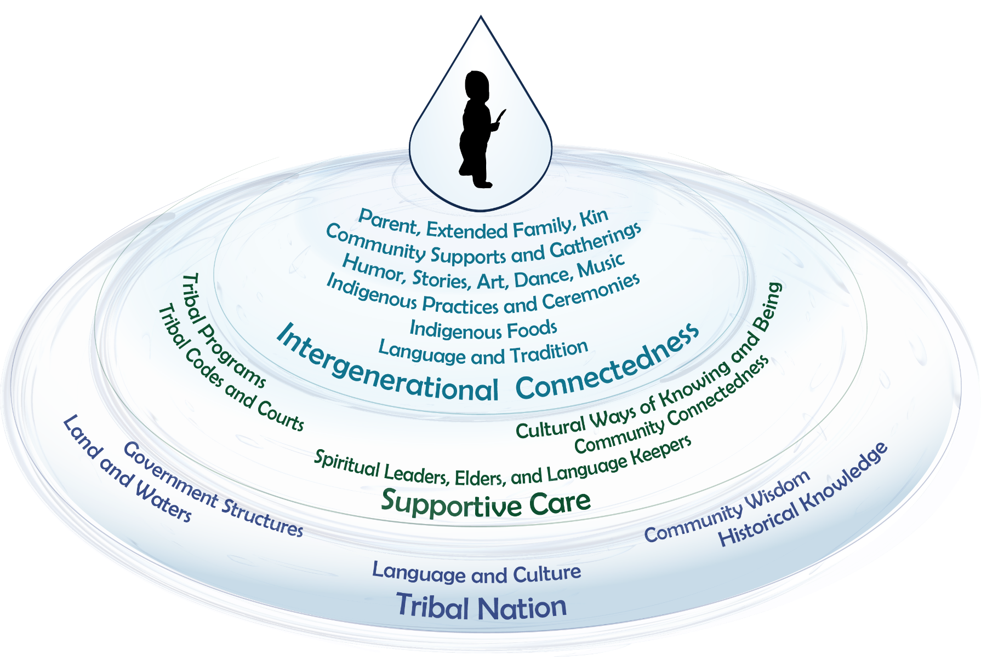

# Bringing Together Circles of Leading and Intergenerational Protective Circles of Care

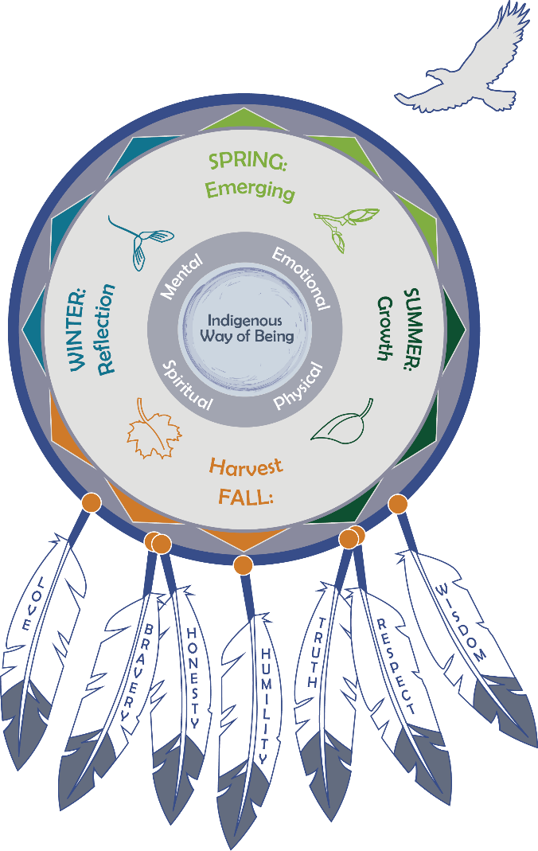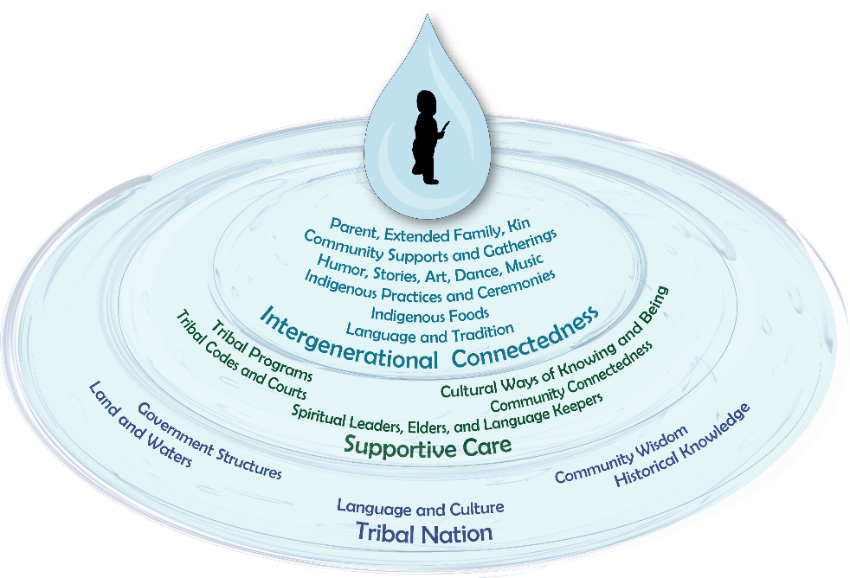

# Shared Learning Activity: Intergenerational Protective Circles of Care

* How is your tribal structure like what was described?
* What elements of your tribal structure are not like what was described?
* How can you, as a leader in your program, build on the strengths of each circle?
* How do you help sustain tribal sovereignty through your programs by planning for the next seven generations?

**Blank Intergenerational Protective Circles of Caring**

We have created a blank IPCC graphic in case you want to document what exists within the circles at your tribe.

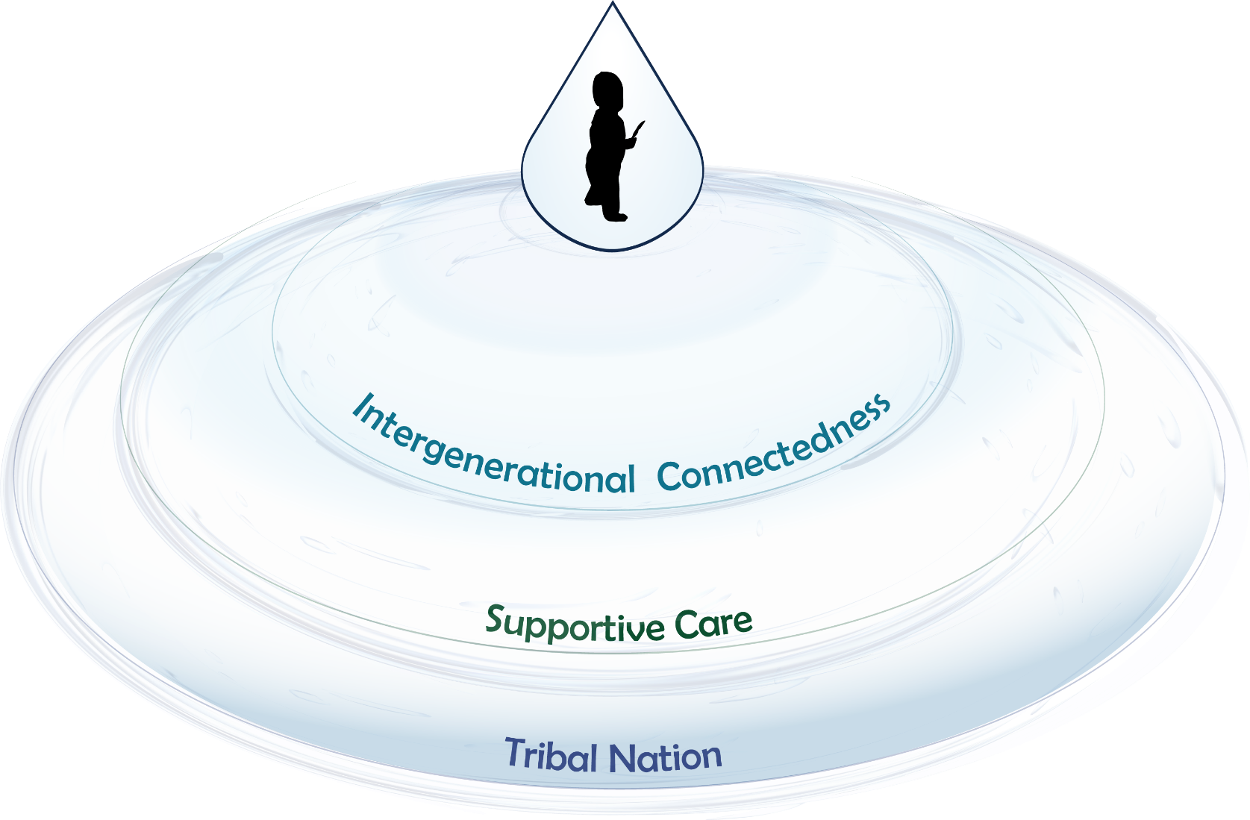

# Eric Martin’s Definition of Leadership

The video is available at <https://youtu.be/nTsvbPONw9I>.

* What did you think about who is considered a leader?
* What do you think is the most important part of what Eric defines as leadership?

# Indigenous Leadership in Practice

This information is for the group activity, and you can use any moments, personal or professional, for this discussion.

Look at these seven leadership topics together and brainstorm how they show up in your work, at your organization, or even in your dream job.

* What practice really shows up in your experience?
* What is the most important?
* And how can you grow to incorporate more leadership practices into your work?

These are more in-depth descriptions of each topic and can be used to ask deeper questions.

* Holistic—based on indigenous values, eagle’s view, and planning for the next seven generations
  + Taking the eagle’s view and seasonal approach
  + Leaders asked to adapt through changes in attitude, beliefs, behaviors
  + Understand trauma and resilience—leading in context
* Community—based on community health and wellness
  + Service to the community valued
  + Works for the people more than for self-achievement
* Spiritually founded—no separation of church and state
  + Self-reflective practices using spiritual teachings and ceremonies to support change and healing
  + Understanding and respecting that beliefs and ceremonial teachings are unique for individuals and their tribal nation. Historically, Christianity and biblical teachings have become a foundational way of life in many indigenous cultures.
* Flexible—able to adapt quickly to respond to current needs
  + Requires transformative learning and shifts in perceptions and practices
  + Able to challenge status quo
* Informal—not hierarchical; power and responsibility collectively shared
  + Shared authority rather than authority over
  + Persuasive rather than positional authority
  + Inclusive of many voices and gifts—as members of our communities, we bring our gifts in service to one another
* Situational— based on inclusion of others’ gifts
  + Step forward when needed to use your gift/strengths
  + Leadership moments acknowledged by everyone as a time for action
* Humility—focus on whole, not self; letting go; self-care
  + Okay to not know, make mistakes, try something else, take risks
  + Okay with uncertainty, sitting in the moment, dealing with resistance, and letting go
  + Self-care, reflection, re-creation, finding a new balance

# Leadership from a Position of Authority

|  |  |  |
| --- | --- | --- |
| Task | Technical | Adaptive |
| **Direction** | Provide problem, definition, and solution (assign or bring in an expert) | Identify the underlying challenge; ask questions and bring up issues |
| **Protection** | Protect from external threats | Talk about external threats and work together to mitigate |
| **Order** |  |  |
| * Orientation | Orient people in status quo roles | Question status quo roles; help to gradually shift people to new roles |
| * Conflict | Restore order (if only temporarily) | Expose conflict or let it emerge naturally |
| * Norms | Maintain status quo norms | Challenge norms or create opportunity for them to be challenged without retribution |

*Source:* Heifetz, R. A., Grashow, A., & Linsky, M. (2009). *The practice of adaptive leadership: Tools and tactics for changing your organization and the world*. Harvard business press.

# Indigenous Adaptive Leadership

|  |  |
| --- | --- |
| Indigenous Approach | Hierarchical Approach |
| Debate is encouraged | Debate is stifled |
| Environment is open, restless, and changing | Environment is stagnant |
| Participants engage in dialogue | Pronouncements are made, no dialogue |
| Knowledge is within us all | Knowledge is held by a few |
| Information is shared | Information is hoarded |
| Process is flowing, creative, noisy | Process is rigidly structured, ordered |
| Action by staff is encouraged | Action by staff is punished |
| Action for self is defined by self | Action for self is defined by others |
| Language includes all | Language includes some |
| Expertise is limitless | Expertise is limited |
| Diversity is recognized and appreciated | Diversity is ignored |

You can define distinguish technical work by the following criteria:

* + Perspectives are aligned.
  + Definition of the problem is clear.
  + Solution and implementation are clear.
  + Primary locus of responsibility for organizing the work is leadership.

But the problem is that most of our challenges aren’t just technical. They require adaptive work.

In adaptive work:

* + Legitimate, yet competing, perspectives emerge.
  + Definition of the problem is unclear.
  + Solution and implementation are unclear and require learning.
  + Primary locus of responsibility is not the leadership.

Adaptive challenges can be painful because they may involve:

* + New learning because knowledge or behaviors to handle the problem don’t yet exist.
  + Refashioning loyalties because people may be asked to look at a problem in a new way that contradicts something held dear—such as the values an individual was raised with or learning from a parent or mentor.
  + The loss of a sense of competence, which is especially challenging for people who like having all the answers.
  + The loss of a sense of equilibrium. It can be difficult to change long-held ways of being.

An example of an adaptive challenge is to help staff understand the importance of documenting family strengths in case notes.

# Discovering Your Leadership Moment

The video is available at <https://youtu.be/AGLCqRmzR8o>.

**Leadership moment flags:**

* No known solution
* People would rather avoid the issue
* Reason and logic alone won’t get you there
* Recurring problem
* Emotional response
* Failure to resolve competing priorities
* Moving forward feels risky
* Casualties
* People must work across boundaries
* Progress is not linear

**Questions to consider:**

* What did you think about the leadership moment flags?
* How can we recognize leadership moments?

# Recognizing Leadership Moments

“Leadership moments are daily opportunities anyone can take to create change. They're those moments that make your heart leap with hopeful anticipation—or with fear of taking the next steps. They hold promise for that long-awaited breakthrough or for the change you know is possible. They also hold the uncomfortable possibility that you, too, need to change. Leadership moments are grounded in the idea that leadership is something that anyone can exercise to achieve a better outcome than the one they've been offered. . . . When deployed using . . . Adaptive Leadership, a leadership moment can create sweeping change throughout teams, organizations, and entire communities.”

— Eric Martin – *Your Leadership Moment:  
Democratizing Leadership in an Age of Authoritarianism*

Write down some leadership moments you have seen or been part of recently.

# Technical vs. Adaptive Leadership

|  |  |
| --- | --- |
| Technical | Adaptive |
| Clearly defined | Harder to define |
| Clear solution and resolution | Unclear solution and recurring |
| Can be solved by expert | Stakeholders, not expert, needed |
| Everyone agrees on the problem and solution | Competing perspectives; emotion |
| Relatively short time to change | Requires long-term changes and adaptation |
| Leader can resolve by edict and authority | Stakeholders share responsibility; changes in attitude, beliefs, behaviors, and collaboration; risky |
| May require learning new information but not extensive | Transformational learning and shifts in perceptions |
| Faces little resistance | Avoidance, resistance, casualties, letting go |

# Margaret’s Story: Case Study

This video is available at <https://youtu.be/sIdLtCDgxI8>.

As a group, you will now apply what you heard in Margaret’s story to your daily life.

Let’s imagine you have stepped out your door and into the fresh landscape of spring. The landscape has been touched by others for generations, and some remnants of past plantings are starting to sprout from the surface.

Your leadership role is like a fresh landscape each day. In your groups, brainstorm what it is that you would like to plant during your leadership role. Take an eagle’s view, and think about where the ripples may appear when you start to grow in the area you want to focus in.

Imagine the possibilities that lie before you, but also think about the tools you may need to be successful in your leadership role.

Over the next few training days, you will continue to use Margaret’s story as a prompt for considering what you want your leadership journey to look like. Feel free to be creative! Draw pictures, use color, and explore what you want to grow!

# Adaptive Leadership

*As you have learned about adaptive leadership, we are providing a space here for you to start writing down what challenges you are currently facing in your program.*

*Challenges you are currently facing:*

*________________________________________________________________________________________________*

*________________________________________________________________________________________________*

*________________________________________________________________________________________________*

*________________________________________________________________________________________________*

*________________________________________________________________________________________________*

*________________________________________________________________________________________________*

*________________________________________________________________________________________________*

*________________________________________________________________________________________________*

*Now that you have listed out some of your current challenges, put them into columns of “technical” and “adaptive.” This can allow you to begin determining how you might want to address these challenges as you learn more about adaptive leadership.*

|  |  |
| --- | --- |
| **Technical** | **Adaptive** |
|  |  |
|  |  |
|  |  |
|  |  |
|  |  |