Tribal Child Welfare Leadership Academy

Session 1

Spring

This product was developed by the National Capacity Building Center for Tribes, which is funded by the Children’s Bureau through cooperative agreement number FAIN #90CZ0028.

# Acknowledgment

Welcome to the Tribal Child Welfare Leadership Academy (TCWLA). This curriculum was adapted from the National Child Welfare Workforce Institute’s (NCWWI) Leadership Academy for Middle Managers (LAMM) using federal dollars. You will see the curriculum has been divided into 4 modules reflecting a seasonal approach. Module 1 begins in the spring, and module 4 ends in the winter. The examples provided throughout the curriculum reflect specific tribal values for some tribes, but we respect that all tribes are not the same and each unique community has values, customs, and practices of their own. The full curriculum is free to the public and can be adapted by your tribal child welfare organization to meet the needs of your staff and your own cultural values.

We are grateful to the Children’s Bureau for funding this project and hope you will find it relevant to your own tribal child welfare leadership needs. When using the curriculum or its materials, we ask that you make attributions to the Capacity Building Center for Tribes and the Children’s Bureau.

***Recommended citation:***

Capacity Building Center for Tribes. (2024). *Tribal Child Welfare Leadership Academy*. Denver, CO: Author.

© 2024, Capacity Building Center for Tribes, Butler Institute for Families, Graduate School of Social Work, University of Denver

This document may be reproduced in whole or part without restriction as long as the Capacity Building Center for Tribes is credited for the work.

The contents of this document are solely the responsibility of the Capacity Building Center for Tribes and do not necessarily represent the official views of the Children’s Bureau.

# Table of Contents

Acknowledgment 2

Table of Contents 3

Training Materials 5

Room Setup 5

Training Design 5

Pre-Training Orientation 5

Welcome and Introductions 6

Open in a Good Way 6

Tribal Child Welfare Leadership Academy: Spring 7

Respecting Our Time Together 7

Note of Caution 8

Foundation of the Tribal Child Welfare Leadership Training 8

Today’s Agenda 9

A Shared Learning Process 10

Storytelling Bingo Activity 11

Indigenous Circles of Leading: An Eagle’s View 12

For Everything There Is a Season and a Time for Every Purpose 14

Spring – Awakening, Preparing, and Planting 15

Preparing Your Soil 16

Indigenous Values: Seven Grandfather Teachings 17

The Eagle’s View 19

Shared Learning Activity: What Stands Out for You? 19

Recognizing Trauma in Our Work 20

Self-Care in Leadership: Tom’s Story 21

Tending to Your Growth: Self-Care 22

Maintaining Balance and Harmony Through the Cycle of Seasons 23

Preparation Means Centering Ourselves and Our Organizations in . . . 24

Intergenerational Protective Circles of Care Video Refresher 25

Intergenerational Protective Circles of Care 26

Shared Learning Activity: Let’s Talk About 28

What Is the Definition of Leadership? 29

The Path to Leadership 30

Indigenous Leadership in Practice 31

Leadership From a Position of Authority 33

Indigenous Adaptive Leadership 34

Discovering Your Leadership Moment 34

Recognizing Leadership Moments 35

Technical vs. Adaptive Leadership 36

Margaret’s Story: Spring 37

Case Study: Applying Margaret’s Story 38

An Eagle’s View 39

Ending Our Day Together in a Good Way 40

Tribal Child Welfare Leadership Academy Curriculum Team 41

# Training Materials

For the in-person training days, you will need the following materials:

* Printed participant workbooks, which are also emailed to participants ahead of time
* Flip chart paper
* Markers
* Paper
* Pens
* Post-Its

# Room Setup

When setting up the in-person classroom, these configurations are best for open discussion:

* Circle tables
* Four to six chairs per table
* Tables set up in a circle
* Drink/snack station in the back of the room

# Training Design

This complete training is 24 hours of training. The breaks are not included in this time frame because those will be tailored to the participants’ needs and the length of each day of training.

**Facilitator Note:** While this training is broken out into 4, 6-hour training days, the delivery of the training can be changed to accommodate program needs—for example, 6, 4-hour days. Depending on the size and engagement of the participants, some sections can take longer than others, so you will want to adjust your timing and breaks accordingly. You will want to work several breaks into the day, such as a 10-minute break at the end of each hour. You can find timers to share on screen that will keep track of the time left in breaks on YouTube. Search the internet for “YouTube” timers for timers, like this 10-minute example: <https://youtu.be/yxu0qHbG_2c>.

# Pre-Training Orientation

In the afternoon, you will have the learners participate in a liberating structures activity. To prepare yourself, review the impromptu networking for a cohort or the 1-2-4-All. You can find instructions at:

* <https://www.liberatingstructures.com/2-impromptu-networking/>
* <https://www.liberatingstructures.com/1-1-2-4-all/>

**Facilitator Note:** As people come into the room, you can play gentle music. The PowerPoint slides don’t start until the after “Welcome,” “Introductions,” and “Open in a Good Way.”

**Tech Help**: If you are meeting in person, it may be helpful to set up a couple of laptops for participants to review the “Indigenous Circles of Leading“ video ([https://youtu.be/NXDceVVE56](https://youtu.be/NXDceVVE56)I)) and the “Intergenerational Protective Circles of Care” video (<https://youtu.be/p0d4R3fIozU>)—one on each laptop.

Welcome and Introductions

10 minutes

Virtual Delivery: You can adapt all the activities in this curriculum for virtual delivery, and we have found that the discussions and engagement can be successful in an online environment through using chat, creating breakout groups, and asking people to come off mute.

Do:

Acknowledge any dignitaries, leadership, and elders who have joined the group.

Recognize Children’s Bureau and the Capacity Building Center for Tribes for creating this training.

Introduce the facilitators, including relevant info that you are comfortable sharing, and then provide detailed intro after blessing.

Offer a land acknowledgment—if in person, for land of the venue, and if virtual, then each facilitator for land they are joining from.

Open in a Good Way

15 minutes

**Facilitator Note:** Make sure you have arranged blessing ahead of time with tribal programs and considered cultural protocols. Try to bring in a tribal elder from the tribes you are training. Find out what the protocol is for gifts and blessing supplies and provide culturally relevant introductions. If virtual, determine if the blessing will be on screen or just audio.

Say:

* As we begin this time together, we want to start our time together in a good way.
* Offer thanks and recognize the person providing the blessing.

Do:

Introduce blessing provider.

Once blessing is done, bring the PowerPoint slide deck up after the “Welcome” and “Open in a Good Way.”

Virtual Delivery: When using Zoom as your sharing platform, make sure you click the two radio buttons in bottom left to share sound and optimize video for clips. The person who shares their screen will need to have good bandwidth and the ability to play videos without lagging.

Slide 1:

Tribal Child Welfare Leadership Academy: Spring

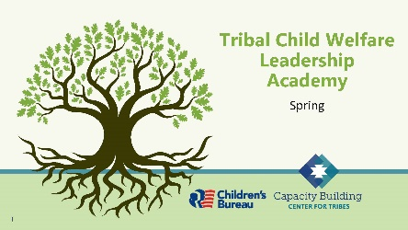

5 minutes

**Facilitator Note:** Please note any housekeeping issues, such as in-person bathroom locations or virtual recordings happening, etc. Let participants know you will be providing breaks during the training, with the frequency or length tailored to meet the participants’ needs.

Do:

Introduce the team and any support staff so they know who to send questions to if they have any issues.

**Tech Help:** When you introduce yourself, discuss all the housekeeping pieces that you need participants to know about. Inform them that you will be present to help with things like printing handouts or accessibility issues. Tech helper will also keep track of when the breaks need to occur.

Virtual Delivery: For virtual deliveries, include how to contact facilitators and tech help during the meeting, where the microphone and video controls are, how to raise a hand in the online platform, and how to show if learners are away from their screen. You may need screenshots to show the participants where these controls are. Also, show participants how to change their names in the virtual platform so that everyone can see their name and their department or tribal child welfare program name.

Slide 2:

Respecting Our Time Together

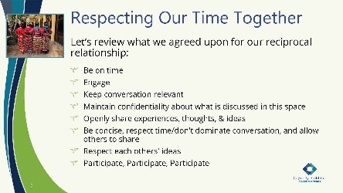

5 minutes

Say:

* We are sharing some ideas for our reciprocal relationship here but would like to give you a few minutes to review and add to our guidelines for our interaction going forward.

Ask:

Are there any more considerations you would like to add?

Do:

Give a few minutes for participants to add guidelines.

Say:

* Thank you to everyone for helping create this respect for our time together. We will revisit these at the beginning of each day.

Slide 3:

Note of Caution

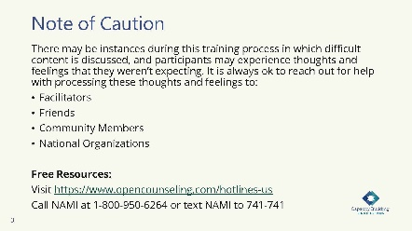

5 minutes

Say:

We know that child welfare can be a trying field even on the best of days. As we move into these training days, we want to acknowledge that the material being covered may be difficult to talk about or listen to. We encourage you to take care of yourself and reach out for help if needed. This slide notes some available resources, and we are always here to talk if needed.

Slide 4:

Foundation of the Tribal Child Welfare Leadership Training

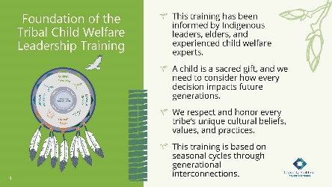

5 minutes

**Facilitator Note:** Based upon the arrangement and flow of the training, this foundation for the training can be introduced during the times you come together. This doesn’t need to be covered in every session, but if there is a large break between facilitations, then please give participants a refresher on the foundations of this training.

Say:

* How you lead and the choices you make can have ripple effects. Success in tribal child welfare programs is achieved when tribal child welfare leaders, tribal leaders, and the community work together and know children are sacred gifts who need to be connected to kin, community, and their environment. These collaborations provide a collective vision to honor the rights of Indigenous children for the next seven generations.
* The intention of this training is to help you build upon your Indigenous leadership skills to build strength and resiliency for your program. Our hope is that you will find universal connections to your own nation’s cultural beliefs and that you will bring your unique perspective to our conversations, so we can all work together to build upon tribal sovereignty.
* Tribes who want to implement the training locally can use their own cultural beliefs, practices, and values. No landscape is the same, and all seeds need special conditions to successfully grow. What you can grow may be limited by the resources you have available. Or you may need to change your environment to grow what is needed to serve your people. We honor and respect all the landscapes you are bringing together in this room, and we hope you can find universal truths in the material we are providing.
* Throughout this training, we will explore the historical events that shaped our current realities and consider the future of our tribal nations for the next seven generations.

Slide 5:

Today’s Agenda

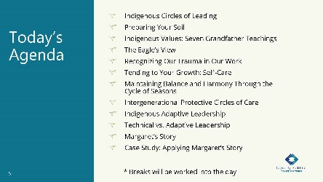

3 minutes

Do:

Review what will be covered today and ask if anyone has any clarifying questions or comments before we begin.

* + Indigenous Circles of Leading
  + Preparing Your Soil
  + Indigenous Values: Seven Grandfather Teachings
  + The Eagle’s View
  + Recognizing Our Trauma in Our Work
  + Tending to Your Growth: Self-Care
  + Maintaining Balance and Harmony Through the Cycle of Seasons
  + Intergenerational Protective Circles of Care
  + Indigenous Adaptive Leadership
  + Technical vs. Adaptive Leadership
  + Margaret’s Story
  + Case Study: Applying Margaret’s Story

Remind everyone that they received a participant workbook that they can follow along in.

Slide 6:

A Shared Learning Process

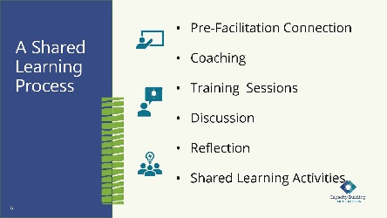

2 minutes

**Facilitator Note:** The slide lists the various methods that the Center for Tribes provided when facilitating. For your training, on this slide you can add to or delete the specific modalities you will or won’t provide.

Say:

* The primary focus of this training is on the self. We believe that when we create strong internalized leadership skills, those skills radiate out to our work with others, which will help grow our programs, communities, and tribes.
* As we move through this journey together, we will teach you new concepts, give you space to reflect, and allow you each to connect with one another in this safe space.
* We are all on this path together, and we encourage you to share your thoughts and ideas as we move together.

Slide 7:

Storytelling Bingo Activity

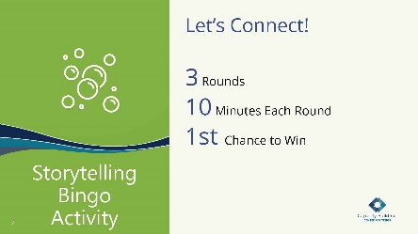

35 minutes

**Facilitator Note:** To complete this bingo activity, each participant needs a pen and a printed bingo card, which is in the participant workbook. Participants will mingle in small groups and mark off squares as they meet people who fulfill the traits listed. Participants will use this same card each day, so remind them to bring the card back for the next session.

Say:

Before we begin the training, let’s find out a little more about each other.

* As we start our training, we want to break into small groups and do an activity to get to know one another. During this training, you’ll have many opportunities to share stories and fill up your bingo cards!
* We want to honor that storytelling is a part of Native traditions. We hope you enjoy the connection that storytelling bingo provides.

**Facilitator Note:** Here are the bingo instructions for this activity:

The objective of this activity is to tell your story and ask others for their story. Break into groups of three for 10 minutes and choose one topic in a square; then each of you share a story. Write in **their** answers below the topic on your card. We will do three rounds of interaction each morning. Throughout the next few days of training, you will have additional opportunities to fill in your squares. The object of “Storytelling Bingo” is to fill in each square for “Blackout Bingo” (every square to be filled).

Do:

Explain “Storytelling Bingo” instructions.

Break participants into small groups, aiming for three people per group. Give each group 10 minutes to talk, and then switch groups. Do this three times, over 30 minutes. Bring everyone back together after the three rounds.

Virtual Delivery: You can do this mingle via Zoom by using breakout rooms. For this breakout, randomly assign participants into breakout groups. Try for three people per room. Add the bingo template to the chat and share that it’s in their training workbook.

**Tech Help:** The learners will be broken up into groups of three. Help keep track of the group members to ensure everyone has a chance to talk to the other learners in this informal opening. The tech helper will keep track of time and let learners know when it is time to rotate.

Say:

* We would now like to move to a review of our tribal child welfare leadership model, so please turn to this handout in your workbook.

Slide 8:

Indigenous Circles of Leading: An Eagle’s View

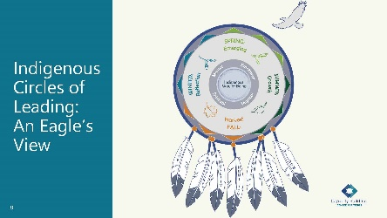

10 minutes

Do:

Refer participants to the laminated copy received in their welcome packet. Having a physical copy allows them to see the model much clearer as we go through the description of how this shaped the training concepts. Remind them that they can also find this in their participant workbook.

Say:

* This training has been influenced and adapted from pilot deliveries to tribal child welfare leaders. Historically, we know that Indigenous ways of learning occur through oral traditions—storytelling and analogies passed down from generation to generation. In the formation of this training, we honored these ancestral ways of teaching and built this training upon an Indigenous holistic connectedness from our being to all things around us.
* As a general overview, the “Indigenous Circles of Leading” model illustrates an eagle’s view of the interconnectedness we have with all relations. Whether we are Native or non-Native, we are serving Native children and families, and understanding this way of leading is a pathway to healing, reconciliation, and resiliency within the communities we serve. It also promotes better outcomes for our future. You will remember some of this from the “Indigenous Circles of Leading” video that you watched before our training sessions began.
* Understanding our interconnectedness as a tribal child welfare leader is the foundation to building upon the “Indigenous Circles of Leading” model.
* The circle surrounding the “Indigenous Way of Being” is symbolic of a universal Indigenous medicine wheel of our emotional, physical, spiritual, and mental well-being. An Indigenous way of being encompasses identity, strengths and weaknesses, and purpose. In this work, our way of being is to honor and respect the sacred gifts of children and recognize our service to others in contributing to the health and wellness of all. Our way of being is in a continual transformation of ourselves and the work we do.

**Facilitator Note:** If you want to suggest additional resources, Don L. Coyhis has devoted much of his life to teaching well-being, and one of his books, *Understanding Native American Culture*, provides insights of recovery and healing for wellness practitioners. It’s a good resource for understanding the medicine wheel and being in balance with ourselves and in relation with others. Also, on our Tribal Information Exchange website, those interested can find the following resource devoted to understanding the medicine wheel: A Guide to Presenting & Facilitating Teachings of the Medicine Wheel (<https://tribalinformationexchange.org/index.php/2017/07/20/a-guide-to-presenting-facilitating-teachings-of-the-medicine-wheel/>)

**Tech Help:** If people are interested in the Tribal Information Exchange resource, help them navigate to the webpage: <https://tribalinformationexchange.org/index.php/2017/07/20/a-guide-to-presenting-facilitating-teachings-of-the-medicine-wheel/>.

Virtual Delivery: Provide link to the Tribal Information Exchange resource in chat: <https://tribalinformationexchange.org/index.php/2017/07/20/a-guide-to-presenting-facilitating-teachings-of-the-medicine-wheel/>.

Say:

* Sometimes you may hear someone refer to a cultural lens, and you may not have been completely sure how to define it. For this training, a cultural lens is how we see things through all four quadrants of the medicine wheel. Our cultural lens is intergenerational, moving backward and forward through time.
* These circles are not stagnant. They are holistic and continually flow between and within one another, much like a small river flowing into the ocean. Our interconnectedness with ancestral teachings and ceremonies sustains our path and well-being into the future. Our ways keep us connected to the Creator and all gifts around us.
* Through a shared learning activity, we want you to explore some questions about how you experience this leadership model.

Do:

Direct participants to the model in their workbook. There is also a handout that has the model’s image, but the words have been removed. This blank handout is what they should use to answer the questions.

Say:

* Take a few minutes to reflect on these questions, which are also listed in your workbook. You can write your answers on the blank model handout in your workbook:
  + What do the seasons mean to you and your tribe?
  + What are your tribal values?
  + What does the eagle’s view mean to you?
  + What about the model stands out most for you?

Do:

Provide a few minutes for learners to think through the questions and write down a few answers.

Slide 9:

For Everything There Is a Season and a Time for Every Purpose

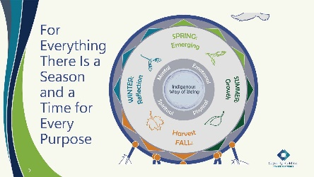

5 minutes

Say:

* In the model, the outer circle is the cycle of seasons. Today, we are going to be focusing on spring. This outer circle also includes the four directions, impacted by the sky, earth, animals, and plants, and the dimensions of health in maintaining balance and harmony.
* The conceptual framework of leading a child and family organization parallels a seasonal cycle. The seasons continually cycle and adapt to changes and growth in the environment. In many traditional cultures, the cycle of seasons is synonymous with ceremonies to restore and maintain harmony. Ceremonies are representative of the balancing of the cycles and the interdependence of all beings.
* Seasonal cycles inform our training sessions.

Ask:

What do the seasons mean in your tribal nation?

Do:

Allow a few participants to answer.

**Facilitator Note**: You can fill in and share these ideas scattered throughout responses.

**• Spring** is the emergence, awakening, renewal, and growth from planting seeds. It is the time for our visions to take root and grow. An individual or organization embraces this stage of life as a time to build relationships through growing and nurturing. It’s seen as a learning phase where we can democratize leadership, recognize the ecosystem, and consider our leadership choices.

**• Summer** is one of the longer seasons, and the sun has a higher position for a time. This season includes growth, which mobilizes and grounds resources. Individual and organizational growth continues through practice, energy, team building, focusing, and modeling self-care while recognizing trauma. In summer, we nurture our vision and seek knowledge to build strength.

**• Fall** is a harvesting time when growth is full and strong. This is a season of preparation and adaptation as we get ready for the upcoming winter. A time for celebration, we recognize personal mastery, and at an organizational level, the path opens to an acceptance of the journey to the current realities as we begin to understand adaptive change.

**• Winter** is a quiet time to reflect on prior seasons, and we often dig into this reflection through storytelling. Self-reflection and organizational reflection provide a systemic process for considering feedback, evaluating progress, and considering progressive outcomes for creating a preferred future. For many, this season can also hold many celebrations and ceremonies.

Say:

* Earlier, we mentioned the training uses seasonal cycles. We will now enter the springtime—a space of awakening, preparing, and planting.

Slide 10:

Spring – Awakening, Preparing, and Planting

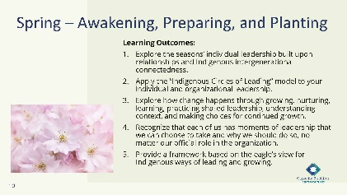

5 minutes

Say:

* The learning outcomes for today are listed on the slide and are also in your workbook. Please take a moment to read the outcomes [or have participants read them out loud].
* One concept you will hear many times is connectedness or interconnectedness based on Indigenous understandings. Each season is a time for us to acknowledge our actions for beginning and nurturing growth. The learning outcomes will build upon each season as we move along our leadership journey.

**Facilitator Note:** The learning outcomes are to:

**•** Explore the seasons’ individual leadership built upon relationships and Indigenous intergenerational connectedness.

**•** Apply the “Indigenous Circles of Leading” model to your individual and organizational leadership.

**•** Explore how change happens through growing, nurturing, learning, practicing shared leadership, understanding context, and making choices for continued growth.

**•** Recognize that each of us has moments of leadership that we can choose to take and why we should do so, no matter our official role in the organization.

**•** Provide a framework based on the eagle’s view for Indigenous ways of leading and growing.

Slide 11:

Preparing Your Soil

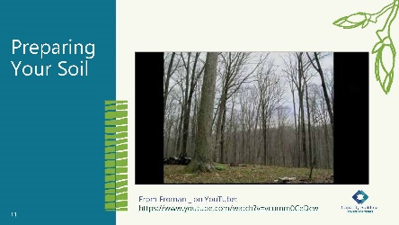

5 minutes

**Facilitator Note:** You should play about thirty seconds of this video to show a landscape changing with the season, which is available at: <https://youtu.be/vcumm0CeDcw?si=tN8pTVyMp1Ve2pOg&t=28>

Do:

Play the video that shows winter thawing and spring emerging.

Say:

* In this video, the landscape is unaltered, and with no intervention, you can expect that what is present in the environment will continue to grow, cycle after cycle.

Ask:

If you came into this scene and you wanted to grow something new, what would you need to do to ensure you were successful? What would you need to know?

Do:

Allow time for participants to silently reflect on the questions. If people want to speak up, they can.

**Facilitator Note:** Highlight these ideas from the responses that participants provide to orient them to the spring season:

**•** Preparing your soil.

**•** Bringing people together, getting in the right mindset, connecting, creating a community of connectedness from the beginning.

**•** Assessing your environment. What needs to be done to plant what you want to grow? (e.g., fertilizing and tilling the soil, knowing the seasons and what to expect).

**•** If choosing to leave untended, the seasons still happen, but the landscape rarely changes without planning and work.

Slide 12:

Indigenous Values: Seven Grandfather Teachings

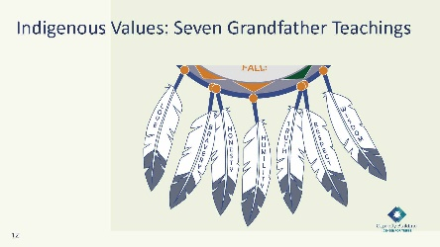

5 minutes

Say:

* Outside of the circle is the eagle and his feathers. The eagle feather is sacred to us and gifted to us so that we remember our values, where we come from, and where we are going. The feathers at the bottom are the seven grandfather teachings from our Anishinaabe relatives. We want to emphasize that we respect every tribal nation’s beliefs, history, and culture, and we acknowledge that they each have their own values and beliefs. We use the seven grandfather teachings as an example but invite you to explore how your own tribal values may use similar teachings.
* The seven grandfather teachings are:
  + Love – Embrace peace and have unconditional regard for others.
  + Bravery – Act with integrity even when fearful.
  + Honesty – Keep one’s word and behave in an honorable way.
  + Humility – Know your place in the larger picture and do not put yourself above the Great Spirit, animals, plants, or other life.
  + Truth – Be honest with yourself and others.
  + Respect – Treat others in a caring manner and with dignity.
  + Wisdom – Value knowledge and learning throughout one’s life.
* The following questions are in your workbook, where you can jot down your responses.

Ask:

What do these eagle feathers mean to you as a leader?

Do:

Take a moment to think about your own tribal values and beliefs.

Share with the group any values or beliefs that are different or any that could be added to this list.

Ask:

How are some values the same but expressed in different ways?

Do you see shared values that transcend culture?

Do:

Provide space for participants to respond.

If you can, capture some of these thoughts on a piece of flip chart paper so that everyone in the room can see the values for the day.

Virtual Delivery: You can ask the participants to come off mute and share their responses verbally or to feel free to share them in the chat.

**Facilitator Note:** You can refer to these after participants share what it means to them. The seven grandfather teachings are:

**• Love** – Embrace peace and have unconditional regard for others.

**• Bravery** – Act with integrity even when fearful.

**• Honesty** – Keep one’s word and behave in an honorable way.

**• Humility** – Know your place in the larger picture and do not put yourself above the Great Spirit, animals, plants, or other life.

**• Truth** – Be honest with yourself and others.

**• Respect** – Treat others in a caring manner and with dignity.

**• Wisdom** – Value knowledge and learning throughout one’s life.

Slide 13:

The Eagle’s View

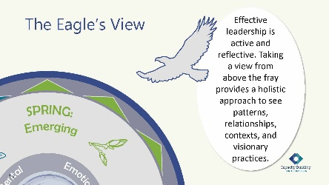

5 Minutes

Say:

* We now move above and see the interconnectedness from an eagle’s view. An eagle is a symbol of strength and courage, and we can also view it as a messenger. They have powerful wings and will soar and glide on wind currents, viewing the land below. From an eagle’s view, the “Indigenous Circles of Leading” embodies a process of continual balance and restoration to build resilience and well-being in ourselves and the work that we do.
* Leading requires not only understanding the individual tasks of staff and regulating their performance (which is management), but also needing to take a view from above the fray to see the patterns, relationships, context, and implications (which is leadership). Being an effective leader is both active and reflective.
* When we are on the earth looking around, we are only able to see what is close to us, so we may miss seeing the larger perspective. It’s only when we take the eagle’s view and fly above everything that we can look down and see patterns. This perspective is essential for assessing the environment for change, which is reflected in the saying, “can’t see the forest for the trees.” Practicing this holistic view and honoring intergenerational connectedness provide guidance for change.

Ask

How can taking an eagle’s view help you as a leader?

Slide 14:

Shared Learning Activity: What Stands Out for You?

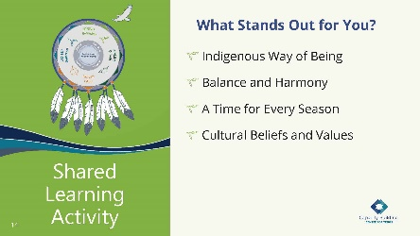

20 minutes

Say:

* For this shared learning activity, we’d like for you to reflect on how this applies to your work. Consider how the “Indigenous Circles of Leading” and taking an eagle’s view apply to your leadership within a tribal child welfare program.
* For each of the circles consider the approach and what stands out for you:
  + Indigenous Way of Being
  + Balance and Harmony
  + A Time for Every Season
  + Cultural Beliefs and Values
* We will now break out into small groups to discuss your answers to the questions for 15 minutes. When you return to the large group, be prepared to share some of your thoughts.

**Facilitator Note:** Tie this back to respect and honor of the tribes, where they come from, and how it is honoring differences in these concepts for them.

**Tech Help:** Please help keep track of time: 15 minutes in groups and 5 minutes of debrief.

Do:

Set up groups of three, face-to-face seating preferred with no tables.

Provide 15 minutes for them to discuss their answers.

Bring everyone back to the larger group and ask for each group to debrief.

Virtual Delivery: Create break-out rooms with groups of three. If using Zoom, you can set a timer so that participants are pulled back to the larger room after 15 minutes.

Slide 15:

Recognizing Trauma in Our Work

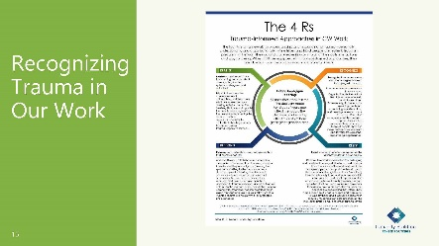

10 minutes

Say:

* Let’s review this infographic that we created with our partners from the National Native Children’s Trauma Center. This handout talks about the 4 Rs of being trauma informed: realize, recognize, respond, and resist. The 4 Rs inform how we respond in leadership moments and the impact on our emotional, physical, spiritual, and mental well-being, but they are also rooted in the resilience that tribes have built from generations of historical trauma.

Ask:

Considering the patterns of presenting responses of trauma because of colonization, how can this help us as leaders create a pathway to healing and resiliency?

Do:

Provide a few minutes for the participants to read the infographic and discuss the ideas.

**Tech Help:** As people discuss their ideas about the 4 Rs, you can document the responses by writing them on flipchart paper.

Virtual Delivery: Place the question in the chat for people to think about. Ask people to place ideas in the chat if they are not comfortable speaking out in the group. Also, the tech helper can summarize the ideas being presented and type them out in the chat for participants.

Do:

Find ways to tie their responses to all elements of the “Indigenous Circles of Leading” model.

Slide 16:

Self-Care in Leadership: Tom’s Story

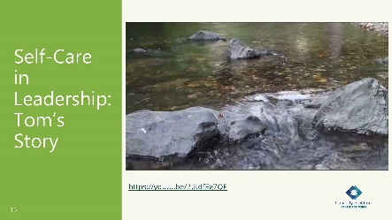

5 minutes

Say:

* Now that we have looked at the 4 Rs, let’s talk a little about self-care.
* First, we are going to rewatch a video, Self-Care in Leadership: Tom’s Story. This video was created by our colleague Tom Lidot.

**Tech Help**: Play Tom Lidot’s self-care video, which is available at: <https://youtu.be/2tjtdfEg7QE>. This video is 2:54 minutes long.

Virtual Delivery: Play Tom Lidot’s video, which is available at: <https://youtu.be/2tjtdfEg7QE>. Make sure you share sound.

Do:

Play Tom Lidot’s Video.

Slide 17:

Tending to Your Growth: Self-Care

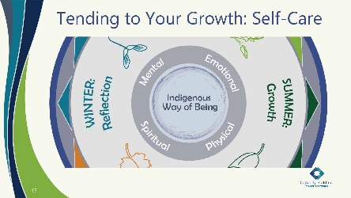

10 minutes

Ask:

What ways do you tend to your own growth and practice self-care? Consider Tom Lidot’s video and his experience with the elder teaching him to honor self-care and maintain balance and harmony.

Virtual Delivery: Ask participants to please come off mute or share by chat.

**Facilitator Note:** Revisit emotional, physical, spiritual, and mental well-being explanation. Remind participants that as leaders we are responsible for our own self-care AND creating a culture within the office that lets staff know their self-care is encouraged.

Do:

Provide time for responses in the moment.

Give relevant examples when needed. Share your ways.

**Facilitator Note:** Here are some examples you may share:

• Emotions are an expression of feelings, mood, response, and purpose derived from our given name, clan, and relatives. An example of balancing one’s emotions is the feelings of love and hate. If one were to consume the other, the emotion can affect our physical, spiritual, and mental well-being.

• “Physical well-being” is understanding our body is a conduit and requires continual self-care for emotional, physical, spiritual, and mental health.

• “Spiritual well-being” means understanding we have an interconnectedness to the Creator and gifts that are appreciated in ceremony. Spirituality is our Indigenous ways of knowing, which include our customs, values, language, and interconnectedness to all things. Cultural attachment provides the strength and resilience to be happy, healthy, and whole.

• “Mental well-being” is focused on our minds and thoughts, which includes knowing our values, ancestral teachings, stories, and beliefs.

**Tech Help:** Help participants navigate to the provided resource websites.

Virtual Delivery: Place <https://tribalinformationexchange.org/files/products/selfcareresourcelist.pdf> and <https://www.youtube.com/watch?v=s8upZnDMXAE&t=11s> links to the self-care resources from the TIE in the chat.

Say:

* In your workbook, we have provided resources for self-care practices, which you can review when you feel like learning more. These are available on our website, the Tribal Information Exchange, and they can help you to develop moments for self-care. Understanding our reaction and stress to dealing with the unknown can take a toll on our emotional, physical, spiritual, and mental well-being, which are included in the “Indigenous Circles of Leading.” You must tend to them to nurture the growth that will come in summer.
* Understand that remaining in balance as a leader allows us to model that for our staff. We know that trauma affects our relatives, our programs, and our nations, so we must engage in a continual cycle of attending to our own self-care. Focusing on all four areas of the medicine wheel ensures balance.

Slide 18:

Maintaining Balance and Harmony Through the Cycle of Seasons

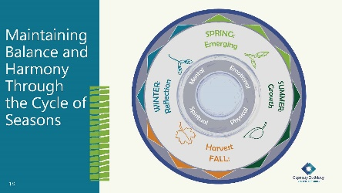

5 minutes

Say:

* Seasons occur in a cycle. We can often tell when the seasons are changing, not only from the climate but the behavior of animals, plant life, and astronomy. In the “Indigenous Circles of Leading,” we begin with spring as a time when we begin a new journey or new project—it is a time to prepare the soil and plant seeds for growth. Consider this a time of moving from an Indigenous way of being to an Indigenous way of doing.
* Change can bring fear of the unknown and trigger intergenerational trauma responses. We want to continuously create space to recognize trauma’s impact on emotional, mental, physical, and spiritual growth and any conflicts that may be present.
* The questions we are going to now discuss are in your workbook, where you can take notes if you would like.

Ask:

What does it mean to prepare ourselves for the upcoming cycle of growth?

How do we decide where we want to invest our energy and what we want our outcomes to be?

How can we use the knowledge of the 4 Rs of trauma to guide our leadership during growth?

Do:

Ask participants to turn to their neighbor and discuss the questions for a few minutes.

Bring participants’ attention back to the larger group and ask if anyone would like to share.

Virtual Delivery: Send groups into randomly assigned breakout rooms of two for five minutes. You can also turn this into a chat discussion, with people coming off mute or adding their answers to the questions in the chat.

**Facilitator Note:** Acknowledging the real experiences people have is important and provides an understanding of responses to change. Below is a summary of the 4 Rs handout, which you can bring into discussion:

**•** Realize trauma in ourselves, families, communities, and programs.

**•** Recognize symptoms of trauma.

**•** Respond with strategies that are trauma informed, acknowledging the past and building strengths for the future.

**•** Resist re-traumatization in our words and actions, including policy and procedural approaches.

Say:

Let’s now look at how we can see all this together.

Slide 19:

Preparation Means Centering Ourselves and Our Organizations in . . .

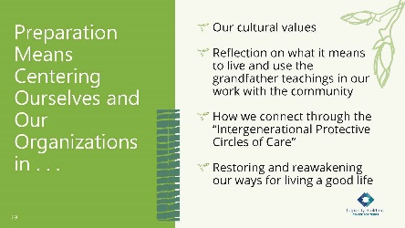

10 minutes

Ask:

What does “preparing the soil” mean to you?

Consider the “Indigenous Circles of Leading” model and the “Intergenerational Protective Circles of Care.” What do they bring to mind?

Do:

Allow for a large group discussion. If participants feel more comfortable in small groups, you can ask them to turn to their other neighbor to discuss for a few minutes.

**Facilitator Note:** You won’t want to click the mouse for the bullets to appear until after you have had a short group discussion. The bullets below will fly in, so each individual bullet will appear as you click the mouse. If one appears that you have discussed in the group, you can say, “Look, you covered that already.” If it hasn’t been discussed, you can say, “This one wasn’t an example you gave; let’s talk about that.”

Preparation means centering ourselves and our organizations in:

**•** Our cultural values

**•** Reflection on what it means to live and use the grandfather teachings in our work with the community

**•** How we connect through the “Intergenerational Protective Circles of Care”

**•** Restoring and reawakening our ways for living a good life

Say:

* Now that we have considered the soil of you and your child welfare program, let’s dig deeper into what surrounds us as leaders.

Slide 20:

Intergenerational Protective Circles of Care Video Refresher

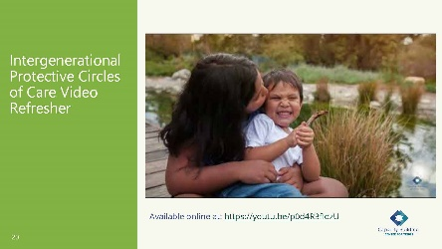

10 minutes

Say:

We are now going to rewatch the video on the Intergenerational Protective Circles of Care.

As you watch think about how this graphic connects to what we’ve discussed today.

Do:

Play the YouTube video, Intergenerational Protective Circles of Care. It is embedded in the slide or available at: <https://youtu.be/p0d4R3fIozU>.

Virtual Delivery: Play the video from YouTube: <https://youtu.be/p0d4R3fIozU>.

Slide 21:

Intergenerational Protective Circles of Care

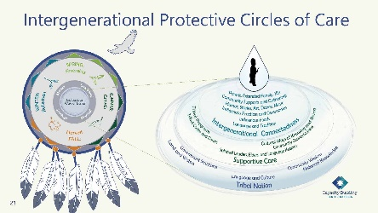

15 minutes

Say:

* To be effective, tribal child welfare leaders need to have a deep knowledge about and know how to access these cultural and community resources. Using a nation-building approach allows tribal programs and tribal child welfare leaders to develop and sustain practices, policies, protocols, and structures that further the goals of tribal sovereignty.
* Let’s revisit what you learned in the video about the “Intergenerational Protective Circles of Care” model.
* At the center of the “Indigenous Circles of Leading” is an “Indigenous Way of Being.” The “Indigenous Way of Being” includes an interconnectedness of our role as leaders within a sovereign tribal nation. While tribal sovereignty is a political status in having the authority and dominion over citizens, sovereignty is also indivisible, meaning it takes into account everything in our way of being as an Indigenous person.
* Intergenerational connectedness is best understood as the existing influence on tribal sovereignty from the seven generations before us and seven generations into the future. In tribal child welfare, our focus is on the child, who is a sacred gift as water is sacred and life-sustaining. The diagram is like a pool of water, and when the water is touched, a ripple effect takes place. Each time we come into contact with or touch a child’s life, the ripples move outward and are surrounded by circles, which we define as a protective circle of care. John Trudell said, “every human being is a raindrop, and when enough of the raindrops become clear and coherent, they then become the power of the storm.” This quote symbolizes sovereignty.
* From our “Indigenous Way of Being,” we are related to all things. A common goal in tribal child welfare is to serve and provide for the long-term well-being, restoration, and cultural beliefs in a decolonized approach. While the circles—”Intergenerational Connectedness,” “Supportive Care,” and “Tribal Nation”—may vary, every tribe is structured and sustained in similar ways. The graphic provides an Indigenous understanding about the roles and responsibilities of formal and informal helpers in tribal communities. Each of the protective circles plays a critical role, and we’ll go through them in more detail.

**Facilitator Note:** At this point, click the mouse during the presentation, and the Intergenerational Protective Circles of Care (IPCC) graphic will grow larger so that it is easier to read.

* The outer circle or “Tribal Nation” is where tribal sovereignty and nation-building best serve the needs of the nation through governance supportive structures, historical teachings, land, natural resources, and water protection. These structures provide oversight and budgetary authority over tribal child welfare and other programs. The “Tribal Nation” is a protection for the other circles. It is composed of tribal political structures (tribal councils, reservation business committees, etc.). These are often elected tribal officials who have the responsibility to take an eagle’s view to oversee the best interests of the tribe and its people. Their job is to defend tribal sovereignty, both internally and externally. Building on historical knowledge and community wisdom through language and culture sustains an Indigenous way of being. This circle is also responsible for the development and maintenance of environments in the land and water that allow the other circles to flourish. This circle could be seen as the warriors who protect the inner circles. Tribal child welfare leaders must be able to utilize the strengths of tribal culture, families, and organizations to protect and exercise sovereignty.
* Supportive care can be informal or formal. Tribal programs or cultural activities support and protect the inner circle, “Intergenerational Connectedness,” and, therefore, families and communities. Formal procedural guides in tribal programs include program policies, tribal codes, law enforcement, and courts. Informally, foundational supportive care is through ceremonies, community gatherings, prayers, communal acknowledgments of life, celebrations, grieving, and renewal. They help to pass on the teachings for how children, families, and communities are to be cared for to remain strong and healthy.
* The inner core is the “Intergenerational Connectedness” circle closest to the child, which includes family or relatives, nuclear, extended, and kin systems; clans and other unifying structures; Indigenous ways of knowing and cultural protocols, language and ceremonial beliefs; and access to elders and spiritual leaders who provide spiritual wisdom and guidance. This can include humor, stories, ancestral foods, songs, teachings, art, dance, beading, basketmaking ceremonies, and social gatherings. These practices are unique for every child, family, and community because of the impact of forced assimilation; however, we know restoration of cultural beliefs and practices promotes long-term resiliency and sustainability.
* As a whole, consider these protective circles as systems or raindrops that collectively exist to serve the community, prevent disruptions, restore balance, and reconnect to traditional ways of being. These systems serve to implement the tribal nation’s values and norms in practice. A tribal child welfare program is the perfect example. When the program embraces an “Intergenerational Connectedness” framework, it supports family and community well-being by reinforcing cultural norms and practices. However, when a tribal child welfare program takes a mainstream approach in a child’s removal, it can inadvertently further erode cultural ways of sustaining their connection to these circles. Tribal child welfare leaders need to understand the role of their organization in relationship to other community structures to collaborate and exercise adaptive leadership to address the needs and contexts in which they work. Tribal sovereignty is realized in programs that support other intergenerational connectedness systems of the tribe.

Slide 22:

Shared Learning Activity: Let’s Talk About

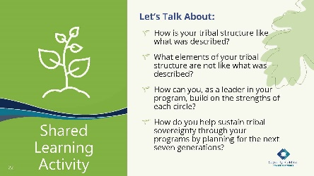

25 minutes

Say:

* Let’s take some time to reflect on the “Intergenerational Protective Circles of Care.” We will now move to a shared learning activity.
* In your workbook, you have the questions we will be answering, as well as a blank version of the “Intergenerational Protective Circles of Care.” We will be using these for this activity.

Do:

Explain shared learning activity.

Say:

* In pairs, you will discuss the four questions on the slide. We will come back and debrief as a larger group, so please have someone ready to share out about your reflections.

**Facilitator Note:** This activity can be an impromptu networking for a cohort or a 1-2-4-all for 1 tribe. The instructions are located at:

**•** <https://www.liberatingstructures.com/2-impromptu-networking/>

**•** <https://www.liberatingstructures.com/1-1-2-4-all/>

If using impromptu networking, you will arrange activity in pairs, and the pairs will rotate every four minutes for three rounds. If using 1-2-4-all, they will get two minutes by themselves, five minutes in pairs, and five minutes in quads, and then come back together as a large group for a 10-minute debrief.

Virtual Delivery: When delivering virtually, use breakout rooms for this activity.

Do:

Send the participants into their first group. Use the instructions in the Facilitator Note above to rotate participants, timing of which depends on the activity you select.

After 12 minutes, pull everyone back together for a 10-minute debrief.

Slide 23:

What Is the Definition of Leadership?

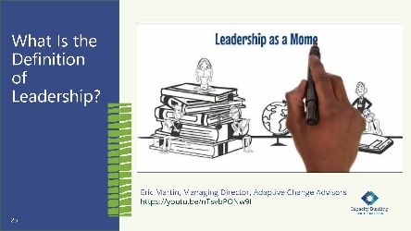

5 minutes

Say:

* As we begin to talk more about adaptive leadership, we want to ground you in what leadership is and can be. I want to introduce Eric Martin. He is a Detroit native turned prominent leadership expert. Eric has brought leadership development to over 300,000 people in 146 countries. His work extends the framework of adaptive leadership, a somewhat provocative leadership practice developed at Harvard.
* He has been an advisor and contributor to this academy by using his framework to recognize and take action when needed to address challenging issues.

Say:

* When watching this video, think of how leadership moments show up in your life.

**Tech Helper:** Play the video that is embedded in the slide, which is also available at <https://youtu.be/nTsvbPONw9I>. Make sure that you are sharing sound.

Do:

Play the 2:09 minute video embedded in the PowerPoint slide.

Ask:

After watching this video, do you think is the most important part of what Eric defines as leadership?

**Facilitator Note:** Leading is about mobilizing, engaging, and elevating people. It’s possible to effect real change when considering leadership as a moment. This emerges from adaptive leadership, which is a set of tools and techniques to see a problem and navigate to a solution.

Say:

* Let’s consider this definition of leadership further.

Slide 24:

The Path to Leadership

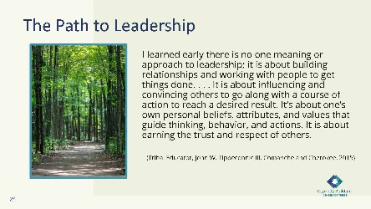

2 minutes

Say:

* Let’s think about the path to leadership. Think of tribal child welfare work as the forest with so many trees or crises to deal with daily that we often can’t see the forest for the trees. Taking an eagle’s view, you can see that leading requires not only understanding the individual tasks of staff but also cultivating the ability to see the patterns, relationships, context, and implications for growth. Being an effective leader is both active and reflective. Being able to take the eagle’s view that we talked about earlier today allows us to see the opportunities to improve our programs through leadership moments.
* The “Indigenous Circles of Leading” model is informed by Indigenous leadership values, the grandfather teachings, and the understanding that we are making decisions that will impact the next seven generations and that we should be grounded in our “Indigenous Way of Being.” The relational view of tribal culture and communities has long been a place for healing, connection, and understanding how tribes have been “getting it right all along.” As we sit in this thought, let’s think about how Indigenous leadership shows up in our practice.

Slide 25:

Indigenous Leadership in Practice

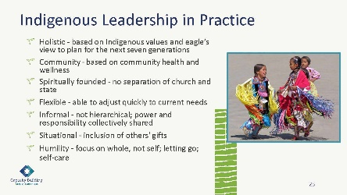

45 minutes

Say:

* In this session, we spent time describing the “Indigenous Circles of Leading” and the “Intergenerational Protective Circles of Care.” As we think about those concepts, we want you to work together to come up with some ideas to showcase with the group. Think about how these show up in your practice and in your tribal child welfare programs. Indigenous leadership in practice is symbolic of dancing in the moment, much like dancing to the beat of the drum in unison.
* We will now break you into four groups, and each group will look at these seven leadership topics together and brainstorm how they show up in your work, at your organization, or even in your dream job. What practice really shows up in your experience? What is the most important? And how can you grow to incorporate more leadership practices into your work?
* We will be available for any questions or thoughts you may want to discuss, so let us know if you need help or want to chat.

Do:

Pass out flip chart paper, post-its, markers, and loose paper for participants to explore their ideas.

Have participants break into small groups and give them 30 minutes to discuss how these leadership practices do, or could, show up in their work.

Alert participants when there are only five minutes left.

Give each group five minutes to discuss the main ideas they came up with and share examples.

**Tech Help:** Place in groups of four and give 30 minutes for them to discuss how these leadership practices show up at their work, in their organization, or in their ideal job. Keep track of time and provide a warning at the five-minute mark.

Virtual Delivery: Post these questions in the chat before learners go to breakout rooms: What practice really shows up in your experience? What is the most important? And how can you grow to incorporate more leadership practices into your work?

**Facilitator Note:** Instruct participants that they could use any moments, personal or professional, for this topic. These are the further descriptions of each topic and can be used during a teach-back to ask deeper questions.

**Holistic – based on Indigenous values and eagle’s view to plan for the next seven generations**

**•** Taking the eagle’s view

**•** Using seasonal cycles

**•** Leaders asked to adapt through changes in attitude, beliefs, behaviors

**•** Understand trauma and resilience—leading in context

**Community – based on community health and wellness**

**•** Service to the community valued

**•** Works for the people more than for self-achievement

**Spiritually founded – no separation of church and state**

**•** Self-reflective practices using spiritual teachings and ceremonies to support change and healing

**•** Understanding and respecting that beliefs and ceremonial teachings are unique for individuals and their tribal nation. Historically, Christianity and biblical teachings have become a foundational way of life in many Indigenous cultures.

**Flexible –able to adjust quickly to respond to current needs**

**•** Requires transformative learning and shifts in perceptions and practices

**•** Able to challenge status quo

**Informal – not hierarchical; power and responsibility collectively shared**

**•** Shared authority rather than authority over

**•** Persuasive rather than positional authority

**•** Inclusive of many voices and gifts—as members of our communities we bring our gifts in service to one another

**Situational – inclusion of others’ gifts**

**•** Step forward when needed to use your gift/strengths

**•** Leadership moments acknowledged by everyone as a time for action

**Humility – focus on whole, not self; letting go; self-care**

**•** Okay to not know, make mistakes, try something else, take risks

**•** Okay with uncertainty, sitting in the moment, dealing with resistance, and letting go

**•** Self-care, reflection, re-creation, finding a new balance

Slide 26:

Leadership From a Position of Authority

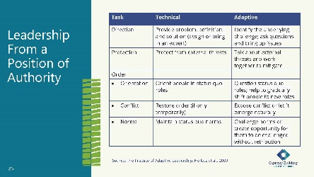

3 minutes

Say:

* Finding yourself in a position of authority is challenging, especially coming from an Indigenous perspective. Combining leadership and authority is an old and understandable habit, and most feel more secure in an authoritative role because it’s easier to tell people what to do. We all want to believe that we can exercise leadership just by doing well at the job we are expected to carry out. But the distinction between exercising leadership and exercising authority is crucial. By practicing adaptive leadership BEYOND authoritative management, you risk telling people what they **need** to hear rather than what they **want** to hear. When leading in an authoritative way, we can also experience that we are not centered and balanced in our mental, spiritual, emotional, and physical ways. We know from the leadership model that this is what surrounds our “Indigenous Way of Being.”
* You have three core responsibilities in an authoritative role: direction, protection, and order. You can practice adaptive leadership whether you are addressing a technical or an adaptive challenge, and the expectation is to clarify roles and offer direction or a vision. As part of organizational growth, think of this as being protective of young seedlings and maintaining stability. Reference: Heifetz, R. A., Grashow, A., & Linsky, M. (2009). The practice of adaptive leadership: Tools and tactics for changing your organization and the world. Harvard business press.)
* The hierarchical approach is like a chain of command dictated through an organizational chart. The process is rigid and orderly, expertise is limited, and diversity is ignored. Often as information is hoarded, the environment becomes stagnant, much like a pool of water that sits without any movement so that the bacteria grow, unchecked, until most life within the water perishes.

Slide 27:

Indigenous Adaptive Leadership

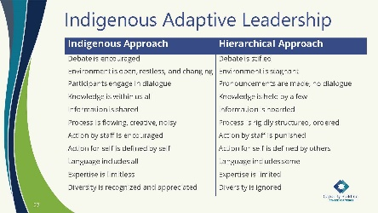

5 minutes

Say:

* From a general sense, an Indigenous approach is open and relational, engaging others to be more creative through their expertise and diversity. This approach is indicative of our ancestral knowledge and practices.
* Comparing and understanding the differences in an Indigenous and hierarchical approach is another consideration in the development of practice. You can find at times that you exist in and work with systems that have a hierarchical approach. As you think back to the “Indigenous Protective Circles of Care,” you can see that the Indigenous approach represents our ways of knowing, being, and doing. We talked about Indigenous leadership in practice on the earlier slide—you can see those ways reflected in that Indigenous approach. Focusing on the Indigenous approach keeps us in balance in our leadership and creates a landscape in which we can step into adaptive challenges in our programs. We are going to talk later about adaptive and technical challenges, and here we are laying the groundwork for how you as a leader can enter into adaptive challenges.
* I will leave you with this thought from Adel Panahi’s Executive Book Summary for the groundwork – “Adaptive Leadership is about change that enables the capacity to thrive” from the Executive Book Summary: Adel Panahi. Change is like seasons, a continual process connected to our environment. This will be important information as we begin to discover leadership moments. Adaptive leadership is about change that enables the capacity building needed for children and families to thrive.

Slide 28:

Discovering Your Leadership Moment

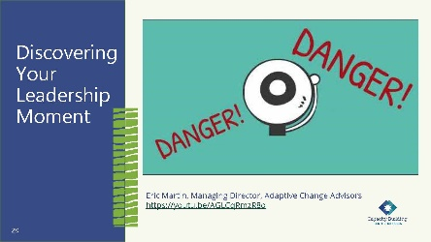

10 minutes

Say:

* We are now going to listen to Eric Martin as he talks about leadership moments. As you watch Eric’s video, reflect on “who” can be a leader and how we recognize leadership moments.

**Tech Helper:** Play the video that is embedded in the slide, which is also available at <https://youtu.be/AGLCqRmzR8o>. Make sure that you are sharing sound.

Do:

Play the 4:55-minute video embedded in the PowerPoint slide.

Ask

Now that you have watched this video, what did you think about the leadership moment flags?

How can we recognize leadership moments?

Do:

Allow time for a few participants to share their thoughts.

Say:

Let’s look at recognizing leadership moments a little more.

Slide 29:

Recognizing Leadership Moments

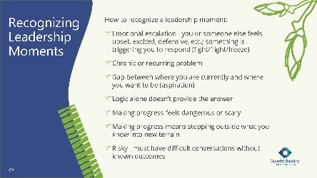

5 minutes

Say:

* In the “Indigenous Circles of Leading” model, the spring season is a growing period. Consider how a tree will adjust to the environment. If two trees sprouted close together, they adjust and become intertwined through their growth. These moments of adaptive growth guide your outcomes.
* “Leadership moments are daily opportunities anyone can take to create change. They’re those moments that make your heart leap with hopeful anticipation—or with fear of taking the next steps. They hold promise for that long-awaited breakthrough or for the change you know is possible. They also hold the uncomfortable possibility that you, too, need to change. Leadership moments are grounded in the idea that leadership is something that anyone can exercise to achieve a better outcome than the one they’ve been offered. . . . When deployed using . . . adaptive leadership, a leadership moment can create sweeping change throughout teams, organizations, and entire communities.” Eric Martin – *Your Leadership Moment: Democratizing Leadership in an Age of Authoritarianism*

Ask:

Do you recognize any of these examples in your own leadership day to day? Quickly jot down some leadership moments in the “Recognizing Leadership Moments” handout in your workbook.

Say:

* Start taking pauses during your workdays to recognize these leadership moments and how you are initially reacting to them.

**Facilitator Note:** Be able to provide some relevant examples. See below:

**•** In tribal child welfare leadership work, there are examples of leadership every day. How you as a leader answered that call from tribal council about a child removal—the racing heart, inability to share all the details that led to the removal to protect confidentiality but the opportunity you took to put forth that your staff is following policy and the child is safe.

**•** How the new caseworker spoke up while staffing a case for permanency to ask questions and point out a possible different option.

Say:

* As leaders we all have leadership moments. As Indigenous people, we were all given gifts that we can use to serve our communities.

Now that we recognize where leadership moments can occur, let’s talk about technical and adaptive challenges leaders will face in their work.

Slide 30:

Technical vs. Adaptive Leadership

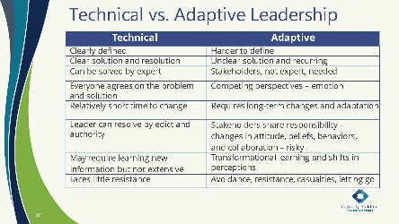

10 minutes

Do:

Play the video on YouTube (<https://youtu.be/YK8SFtYG1FM>), “What Are Technical And Adaptive Problems” by Sousan Abadian - Defining Problems | Harappa Education (2:34 minutes).

Say:

* Understanding the distinction between adaptive and technical work is critical to achieving your vision as a leader. It is important to note here that you spend only about 10% of your time in adaptive challenges, but if not seen as adaptive challenges, then they can continue to recur if technical solutions are only provided.
* As you can see on the slide, you can define technical work by specific criteria, but the problem is that most of our challenges aren’t just technical. They require adaptive work.
* What is different about an adaptive challenge? A challenge is adaptive when it requires something new—a new behavior, change of beliefs or values, knowledge, action, or way of thinking that is not in the group’s current expertise. In adaptive challenges, people don’t know how to solve the problem, and in fact, people often are the problem. Adaptive challenge is “growing a worker” by building their competency to be a critical thinker. It requires people to learn new ways, change behavior, reach new understandings, see the world through new filters, and work through the problem in a collective process. Bringing diverse voices to the table increases both the ability to recognize the adaptive challenge and the adaptive competence of the team.
* Adaptive challenges can be painful because the process can be difficult, but as tribal child welfare leaders, many of us have already been practicing adaptive leadership. We are adapting our leadership when we are working with tribal leaders and tribal councils, which is different than working with state child welfare directors and state social workers. How we provide leadership for tribal vs. nontribal staff or for interns vs. tribal elders requires adaptive skills that inform and improve our leadership.

Ask:

What questions would you ask of the worker as an adaptive solution?

Slide 31

Margaret’s Story: Spring

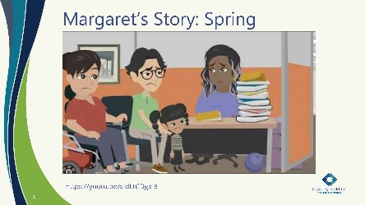

10 minutes

Say:

* We are ending our focus on spring. Margaret’s story is another example of a leadership moment at the administrative level. We will be hearing about Margaret’s story in each season.
* Margaret Orrantia was an early contributor to this leadership academy. In this video, she shares her story of the challenges she experienced coming in as a new tribal child welfare director to a struggling tribal organization. She describes the many challenges in her initial discovery.
* As you listen to Margaret’s story, listen for the leadership moments and her responses.

**Tech Helper:** You will play the video embedded in the PowerPoint slide, which is 5:42 minutes. The video is also on YouTube at <https://youtu.be/sIdLtCDgxI8>.

Slide 32:

Case Study: Applying Margaret’s Story

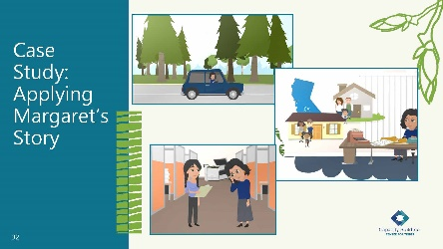

20 minutes

Say:

* Now, for your last interaction in this season, we would like for you to apply what you heard in Margaret’s story to what you are starting to envision for your leadership role. You have a handout in your workbook that lays out what we would like for you to do for the next 15 minutes. When we come back together, we will have a few minutes to discuss what you want to share with the group.

Do:

Break participants into small groups. The members of this final group will stay the same for each end of season activity, applying Margaret’s concepts to their role and vision.

Alert participants when there are only five minutes left in their group time.

After 15 minutes, bring participants back together for a larger group discussion about what they came up with.

**Tech Help**: Record who is in each group because the end-of-the-day case study groups for all four days should have the same members.

**Facilitator Note:** Here are the instructions from the case study handout:

As a group, you will now apply what you heard in Margaret’s story to your daily life.

Let’s imagine you have stepped out your door and into the fresh landscape of spring. The landscape has been touched by others for generations, and some remnants of past plantings are starting to sprout from the surface.

Your leadership role is like a fresh landscape each day. In your groups, brainstorm what it is that you would like to plant during your leadership role. Take an eagle’s view and think about where the ripples may appear when you start to grow in the area where you want to focus.

Imagine the possibilities that lie before you, but also think about the tools you may need to be successful in your leadership role.

Over the next few training days, you will continue to use Margaret’s story as a prompt for considering what you want your leadership journey to look like. Feel free to be creative! Draw pictures, use color, and explore what you want to grow!

Do:

Provide time for participants to share what they found useful from the case-study analysis and application.

Slide 33:

An Eagle’s View

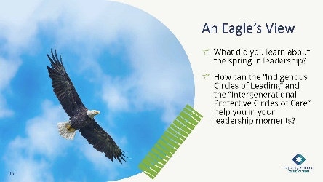

5 minutes

Say:

* As this season comes to a close, we are thankful for each of you allowing us to share this spring season training. We would invite you to do a little reflection before we leave as a group.

**Facilitator Note:** Only need one or two responses. If there are none, share some relevant examples.

Ask:

What did you learn about leadership in the spring?

How can the “Indigenous Circles of Leading” and the “Intergenerational Protective Circles of Care” help you in your leadership moments?

Do:

Revisit some reflections from the leadership model, protective circles of care, and adaptive leadership. Allow time for questions and any reflection moments participants may have.

Say:

* Remember the date and time of the next session.

Slide 34:

Ending Our Day Together in a Good Way

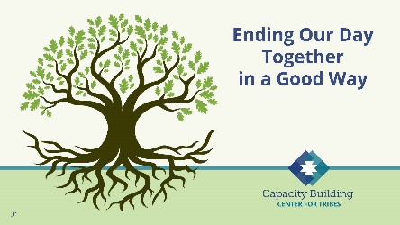

10 minutes

Say:

* We now want to end our day together in a good way.

Do:

Introduce closing arranged ahead of time. This could be a blessing, a talking circle, or even just sharing of a word that stuck with them from the day of training.

# Tribal Child Welfare Leadership Academy Curriculum Team

This curriculum is the collaborative effort of many individuals and agencies working together to create the Tribal Child Welfare Leadership Academy training, an adaptation of the NCWWI Leadership Academy for Middle Managers. We acknowledge the many tribal leaders, formal, informal, and hereditary, who provided input and guidance to the process and outcome. The core curriculum team includes:

**Carolyn Benard**

Logistical Coordination. Butler Institute for Families, University of Denver. Grant and Project Coordinator for Capacity Building Center for Tribes. Denver, CO.

**Tabitha Carver-Roberts**

Curriculum Revision Editor. Senior Program Associate, Butler Institute for Families, University of Denver.

**Jackie Crowshoe,** Turtle Mountain Band of Chippewa

Resource Coordination and Culture Bearer. Capacity Building Center for Tribes, University of Southern Maine, Muskie School of Public Service. Tribal Child Welfare Policy Associate.

**Anne Comstock**

Project Management and Logistical Coordination. Tribal Law and Policy Institute/Center for Tribes Consultant.

**Emily Iron Cloud-Koenen,** Oglala Lakota

Lead Coaching Coordinator and Culture Bearer. Former Executive Director of Lakota Oyate Wakaneia Owicakiyapi, which is located on the Pine Ridge Reservation in South Dakota. Consultant for the Capacity Building Center for Tribes.

**Priscilla Day,** Anishinaabe and an enrolled tribal member of the Leech Lake Reservation

Lead Curriculum Writer and Culture Bearer. Director, Center for Regional and Tribal Child Welfare Studies and a tenured full professor at the Department of Social Work at the University of Minnesota Duluth, where she has taught since 1993. Advisory Board Member and Consultant for the Capacity Building Center for Tribes.

**Kathy Deserly**

Project Advisor and Co-Director, Tribal Law and Policy Institute/Center for Tribes. Worked in the field of child welfare for Native communities since 1974. Has provided extensive training and technical assistance to Native and non-Native programs. Became a founding board member of the Indian Child and Family Resource Center in Helena, MT. Served as the Associate Director for the National Child Welfare Resource Center for Tribes.

**Rachel Fore,** Cherokee

Curriculum Writer and Culture Bearer. Administrative Operations Leader with Cherokee Nation Indian Child Welfare in Oklahoma. Her work involves managing the administrative, financial, and support service programs for her agency. Rachel came to work for Cherokee Nation in 2009.

**Rita Hart,** Jicarilla Apache and Choctaw

Curriculum Writer and Culture Bearer, Project Senior Associate, Butler Institute/Center for Tribes. Extensive experience in the field of state child welfare, Indian child welfare, and Bureau of Indian Affairs.

**Robin Leake**

Principal Investigator and Co-Director, Capacity Building Center for Tribes. Research Associate Professor, Butler Institute for Families, University of Denver.

**Tom Lidot,** Chilkat Tlingit

Facilitator, Curriculum Writer and Culture Bearer. Tribal STAR Program Leader. Academy for Professional Excellence, San Diego State University, School of Social Work. Consultant Advisor Center for Tribes.

**Bob Lindecamp**

Project Advisor. ICF International. Senior Consultant to the Children’s Bureau for Capacity Building Center for Tribes and the National Child Welfare Workforce Institute. Selbyville, Delaware.

**Betty Nez,** Navajo

Coaching Advisor and Culture Bearer. Director of Zuni Tribal Social Services. Manages the Indian Child Welfare Act (ICWA) program, the Child Protective Services program, case management services, and the Foster Care and Family Preservation program. She has been working for Zuni Tribal Social Services for nine years.

**Rose-Margaret Orrantia,** Yaqui

Coaching Advisor and Culture Bearer. Previously worked at the Institute of American Indian Arts in Santa Fe, NM, for 18 years. Returning to San Diego, she served as the Executive Director of Indian Child and Family Services (ICFS), a state licensed foster family and adoption agency serving the American Indian population in San Diego and Riverside Counties.

**Deborah Reed**

Project Advisor. Assistant Professor of Practice/Project Leader. Leadership Academy for Middle Leaders, Center for Improvement of Child and Family Services-CWP. School of Social Work, Portland State University.

**Tribal Content Experts**

**Brenda Gilman Bagwill**

Tribal Patient/Liaison and ICWA Advocate  
Sycuan Band of Kumeyaay Nation

**Sunni Dominguez**

Council member  
Community Liaison for Tribal STAR  
Iipay Nation of Santa Ysabel

**Season Goodpasture**

Director of Social Services for Pala Band of Mission Indians  
Maidu and Paiute of the Susanville Rancheria  
**Jahari Harrison**

Southern Indian Health Council  
Indian Child Social Services  
Carib-Kalinago

**Karan Kolb**

Indian Health Council  
Director of Social Services  
Rincon Band of Luiseno

**Melvin Lewis**

Director of Social Services  
Ft Mojave Indian Tribe

**Carolina Manzano**

CEO Southern Indian Health Council  
Alpine, CA

**Linda Ruis**

Director of Tribal Social Services  
Iipay Nation of Santa Ysabel