Tribal Child Welfare Leadership Academy

**Participant Workbook**

Summer

This product was developed by the National Capacity Building Center for Tribes, which is funded by the Children’s Bureau through cooperative agreement number FAIN #90CZ0028.



Table of Contents

Summer Agenda 3

Summer Learning Outcomes 4

Indigenous Circles of Leading 5

Intergenerational Protective Circles of Care 6

Breakout Group: Tribal Child Welfare Success 7

Shared Purpose through Adaptive Leadership 8

Breakout Group: Pair Share 9

Teach Back Instructions 10

Historical Trauma 11

Secondary Traumatic Stress 12

Lateral Violence 14

Internalized Oppression 15

Behaviors (Lateral/Internalized Oppression) 16

Healing: Restoring Harmony and Balance 17

Growth in a Healing Organization 18

Path to a Just Society 19

Margaret’s Story: Case Study 20

Adaptive Leadership 21

# Summer Agenda

* Indigenous Circles of Leading
* Intergenerational Protective Circles of Care
* Defining Success in Child Welfare
* Shared Purpose Through Adaptive Leadership
* Teach-Back Opportunity: Addressing Trauma in Our Work
* Transition to Healing
* Healing: Restoring Harmony and Balance
* Growth in a Healing Organization
* Path to a Just Society
* What Is Our Role
* Margaret’s Story
* Case Study: Applying Margaret’s Story
* Continuing Our Growth

# Summer Learning Outcomes

1. Explore the season’s individual leadership built upon relationships and indigenous intergenerational connectedness.
2. Explore how change happens through growing, nurturing, learning, practicing shared leadership, understanding context, and making choices for continued growth.
3. Apply the “Intergenerational Protective Circles of Care” framework to your leadership within your tribal nation.
4. Recognize that each of us has moments of leadership that we can choose to take and why we should do so, no matter what our official role is in the organization.



# Indigenous Circles of Leading

Overview video: <https://youtu.be/NXDceVVE56I>

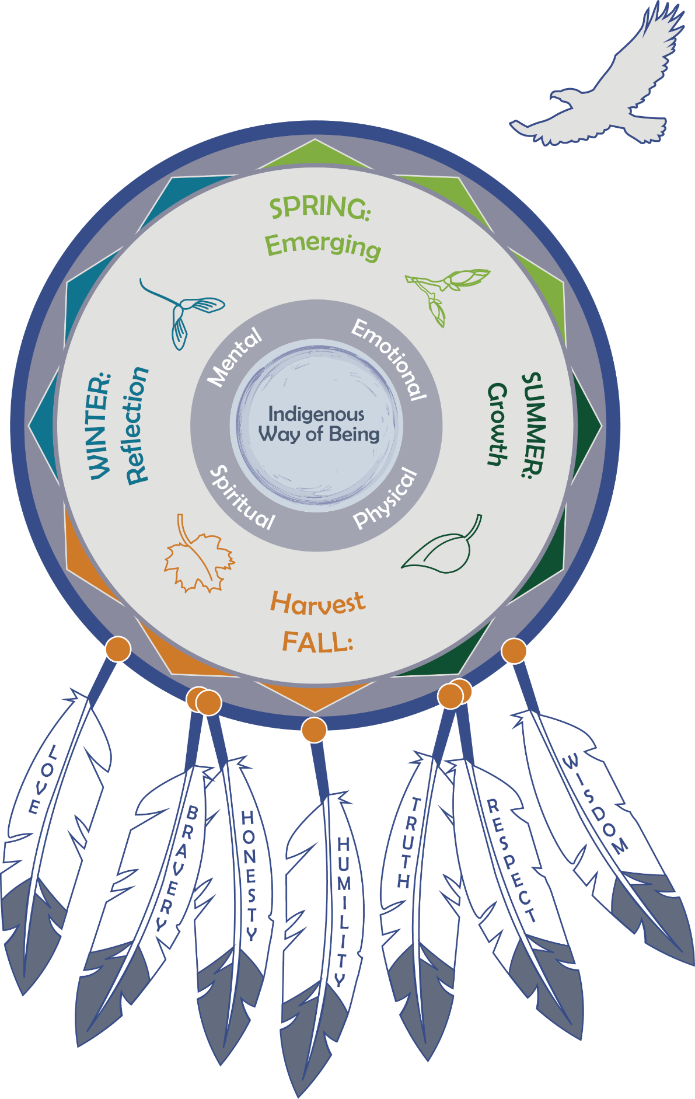

# Intergenerational Protective Circles of Care

The explanatory video for the IPCC is available at: <https://youtu.be/p0d4R3fIozU>.

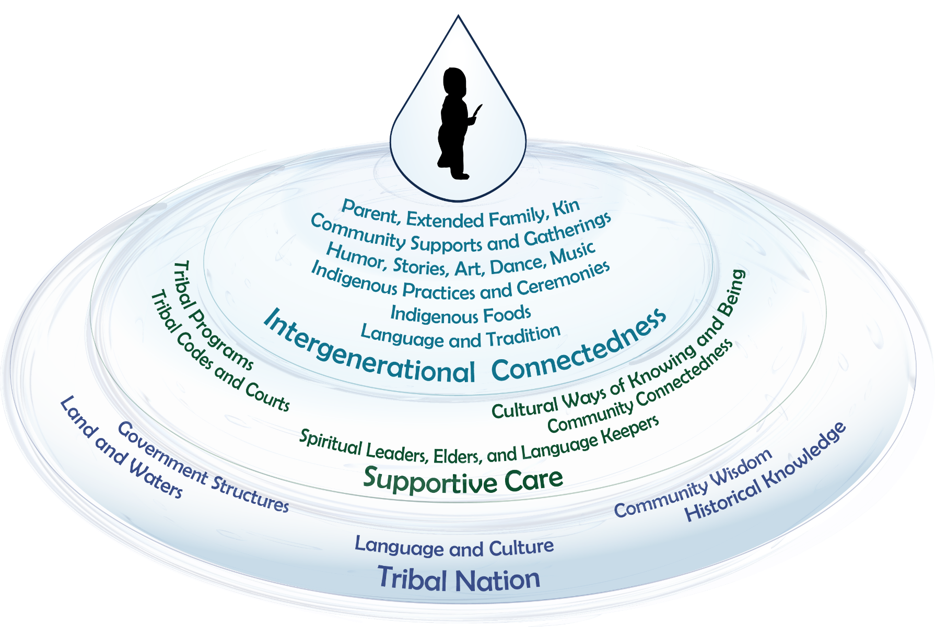

# Breakout Group: Tribal Child Welfare Success

*Child welfare success promotes the well-being of children by ensuring safety and achieving permanency for children.*

What if you could create your own definition of tribal child welfare success? How would you define it?

Remember that you will use this definition over the training days to help guide your vision. At this point it doesn’t have to be final, but you’ll want an idea as to the points that are important to you!

# Shared Purpose through Adaptive Leadership

Eric Martin’s video, “Shared Purpose Through Adaptive Leadership”: <https://youtu.be/TiNeXfu0nqQ>

* How do you currently mobilize others toward a shared purpose?
* In this video, what are the key points that Eric Martin makes about mobilizing others?
* How can the Indigenous Circles of Leading and the Intergenerational Protective Circles of Care be used to find a shared purpose?

# Breakout Group: Pair Share

* Who are you? (however you identify yourself)
* What do you do? (Name one thing you do that you feel grateful for doing. It gives you joy—this doesn’t have to be related to work.)
* Who do you do it for? (Who are the people you do it for? Imagine them when you do this thing and use actual names and people.)
* What do those people want or need? When you do what you do, you are serving a need—what do the people want or need? (health, safety, connection)
* How do they change as a result?
* How do those people change when you do what you do? What changes for them or for their community?

# Teach Back Instructions

A teach back is a chance for you to bring your lived professional and personal experience to the content pieces we will give you. During the process, the Protective Circles of Care can be a reference for you and how these show up in your work, particularly paying attention to the supportive care circle where your tribal child welfare program exists.

Each group will have a specific topic area—historical trauma, internalized oppression, lateral violence, and secondary traumatic stress. We have provided information in this handout for you to consider, and each group will develop a 5- to 10-minute presentation on their topic area that speaks to how that topic area shows up in your organization and your work. If you find it easier to discuss hypotheticals and talk about how it could show up in program work, that is ok, too. The overall idea is to help your fellow leaders understand what these topics are so that they’ll know what to look for in their work!

Resources for you to use in your research and discussions are on the following pages, and instructions for the assignment are:

* Break into four groups.
* Each group gets a topic – historical trauma, internalized oppression, lateral violence, and secondary traumatic stress.
* Develop a five presentation.
* You will find your group’s resources in your workbook.
* You have 40 minutes to develop a teach back

## Historical Trauma

We’ve all heard about historical trauma, and every tribe has their own stories about events that shaped their tribe, as well as events that we all have in common. Some of those experiences include boarding or residential schools and forced relocations.

No one has been able to fully document the impact of historic trauma on Native peoples, but many of the mental health, chemical dependency, and other issues that are so prevalent in Indian communities can be directly tied to past trauma.

**More Resources on Historical Trauma:**

Brown-Rice, Kathleen. “Examining the Theory of Historical Trauma Among Native Americans.” The Professional Counselor. <https://tpcjournal.nbcc.org/examining-the-theory-of-historical-trauma-among-native-americans/>

Native Hope. n.d. “Understanding Historical Trauma and Native Americans.” <https://blog.nativehope.org/understanding-historical-trauma-and-native-americans>

Twin Cities PBS. March 4, 2020. “Historical Trauma in Native American Communities.” <https://youtu.be/qppilbNiDc4>

## Secondary Traumatic Stress

Part of each social worker’s day is meeting and listening to families and children in crisis. Repeated exposure to the pain of others can produce trauma responses for the caseworker, supervisor, or staff, even if these workers aren’t the ones experiencing the direct trauma. Over the years, these traumatic experiences can build up, causing burnout, compassion fatigue, and other trauma responses. When not processed, these secondary exposures to trauma can lead to secondary traumatic stress.

A partial list of symptoms and conditions associated with secondary traumatic stress includes:

* Hypervigilance
* Hopelessness
* Inability to embrace complexity
* Inability to listen, avoidance of clients
* Anger and cynicism
* Sleeplessness
* Fear
* Chronic exhaustion
* Physical ailments
* Minimizing guilt

**More Resources on Secondary Traumatic Stress:**

Capacity Building Center for Tribes. 2022. “Understanding Secondary Traumatic Stress (STS) in Your Tribal Child Welfare Program.” <https://youtu.be/kMzUvELZtPQ>

Child Welfare Information Gateway. n.d. “Secondary Traumatic Stress.” <https://www.childwelfare.gov/topics/management/workforce/workforcewellbeing/burnout/secondary/>

The National Child Traumatic Stress Network. n.d. “Secondary Traumatic Stress.” <https://www.nctsn.org/trauma-informed-care/secondary-traumatic-stress>

Siegfried, Christine B. n.d. “Child Welfare Work and Secondary Traumatic Stress.” <https://cascw.umn.edu/wp-content/uploads/2014/07/CW-SecondaryTraumaticStress.pdf>

The Center for Advanced Studies in Child Welfare. November 5, 2018. “Understanding Secondary Traumatic Stress in Child Welfare.” <https://youtu.be/dtm3s0DyuaA>

## Lateral Violence

Lateral violence is bullying or other kinds of disruptive behavior that a coworker commits against another worker who is equal to or lower than in position. As these behaviors accumulate, the negative effects intensify. As people become more traumatized, they frequently will repeat the behavior toward other coworkers, creating a toxic environment and a cycle of trauma.

**More Resources on Lateral Violence:**

Christie, W., Jones, S., (December 9, 2013) “Lateral Violence in Nursing and the Theory of the Nurse as Wounded Healer” *OJIN: The Online Journal of Issues in Nursing* Vol. 19 No. 1. <https://ojin.nursingworld.org/MainMenuCategories/ANAMarketplace/ANAPeriodicals/OJIN/TableofContents/Vol-19-2014/No1-Jan-2014/Articles-Previous-Topics/Lateral-Violence-and-Theory-of-Wounded-Healer.html>

Coalition to Stop Violence Against Native Women. n.d. “Lateral Violence.” <https://www.csvanw.org/lateral-violence>

Massachusetts Nurses Association. April 15, 2011. “Is It Lateral Violence, Bullying, or Workplace Harassment?” <https://www.massnurses.org/news-and-events/archive/2011/p/openItem/6082>

SAMHSA Tribal Training and Technical Assistance Center. n.d. “Bullying in Indian Country.” <https://www.samhsa.gov/sites/default/files/ttac-bullying-factsheet-2.pdf>

## Internalized Oppression

A description of internalized oppression is when people are targeted, discriminated against, or oppressed over a period of time, and they internalize (believe and make part of their self-identity) the stereotypes that others believe about their group. It can result in negative self-perceptions (often unconscious) that in some way they are inherently not as worthy, capable, good, etc., as people outside their group. Groups and individuals can experience oppression or discrimination inward and act in negative ways toward their own group.

**More Resources on Internalized Oppression:**

Center for Community Health and Development at the University of Kansas. n.d. “Healing from the Effects of Internalized Oppression.” Community Toolbox. <https://ctb.ku.edu/en/table-of-contents/culture/cultural-competence/healing-from-interalized-oppression/main>

David, E. J. R., editor. 2013. *Internalized Oppression.* “What Is Internalized Oppression, and So What?” New York: Springer. <https://connect.springerpub.com/content/book/978-0-8261-9926-3/part/part01/chapter/ch01>

Internalization. n.d. NCJC. <https://www.nccj.org/internalization>

Springer. My Experience with Internalized Oppression. <https://youtu.be/7QHGzfORZTM>

## Behaviors (Lateral/Internalized Oppression)

* Gossip
* Undermining
* Sabotage
* No respect for lines of authority
* Backstabbing
* Blaming others
* Creating chaos
* Lack of healthy communication
* Lack of collaboration
* Abuse of power
* Lack of trust
* Highly defensive behavior
* Highly critical of other Indian people
* Fearful
* Suspicious
* Unhealthy boundaries
* “No talk” rule

# Healing: Restoring Harmony and Balance

**Human Growth**

* Mentally
* Physically
* Emotionally
* Spiritually

**Behaviors That Promote Harmony**

* Reflection/Mindfulness/Nature/Prayer
* Movement – walk, run, dance, play
* Cultural Practices – ceremonies, drum, sing, dance, bead, gather, social activities
* Active Listening to All Voices
* Letting Go
* Willingness to Change/Adapt/Grow

# Growth in a Healing Organization

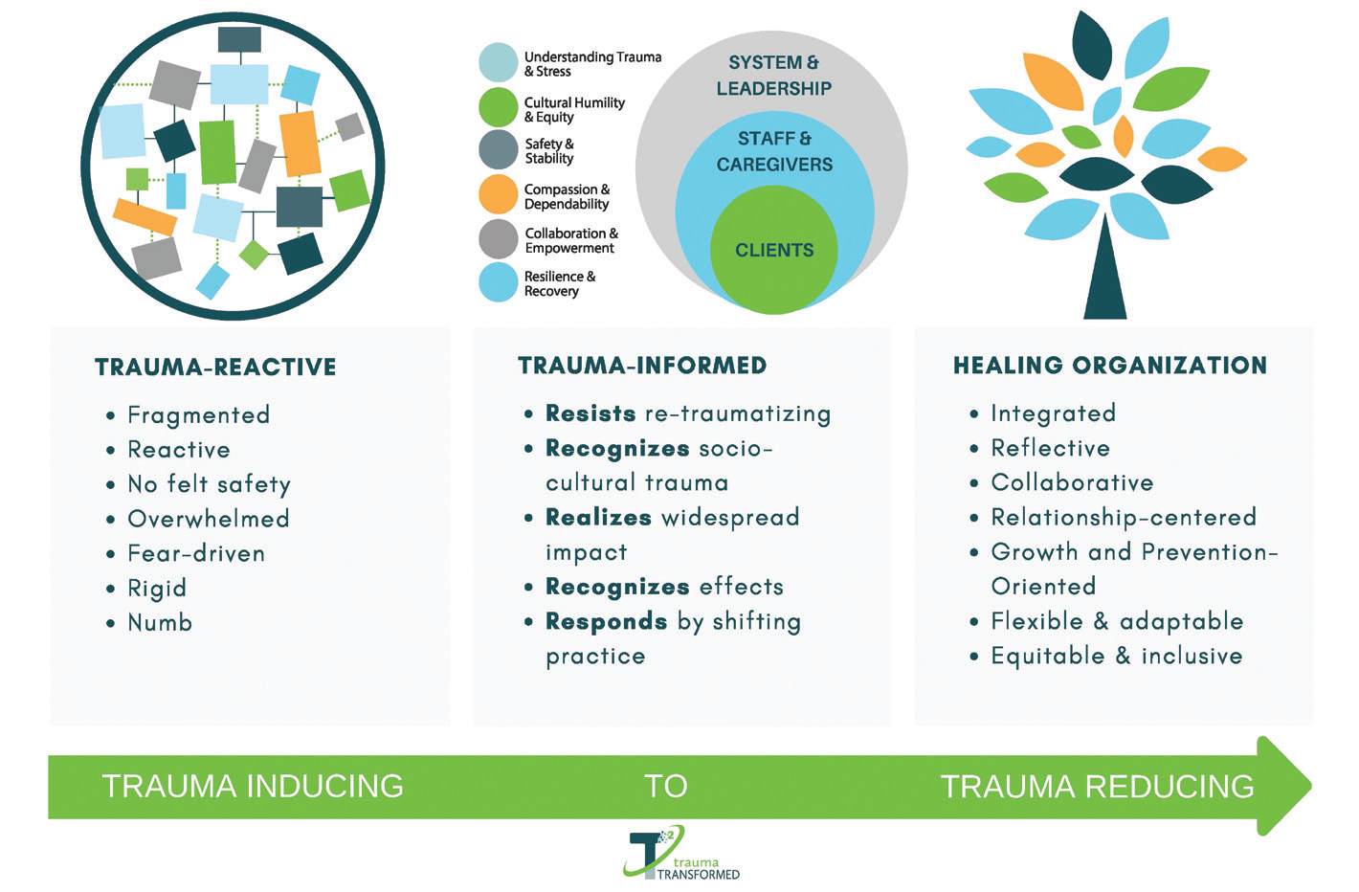

Source: <https://traumatransformed.org/>

* What do you think the behaviors in a trauma-inducing organization are?
* What would a healing organization look like?

# Path to a Just Society

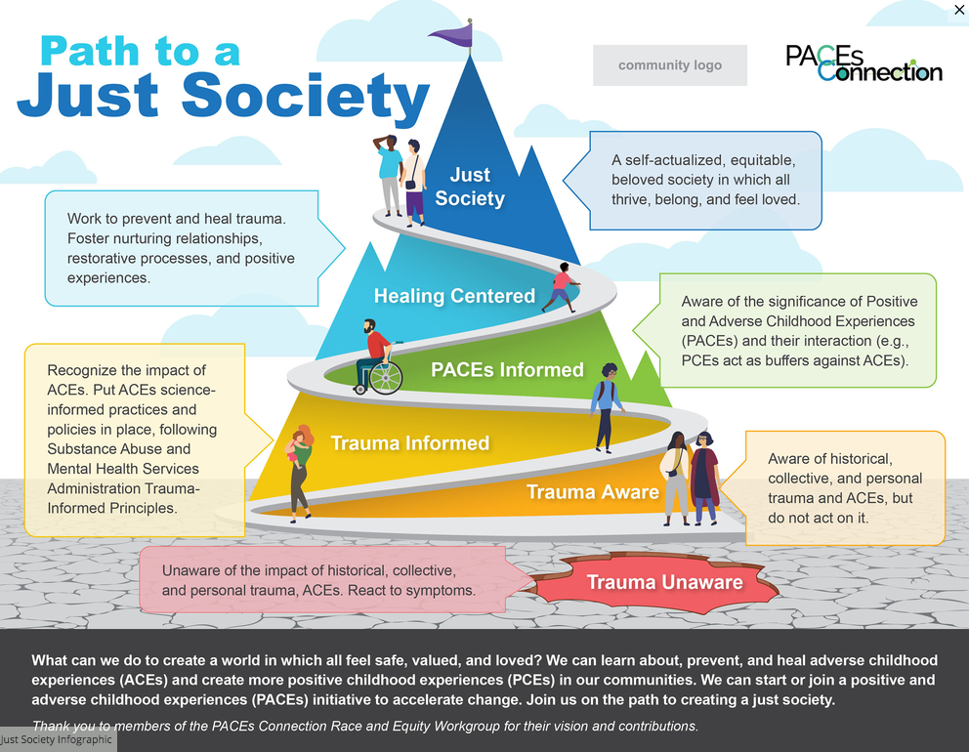

Source: <https://www.pacesconnection.com/>

* Looking at the graphic, where would you place yourself and your organization on the path to a just society? Where do you want to be?
* From the eagle’s view, what do you need to do as a leader to get to where you want to be?

# Margaret’s Story: Case Study

Now that you have looked at what you want to grow and imagined your landscape, let’s see where you are!

In today’s case study group, we want you to look at what external supports you may need to be able to maintain your growth. Just as our plants need water, sunlight, rest, and caretaking, you, too, can’t grow without external supports.

Looking at the IPCC and the path to a healing organization, what are some key supports or partnerships you need to nurture to be successful in your journey?

Discuss these topics with your group and create a debrief. Don’t forget, you get to define how you represent your approach, so be creative, and let your imagination roam!

# Adaptive Leadership

*As you have learned about adaptive leadership over the first two days, we are providing a space here for you to start writing down what challenges you are currently facing in your program.*

*Challenges you are currently facing:*

*________________________________________________________________________________________________*

*________________________________________________________________________________________________*

*________________________________________________________________________________________________*

*________________________________________________________________________________________________*

*________________________________________________________________________________________________*

*________________________________________________________________________________________________*

*________________________________________________________________________________________________*

*________________________________________________________________________________________________*

*Now that you have listed out some of your current challenges, put them into columns of “technical” and “adaptive.” This can allow you to begin determining how you might want to address these challenges as you learn more about adaptive leadership in the next two days.*

|  |  |
| --- | --- |
| **Technical** | **Adaptive** |
|  |  |
|  |  |
|  |  |
|  |  |
|  |  |