Tribal Child Welfare Leadership Academy

Session 2

Summer

This product was developed by the National Capacity Building Center for Tribes, which is funded by the Children’s Bureau through cooperative agreement number FAIN #90CZ0028.

# Acknowledgment

Welcome to the Tribal Child Welfare Leadership Academy (TCWLA). This curriculum was adapted from the National Child Welfare Workforce Institute’s (NCWWI) Leadership Academy for Middle Managers (LAMM) using federal dollars. You will see the curriculum has been divided into 4 modules reflecting a seasonal approach. Module 1 begins in the spring, and module 4 ends in the winter. The examples provided throughout the curriculum reflect specific tribal values for some tribes, but we respect that all tribes are not the same and each unique community has values, customs, and practices of their own. The full curriculum is free to the public and can be adapted by your tribal child welfare organization to meet the needs of your staff and your own cultural values.

We are grateful to the Children’s Bureau for funding this project and hope you will find it relevant to your own tribal child welfare leadership needs. When using the curriculum or its materials, we ask that you make attributions to the Capacity Building Center for Tribes and the Children’s Bureau.

***Recommended citation:***

Capacity Building Center for Tribes. (2024). *Tribal Child Welfare Leadership Academy*. Denver, CO: Author.

© 2024, Capacity Building Center for Tribes, Butler Institute for Families, Graduate School of Social Work, University of Denver

This document may be reproduced in whole or part without restriction as long as the Capacity Building Center for Tribes is credited for the work.

The contents of this document are solely the responsibility of the Capacity Building Center for Tribes and do not necessarily represent the official views of the Children’s Bureau.

# Table of Contents

Acknowledgment 2

Table of Contents 3

Training Materials 4

Room Setup 4

Training Design 4

Welcome and Introductions 5

Open in a Good Way 5

Tribal Child Welfare Leadership Academy: Summer 6

Respecting Our Time Together 6

Note of Caution 7

Foundation of the Tribal Child Welfare Leadership Training 7

Today’s Agenda 8

Storytelling Bingo Activity 9

Summer – Growth, Nurturing 10

Indigenous Circles of Leading 11

Overview: Intergenerational Protective Circles of Care 11

Breakout Activity Grounding Our Resources in Defining Child Welfare Success 13

Shared Purpose Through Adaptive Leadership 15

Breakout Activity: Pair Share 16

Teach-Back: Addressing Trauma in Our Work 17

Transition to Healing 19

Healing: Restoring Harmony and Balance 19

Growth in a Healing Organization 21

Path to a Just Society 23

Margaret’s Story: Summer 24

Shared Learning Activity: Margaret Case Study 25

Continuing Our Growth 26

The Eagle’s View 27

Ending in a Good Way 27

Tribal Child Welfare Leadership Academy Curriculum Team 29

# Training Materials

For the in-person training days, you will need the following materials:

* Printed participant workbooks, which are also emailed to participants ahead of time
* Flip chart paper
* Markers
* Paper
* Pens
* Post-Its

# Room Setup

When setting up the in-person classroom, these configurations are best for open discussion:

* Circle tables
* Four to six chairs per table
* Tables set up in a circle
* Drink/snack station in the back of the room

# Training Design

This complete training is 24 hours of training. The breaks are not included in this time frame because those will be tailored to the participants’ needs and the length of each day of training.

**Facilitator Note:** While this training is broken out into 4, 6-hour training days, the delivery of the training can be changed to accommodate program needs—for example, 6, 4-hour days. Depending on the size and engagement of the participants, some sections can take longer than others, so you will want to adjust your timing and breaks accordingly. You will want to work several breaks into the day, such as a 10-minute break at the end of each hour. You can find timers to share on screen that will keep track of the time left in breaks on YouTube. Search the internet for “YouTube” timers for timers, like this 10-minute example: <https://youtu.be/yxu0qHbG_2c>.

**Facilitator Note:** As people come into the room, you can play gentle music. The PowerPoint slides don’t start until after the “Welcome,” “Introductions,” and “Open in a Good Way.”

Welcome and Introductions

10 minutes

Virtual Delivery: You can adapt all the activities in this curriculum for virtual delivery, and we have found that the discussions and engagement can be successful in an online environment through using chat, creating breakout groups, and asking people to come off mute.

Do:

Acknowledge any dignitaries, leadership, and elders who have joined the group.

Recognize Children’s Bureau and the Capacity Building Center for Tribes for creating this training.

Introduce the facilitators, including relevant info that you are comfortable sharing, and then provide detailed intro after blessing.

Offer a land acknowledgment—if in person, for land of the venue, and if virtual, then each facilitator for land they are joining from.

Open in a Good Way

15 minutes

**Facilitator Note:** Make sure you have arranged blessing ahead of time with tribal programs and considered cultural protocols. Try to bring in a tribal elder of the tribes you are training. Find out what the protocol is for gifts and blessing supplies and provide culturally relevant introductions. If virtual, determine if the blessing will be on screen or just audio.

Say:

* As we begin this time together, we want to start our time together in a good way.
* Offer thanks and recognize the person providing the blessing.

Do:

Introduce blessing provider.

Once blessing is done, bring the PowerPoint slide deck up after the “Welcome” and “Open in a Good Way.”

Virtual Delivery: When using Zoom as your sharing platform, make sure you click the two radio buttons in bottom left to share sound and optimize video for clips. The person who shares their screen will need to have good bandwidth and the ability to play videos without lagging.

Slide 1:

Tribal Child Welfare Leadership Academy: Summer

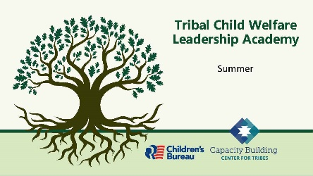

10 minutes

Say:

* Thank you for joining us in that beautiful way to start our second day of training. We are now venturing into the next step in our leadership journey.
* Take a moment to share a word to let us know how you are feeling today.

**Facilitator Note:** For in-person training, you can provide two longer breaks during the day. For virtual trainings, we have found that providing shorter breaks at the end of each hour helps with concentration.

Do:

Reintroduce tech support, so they know who to send questions to if they have any issues; if any issues came up the day before, let the participants know the solutions.

**Tech Help:** When you introduce yourself, discuss all the housekeeping pieces that you need participants to discuss. Inform them that you will be present to help with things like printing handouts or accessibility issues. The tech helper will also help keep track of time for breaks.

Virtual Delivery: For virtual deliveries, include how to contact facilitators and tech help during the meeting, where the microphone and video controls are, how to raise a hand in the online platform, and how to show if learners are away from their screen. You may need screenshots to show the participants where these controls are.

Slide 2:

Respecting Our Time Together

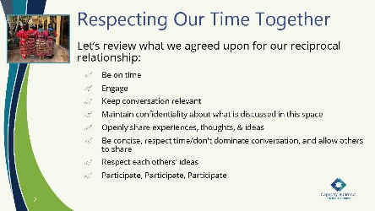

5 minutes

**Facilitator Note:** If new participants have joined the group, allow for them to contribute to the agreements as you see fit.

Say:

* Let’s revisit how we will respect our time together.

Do:

Read the content on the slide.

Ask:

Does anyone have anything they want to add?

Say:

* Thank you to everyone for reciprocating this respect for our time together. We will revisit these at the beginning of each day.

Slide 3:

Note of Caution

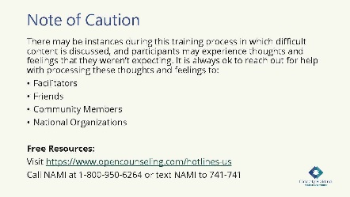

5 minutes

Say:

We want to again encourage you to take care of yourself and reach out for help if needed. If you need anything, feel free to reach out to your trusted colleagues, friends, or professionals.

Slide 4:

Foundation of the Tribal Child Welfare Leadership Training

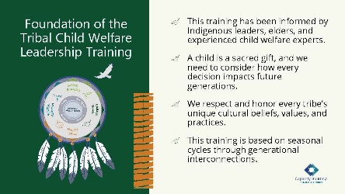

5 minutes

Say:

Here is an opportunity to revisit the foundation of this training. Review what is on the slide and let me know if you have any questions.

**Facilitator Note:** This is what is on the slide. You can pick a topic from below to discuss:

How you lead and the choices you make can have ripple effects. Success in tribal child welfare programs is achieved when tribal child welfare leaders, tribal leaders, and the community work together and know children are sacred gifts who need to be connected to kin, community, and their environment. These collaborations provide a collective vision to honor the rights of Indigenous children for the next seven generations.

The intention of this training is to help you build upon your Indigenous leadership skills to build strength and resiliency for your program. Our hope is that you will find universal connections to your own nation’s cultural beliefs and that you will bring your unique perspective to our conversations, so we can all work together to build upon tribal sovereignty.

Tribes who want to implement the training locally can use their own cultural beliefs, practices, and values. No landscape is the same, and all seeds need special conditions to successfully grow. What you can grow may be limited by the resources you have available. Or you may need to change your environment to grow what is needed to serve your people. We honor and respect all the landscapes you are bringing together in this room, and we hope you can find universal truths in the material we provide.

Throughout this training, we will explore the historical events that shaped our current realities and consider the future of our tribal nations for the next seven generations.

Slide 5:

Today’s Agenda

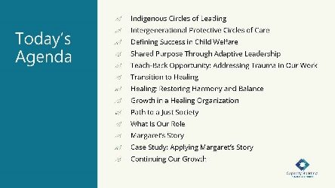

10 minutes

Do:

Review what will be covered today and ask if anyone has any clarifying questions or comments before we begin.

* + Indigenous Circles of Leading
  + Intergenerational Protective Circles of Care
  + Defining Success in Child Welfare
  + Shared Purpose Through Adaptive Leadership
  + Teach-Back Opportunity: Addressing Trauma in Our Work
  + Transition to Healing
  + Healing: Restoring Harmony and Balance
  + Growth in a Healing Organization
  + Path to a Just Society
  + What Is Our Role
  + Margaret’s Story
  + Case Study: Applying Margaret’s Story
  + Continuing Our Growth

Remind everyone that they received a participant workbook that they can follow along in.

Slide 6:

Storytelling Bingo Activity

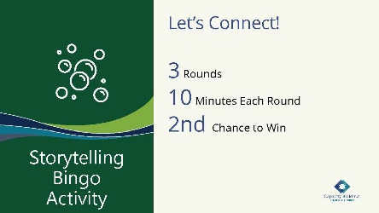

35 minutes

Say:

The conversations and sharing that we have had so far have been a blessing as we continue to learn from each other. Before we start this day, let’s find out a little more. We will continue the bingo game that we started during our first session. Let’s see how many more squares you can fill this morning!

**Facilitator Note:** Here are the bingo instructions to refresh your memory from the spring training.

Tell your story and ask others for their story. Break into a group of three for 10 minutes and choose a topic in a square; then each of you share a story. Write in **their** answers below the topic on your card. We will do three rounds of interaction each morning. Throughout the next few days of training, you will have additional opportunities to fill in your squares. The object of “Storytelling Bingo” is to fill in each square for “Blackout Bingo” (every square to be filled).

Virtual Delivery: You can do this mingle via Zoom by using breakout rooms. For this breakout, randomly assign participants into breakout groups. Try for three people per room. Add the bingo template to the chat and share that it’s in their training workbook and on Padlet under “Handouts.” Place the Padlet link in the chat: <https://padlet.com/butler_institute/b4u590jzlx8vai9p>.

**Tech Help:** The learners will be broken up into groups of three. Help keep track of the group members to ensure everyone has a chance to talk to the other learners in this informal opening. The tech helper will keep track of time and let learners know when it is time to rotate.

Slide 7:

Summer – Growth, Nurturing

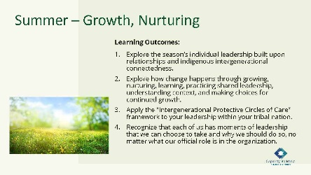

5 minutes

Say:

* As we continue our journey through the seasons, we have arrived in summer.
* Spring is slipping away as we begin to experience new growth. As we move into the summer, we notice growth and maturity and identify how we can keep the weeds out so that we have a fruitful growing season.
* The summer solstice provides the longest stretch of sunshine in a day, and it launches the summer season. The summer is a time for growth, which mobilizes and grounds resources. Let’s review how we are going to build your leadership resources today.
* The learning outcomes for today are listed here and in your workbook. Please take a moment to read the outcomes [or have participants read them out loud].

Slide 8:

Indigenous Circles of Leading

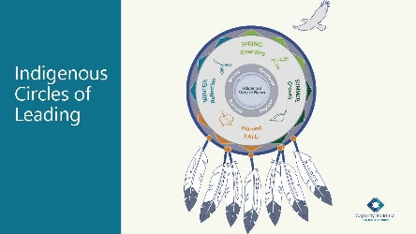

10 minutes

Say:

* Let’s review the Indigenous Circles of Leading training model. As a training model, it’s a holistic approach based on our Indigenous ways of knowing, being, and doing. Each circle is interconnected and continually evolving. We know that there is a time for every purpose, and we have built this training experience around the seasons. The eagle feathers represent those values that we consider in our work.

Ask:

As we move into the summer season, we want you to engage with us around two questions:

* + What does the eagle’s view mean to you?
  + What did you take away from yesterday’s explanation and interaction of this model?

Do:

Provide a few minutes for participants to respond.

**Facilitator Note:** Here are some relevant things covered that you can use to guide the conversation:

We ground our leadership with the grandfather teachings of love, bravery, honesty, humility, truth, respect, and wisdom, as values of how we show up every day and what guides our conduct with those we serve and the people that we work with. We recognize that tribes may have different values, and these are examples from our Anishinaabe relatives. We honor our differences and know that each of you will bring these into your leadership journey.

The center of the model is the place of our Indigenous ways of being where we keep ourselves balanced and embrace harmony within our intergenerational connectedness as a tribal nation. We continually seek balance in our mental, emotional, spiritual, and physical needs, and that’s how we practice self-care for ourselves and how we model self-care, not only for ourselves but also for others.

Slide 9:

Overview: Intergenerational Protective Circles of Care

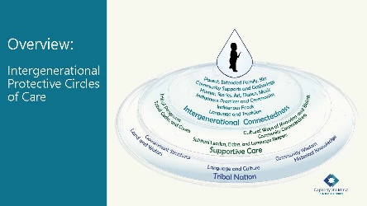

15 minutes

Say:

* Now, let’s briefly revisit the Intergenerational Protective Circles of Care.
* Considering your vision of tribal child welfare success and a child as a sacred gift, our next step is to consider how your tribal program operates as a protective circle of care.

Ask:

How does this graphic illustrate the way sovereignty is embedded throughout your tribal nation’s structure?

**Facilitator Note:** Items to identify as the discussion goes:

**•** Who is working on behalf of children? Include your positions, the court, ICWA, the community, their parents or caregivers, resource families, and other tribal programs.

**•** How are we working on behalf of children? Some ways could include permanency, healing, relationship building, healthy attachment, wraparound services, educating about and being trauma responsive, and embracing the family as a whole.

Say:

* As we wind up the review of the Intergenerational Protective Circles of Care, remember the circle is a ripple. The diagram is like a pool of water, and when the water is touched, a rippling effect takes place. Each time we come into contact or touch a child’s life, the ripples move outward and are surrounded by circles, which we define as protective circles of care. John Trudell said, “Every human being is a raindrop, and when enough of the raindrops become clear and coherent, they then become the power of the storm.” This quote symbolizes sovereignty.
* As we consider the seasonal cycles for ever-evolving and dynamic sovereignty, these circles are based on restoration and growth and a way for nation building. These circles emphasize nurturing cultural beliefs through the acknowledgment that we are all relatives, serving our relatives through decolonized approaches; meeting people’s needs where they are and when they are, and streamlining services in a way that doesn’t create family disconnect (food, furniture, rent, diapers, in-home family conferencing, substance abuse, behavioral health and other needs, etc.). The goal is to always identify the sustaining relationships and connections to the child’s culture and tribal nation. ICWA is founded on this belief. Each of the protective circles of care support the caregivers, which may be the biological parents, the grandparents, their kin or clan, and even community to resume protective care and control of the child.

Ask:

If you viewed this model from an eagle’s view, how does it support our intergenerational connectedness?

Do:

Allow a few participants to share their ideas with the group.

**Facilitator Note:** If needed, you can share:

We see these circles as informal and formal activities to support the intergenerational connectedness from our resiliency of seven generations before, to continuing our resiliency seven generations into the future. We know our strength is through ceremonies, community gatherings, prayers, communal acknowledgments of life, celebrations, grieving, and renewal. These connections are intended to be passed on through the teachings about how children, families, and communities are to be cared for to remain strong and healthy.

Ask:

How could you use this model within your own tribal nation?

Do:

Allow a few participants to share their ideas with the group.

**Facilitator Note:** This approach is a teaching tool, not only for leaders but also for the communities. You can share these ideas with the learners as they discuss the question:

**•** Restoring the community in your role as a protective circle of care would share the responsibility of providing care for a child or supporting a family.

**•** Restore an understanding with your program staff and help them consider their role in this protective circle of care.

**•** A plant requires nurturing through watering, weeding, and tending to promote growth. Building and restoring these circles is much like that; it takes time and the knowledge about our gifts from Creator.

Slide 10:

Breakout Activity Grounding Our Resources in Defining Child Welfare Success

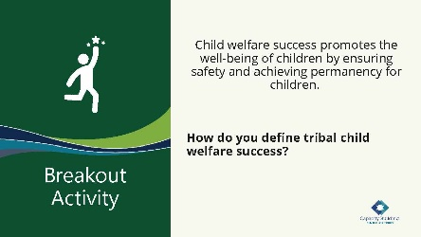

50 minutes

**Facilitator Note:** This definition presented is a generalized definition. It is being used as a starting point to drive deeper discussion about what success looks like for the learners’ tribal programs.

Ask:

What do you think about this definition? Does it resonate with you?

Say:

* What if we said that this generalized definition doesn’t have to be the definition your program uses? We would like to give you all space to think about how you would define tribal child welfare success for your unique program, using your cultural beliefs and values. As you think about what this definition could be, make sure that you look at it from an eagle’s view, using the summer’s theme of growth and inclusion of your tribe’s future.
* We are going to break into groups to work on creating your own definition of tribal child welfare success. You will use this definition to inform your vision for your organization, which we will be working on in the next two days of training. As you work on this, please know that this doesn’t have to be your final definition, as you can continue to shape it as the training unfolds.

Virtual Delivery: You can use breakout rooms to conduct the breakout activity.

**Facilitator Note:** If you have small groups from different tribal programs, have one group for each tribal program. If delivering the training to only one tribal program, break the participants into groups of three to four people.

Do:

Break the participants into groups.

Give each group a couple of pieces of flip chart paper, loose paper, and post-it notes for their brainstorm.

Give the groups 25 minutes to create their definitions.

Provide a warning when there are only five minutes left.

Allow 15 minutes for the groups to debrief their definitions of child welfare success.

After the debrief, summarize the leadership academy’s definition of tribal child welfare success.

**Facilitator Note:** The participants will need the definitions they create now for another activity during the winter module. You can preserve these definitions to ensure that you have a copy to give back to them. Here are a few ways to maintain their definitions.

Have them write the definition and their name on a piece of paper that you hold onto until the winter module.

If using an online platform, have them enter their definition in the chat and save the chat.

Say:

* We know that deciding on this definition is a very difficult process. The developers of this course did this exact same exercise, and we worked together for days to define what success looked like for us. We centered our definition on the belief that children are sacred gifts from the Creator.
* We believe that every child:
  + Has a sacred role in and a gift to contribute to the world.
  + Should be able to know their tribal identity and learn to maintain relationships with all beings in a good way.
  + Can grow into an adult who helps sustain a thriving and healthy community.
  + Deserves tribal child welfare leaders, tribal leaders, and the community to work together to protect them with a vision of community and family well-being.
  + Needs us to collaborate to fulfill this vision and honor the rights of Indigenous children for the next seven generations

Slide 11:

Shared Purpose Through Adaptive Leadership

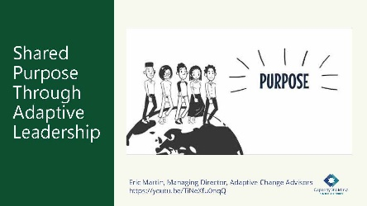

10 minutes

Say:

* Now we are going to move from individual purpose to shared purpose. In this video, Eric Martin will share how we can engage others in our vision. While you watch this video, consider the following: How do you mobilize others toward a shared purpose? What are the key points?

Ask:

What key points did you hear? What did you hear about mobilizing others?

**Tech Help:** Play video, “Shared Purpose,” which is embedded in the slide and is 3:59 minutes. The video is also available at <https://youtu.be/TiNeXfu0nqQ>.

Do:

Allow time for a brief group discussion.

**Facilitator Note:** Here are the key points from the video that you can state if needed:

**•** Leadership is about achieving shared purpose with others under conditions of uncertainty.

**•** A “force-based” approach to change seldom, if ever, works in the long run.

**•** Being connected to your purpose provides a source of courage for you when you exercise leadership.

**•** It is increasingly accepted nowadays to discuss purpose beyond just organizational mission or vision statements.

**•** When you’re not connected to your purpose, you get lost in your work and the bigger picture of why you do what you do.

**•** Purpose is discovered in relationship with other people and their purposes.

**•** Leadership from a shared sense of purpose with others allows us to cross divides and boundaries that hold back true progress.

Ask:

How can the Indigenous Circles of Leading and the Intergenerational Protective Circles of Care be used to find a shared purpose?

Do:

Allow time for a brief group discussion.

Move into the breakout activity.

Slide 12:

Breakout Activity: Pair Share

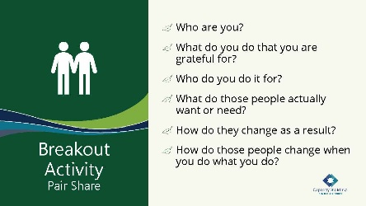

15 minutes

Say:

* We will now move into a pair share. We are going to put you into breakout groups. As a pair, discuss the following questions, which are also available in your workbook.
  + Who are you? (however you identify yourself)
  + What do you do? (Name one thing you do that you feel grateful for doing. It gives you joy—this doesn’t have to be related to work.)
  + Who do you do it for? (Who are the people you do it for? Imagine them when you do this thing and use actual names and people.)
  + What do those people want or need? When you do what you do, you are serving a need—what do the people want or need? (health, safety, connection)
  + How do they change as a result?
  + How do those people change when you do what you do? What changes for them or for their community?

Do:

Break the participants into groups of two and give them 10 minutes to discuss the questions above.

Bring the group back together for a five-minute debrief.

Ask:

How did that go?

Was it easy or hard?

Have you thought about these things before?

Do:

Allow time for a brief group discussion.

Slide 13:

Teach-Back: Addressing Trauma in Our Work

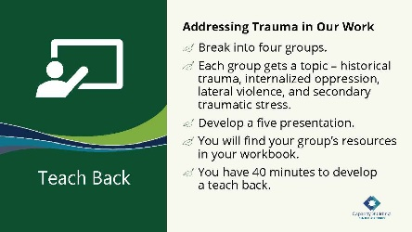

60 minutes

Say:

* Now we provide a teach-back opportunity for participants to teach us the impact of historic trauma; how lateral violence, secondary traumatic stress and internalized oppression show up in the work and affect your programs; and ways that you can address each.
* A teach back is a chance for you to bring your lived professional and personal experience to the content pieces we will give you. During the process, the Protective Circles of Care can be a reference for you and how these show up in your work, particularly paying attention to the supportive care circle where your tribal child welfare program exists. Also, don’t forget the 4 Rs handout from the spring, as well as the Indigenous Circles of Leading, which can provide more context for the teach back.
* To explain this process, we will place you into four breakout groups. Each group will have a specific topic area – historical trauma, internalized oppression, lateral violence, and secondary traumatic stress. We will provide each group information to consider, and each group will develop a 5- to 10-minute presentation on their topic area and how that topic area shows up in your organization and your work. You will find your group’s resources in your workbook.
* We will have time for other groups to ask questions of the presenting group after each presentation.

**Facilitator Note:** To be clear, we are asking for how participants see this show up in their work, how it affects their work, and how they may manage this as leaders.

Ask:

What questions do you have?

Do:

Allow a moment for questions.

Break participants into groups and give them 40 minutes to read the handouts.

Give a warning when only five minutes are left.

Provide space for each group to do a 5- to 10-minute presentation.

**Facilitator Note:** Make sure you walk around and help answer questions for the groups. If anyone gets stuck, ask them questions, such as:

**•** What things have you witnessed outside of your program or current role?

**•** Can you explore that topic a little more with me?

**•** How have historic and other kinds of trauma impacted your child welfare program?

**•** What behaviors do you see, and how does it impact the work?

**•** How has your agency dealt with these behaviors, and what other ideas do you have to address these issues?

Also, provide flip chart paper for groups who may want to draw out presentations. Participants don’t have to go to the front of the room for their presentations.

**Tech Help:** Place participants into groups of three or four. Different tribal programs can be mixed for this shared learning activity.

**Facilitator Note:** As part of this teach back, have all facilitators ready to help those who are triggered by the content and need to talk. Create a safe space and make it so that the participants can join that area at any time during the activity. In that area, have a facilitator or coach ready to talk through the participant’s reactions or thoughts.

When this activity is done, do a quick grounding activity before break to help participants bring themselves mentally to the training and help them move from the trauma space. Remind them to practice self-care during the break and say a prayer, sing a song, smudge, etc.—something to close out that potentially hard conversation.

Virtual Delivery: Have the participants share any resources they used or found valuable in the chat so that others have them.

Slide 14:

Transition to Healing

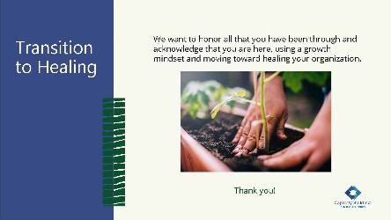

5 minutes

Say:

* We honor the knowledge that these traumas are forever present in our programs and in our history. We want to promote healing and resiliency in the children and families we serve and reflect that perspective in how we lead in child-serving programs. We thank you for sharing through the teach-back on this content as we move toward discussing healing and resiliency and our role as leaders.

Slide 15:

Healing: Restoring Harmony and Balance

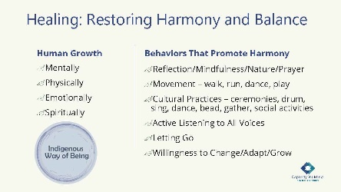

10 minutes

Say:

* We want to move toward talking about healing by restoring harmony and balance.
* This is important for each of us as individual leaders and collectively as a part of your tribal program.
* To practice the content by engaging, let’s begin by each taking three deep breaths to bring ourselves back to this space and our time together for the remainder of our day.
* I hope that this simple exercise brings you back to our time in a good way.
* When we begin talking about healing, restoring harmony, and balance, we see that being out of balance causes sickness in four areas: mental, physical, emotional, and spiritual. From an eagle’s view, the Indigenous Circles of Leading model embodies a process of continual balance and restoration to build resilience and well-being in ourselves through interconnectedness.

Ask:

Let’s consider a typical day in child welfare:

* + What do you need?
  + What do you have to do to center yourself?

Say:

* Here’s an example: You are in your office with the phone ringing constantly and emails dinging on your computer. You have a big meeting you have to run to in 10 minutes. Also, you have heard there may be a sibling group that will need to be placed. You need to ground yourself so that you can be the best leader for everyone.

Ask:

Who would like to share what they would need in that moment and what they need to do?

Do:

Allow for a few participants to provide some ideas.

Write the answers on a piece of flip chart paper.

Virtual Delivery: When seeking feedback, the participants can come off mute and share or post their answers in the chat.

**Facilitator Note:**

Refer to the Indigenous Circles of Leading model to remind participants that these are the areas that surround the Indigenous Way of Being.

**•** Finding balance in life and health is symbolic of the universal Indigenous medicine wheel. A wheel that is unbalanced will wobble and have difficulty turning in a cyclical movement, while a balanced wheel will cycle straight with ease and in harmony with all.

**•** In many traditional cultures, the cycle of seasons is a vital part of various ceremonies to restore and maintain harmony. Ceremonies are representative of the balancing cycles and the interdependence of all beings.

Say:

* As leaders, you are under daily pressures that are pulling you in many different directions, and your staff depend on your strength. By looking at the behaviors that promote harmony, we can see many ways to restore harmony and balance to ourselves as leaders. This is not an exhaustive list but is presented to provide a thought generator for each of you to uncover ways of promoting your own harmony and balance and bringing that harmony and balance to your tribal programs.

Slide 16:

Growth in a Healing Organization

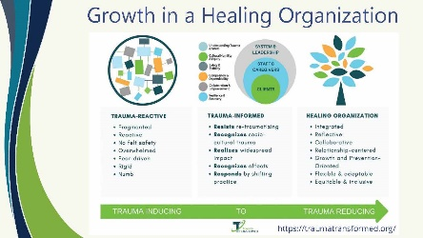

10 minutes

Say:

* You all did an amazing job teaching back the section on trauma, internalized oppression, lateral violence, and secondary traumatic stress today. We know this is something that affects our tribes, communities, and programs. Because we know how impactful this can be to our organizations, we want to look at how we can move toward being part of a healing organization.
* You see on the graphic that it is a continuum from trauma inducing all the way over to trauma reducing. We talk about this because we can’t get away from the fact that our staff, leaders, and the families we serve all have different traumas—personal traumas, community traumas, and even historical traumas. Each day, your staff also must deal with secondary trauma involved within their caseloads.

Ask:

What do you think the behaviors in a trauma-inducing organization are?

**Facilitator Note:** A trauma-inducing organization is a reactive environment where everything’s just fragmented.

There’s no real psychological safety, and many times you feel like every decision you make could impact your own safety—whether that is your position or your role—and it’s a fear-driven environment where people just become numb over time.

Say:

* As you look along the continuum, what do you think the behaviors in a trauma-informed organization are?

**Facilitator Note:** Here is an example of being trauma informed with the capability to realize, recognize, respond, and resist in a way so that we don’t continue traumatization:

One experience while working in a tribal child welfare program was that often we talked about being trauma informed and then there would be things that would happen between my colleagues that I could recognize easily as trauma responses. We didn’t know how to move past the trauma responses by saying, “I’m sorry. Is this too much for you right now? Do we need to come back to this at another time?” Or “Do you need to be given space right now?” We as program staff didn’t know how to do any of that, and so, while it’s a trauma-informed environment and we understand the effects of trauma, sometimes we didn’t know how to communicate in a trauma-informed way.

Say:

* If we look further to the right of the continuum moving more to trauma reducing, we find that the farthest is a healing organization.
* This takes us back to the Indigenous Circles of Leading model, realizing that at the center of the model is our Indigenous way of being and surrounded by it is the need for care of our own growth, which includes balancing our mental, emotional, physical, and spiritual selves.

Ask:

What would a healing organization look like?

**Facilitator Note:** The healing organization allows space for us to say, “I’m having trouble, and I need to go take care of myself” or “I need to sit with you for a minute and talk through what I’m experiencing right now.”

When we can create and keep space, everyone is integrated, and the culture is reflective, providing staff the opportunity to exist in a way that allows me to acknowledge, “I should have come to you yesterday in a different way. I was accusatory, and I shouldn’t have been.” This provides an understanding that I might have triggered a trauma for you, and I want to help heal this.

Staff can be reflective about their role/your role, and when things don’t go the way you want them to, your response can be relationship centered.

Allowing for space in which everyone is focused on the relationships and what they mean to the organization moves us toward the trauma-reducing environment of a healing organization.

Some reflective practices include:

**•** Asking questions like, How do you feel? What do you notice in yourself? What do you think is driving this reaction?

**•** Having conversations in private.

**•** Refraining from one-upmanship when describing trauma or workplace stressor stories.

Say:

* All the things mentioned create room for personal and professional growth in our healing organizations, and they’re flexible and adaptive, which can create equity and inclusion of all. As we talk about becoming a healing organization, we want to see how this can play out within our tribal communities.

Slide 17:

Path to a Just Society

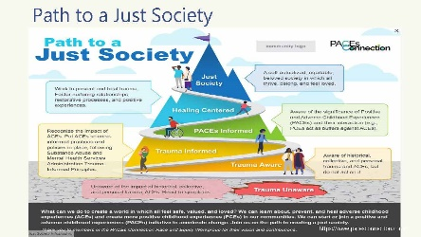

10 minutes

Say:

* This graphic comes from the PACEs Connection website. It was developed with the goal to create common language and identify points along the path to a just society. The graphic can give us, as individuals and as organizations, a gauge of where we are, where we want to go, and what’s really needed to get there.
* This graphic shows a path toward a just society, which is defined as “a self-actualized, equitable, beloved society in which all thrive, belong, and feel loved.”

Ask:

You don’t have to share this openly but reflect on this question: Looking at the graphic, where would you place yourself and your organization on the path to a just society? Where do you want to be?

From the eagle’s view, what do you need to do as a leader to get to where you want to be?

Do:

Create space for participants to discuss.

**Facilitator Note:** How do we define ACEs or being trauma aware?

**•** Adverse Childhood Experiences or ACEs: As a summary, adverse childhood experiences are things like a child living with a parent suffering from a mental health issue, a parent or caregiver with substance use disorders, or even an incarcerated parent. These adverse childhood experiences are quantified in an ACEs quiz that considers 10 of these kinds of factors and gives you a score from 1 to 10. This is called your ACE score.

**•** Trauma Unaware: This is a big hole, where children and families fall through the cracks. It comes from the impact of collective trauma, historical trauma, or personal traumas.

Say:

* For reflection, how can this inform your thoughts about moving toward a healing organization?

Slide 18:

What Is Our Role in Organizational Change to Promote Healing?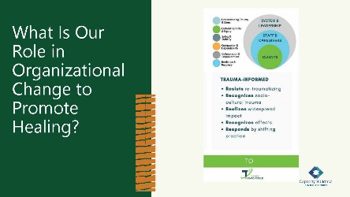

5 minutes

Say:

* In the summer season, we begin to see weeds appear. We take time to tend to the fullness of growth. Tending to this growth is symbolic of the journey to a just society and allows us to begin to feel continual positive growth in our surroundings. Our role as leaders in promoting a healing organization keeps in context these circles—especially these three circles: system and leadership, staff and caregivers, and clients. These circles are the protective circles of care. From a trauma lens, each circle’s purpose is to understand trauma and stress, practice cultural humility and equity, ensure safety and stability, have compassion and dependability, collaborate and empower, and build resiliency and recovery.

Say:

* Now, let’s return to Margaret and her leadership story.

Slide 19:

Margaret’s Story: Summer

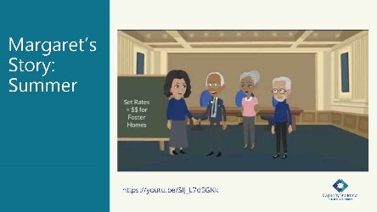

5 minutes

Say:

* We heard part of Margaret’s story in the spring training. She identified her role, resources, and upcoming challenges as a new director. In this video, Margaret continues her story in nurturing and growth within her organization.

Ask:

As we listen to this video, where do you see her leadership moments?

**Tech Help:** Play video, “Margaret Summer,” which is 3:59 minutes long and available at: <https://youtu.be/SIJ_L7d5GKk>.

Slide 20:

Shared Learning Activity: Margaret Case Study

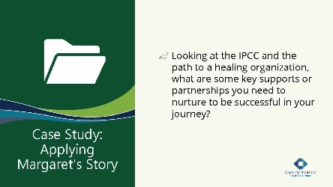

25 minutes

Say:

We are now going to return to the same groups that we finished out with yesterday. You will have 15 minutes to discuss the question. Your workbook has the question we will be discussing.

In your small groups, we want you to think about this question:

* + Looking at the IPCC and the path to a healing organization, what are some key supports or partnerships you need to nurture to be successful in your journey?

Do:

Break participants into small groups.

Alert participants when there are only 5 minutes left in their group time.

After 15 minutes, bring participants back together for a larger group discussion about what they came up with.

Allow for a short debrief.

**Facilitator Note:** Key topics from the video:

In Margaret’s story, the team developed a shared purpose and began advocating for change. She identified the growth and nurturing needed within her program. What leadership moments did you hear:

**•** Advocacy to her leadership

**•** Workers having meetings with families

**•** Requested increase in foster care funding

**•** Increased worker pay

Say:

We know adaptive change is a natural process. You can consider this process as a plant that will survive even without much nurturing and begins to thrive with a little attention.

Ask:

How did Margaret demonstrate democratized leadership—giving it back to the people?

**Facilitator Note:** Some ideas for discussion are:

Margaret was very passionate about reunifying families and providing tribal placements for children. She advocated and included workers and leaders in this effort. People learn from people.

Slide 21:

Continuing Our Growth

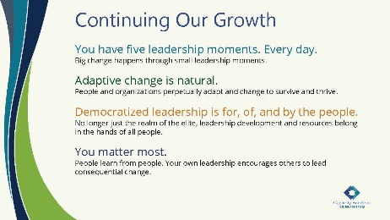

5 minutes

Say:

* As we close this session, reflect on the nurturing and growth that is an integral part of leadership. Building an interconnected Intergenerational Protective Circle of Care for children is a shared purpose. Being a leader includes the following:
  + Everyone has five leadership moments. Every day.
  + Adaptive change is natural.
  + Democratized leadership is for, of, and by the people.
  + You matter most.
* In Margaret’s story, she helps us to understand leading adaptive change is a shared purpose not only for her leadership, but for the people. It’s a perfect example of growth and nurturing through summer.

Say:

* Before we end the day, we want to take a few minutes to reflect on how the training is going so far.

Slide 22:

The Eagle’s View



10 minutes

Say:

* As you think about the content of today, remember to always take an eagle’s view to recognize leadership moments and be adaptive to promote growth.

Ask:

How are you feeling about the last two days of training? Can you share a word or two about how you are feeling?

Do:

Have participants verbally share their words.

Virtual Delivery: Ask participants to come off mute and say or type in the chat a word or two about the last two days of training.

Slide 23:

Ending in a Good Way

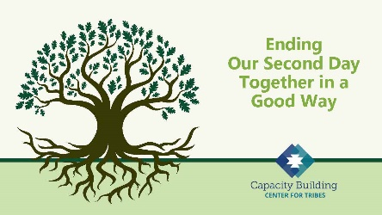

15 minutes

Say:

* This concludes the first two days of training. We are so thankful for each of you sharing this space with us, for every time there is a season. Our next session will move into the fall season. It’s been a blessed two days.

Do:

End in a good way by sharing a prayer or poem.

Remind them of the next session’s date and time.

# Tribal Child Welfare Leadership Academy Curriculum Team

This curriculum is the collaborative effort of many individuals and agencies working together to create the Tribal Child Welfare Leadership Academy training, an adaptation of the NCWWI Leadership Academy for Middle Managers. We acknowledge the many tribal leaders, formal, informal, and hereditary, who provided input and guidance to the process and outcome. The core curriculum team includes:

**Carolyn Benard**

Logistical Coordination. Butler Institute for Families, University of Denver. Grant and Project Coordinator for Capacity Building Center for Tribes. Denver, CO.

**Tabitha Carver-Roberts**

Curriculum Revision Editor. Senior Program Associate, Butler Institute for Families, University of Denver.

**Jackie Crowshoe,** Turtle Mountain Band of Chippewa

Resource Coordination and Culture Bearer. Capacity Building Center for Tribes, University of Southern Maine, Muskie School of Public Service. Tribal Child Welfare Policy Associate.

**Anne Comstock**

Project Management and Logistical Coordination. Tribal Law and Policy Institute/Center for Tribes Consultant.

**Emily Iron Cloud-Koenen,** Oglala Lakota

Lead Coaching Coordinator and Culture Bearer. Former Executive Director of Lakota Oyate Wakaneia Owicakiyapi, which is located on the Pine Ridge Reservation in South Dakota. Consultant for the Capacity Building Center for Tribes.

**Priscilla Day,** Anishinaabe and an enrolled tribal member of the Leech Lake Reservation

Lead Curriculum Writer and Culture Bearer. Director, Center for Regional and Tribal Child Welfare Studies and a tenured full professor at the Department of Social Work at the University of Minnesota Duluth, where she has taught since 1993. Advisory Board Member and Consultant for the Capacity Building Center for Tribes.

**Kathy Deserly**

Project Advisor and Co-Director, Tribal Law and Policy Institute/Center for Tribes. Worked in the field of child welfare for Native communities since 1974. Has provided extensive training and technical assistance to Native and non-Native programs. Became a founding board member of the Indian Child and Family Resource Center in Helena, MT. Served as the Associate Director for the National Child Welfare Resource Center for Tribes.

**Rachel Fore,** Cherokee

Curriculum Writer and Culture Bearer. Administrative Operations Leader with Cherokee Nation Indian Child Welfare in Oklahoma. Her work involves managing the administrative, financial, and support service programs for her agency. Rachel came to work for Cherokee Nation in 2009.

**Rita Hart,** Jicarilla Apache and Choctaw

Curriculum Writer and Culture Bearer, Project Senior Associate, Butler Institute/Center for Tribes. Extensive experience in the field of state child welfare, Indian child welfare, and Bureau of Indian Affairs.

**Robin Leake**

Principal Investigator and Co-Director, Capacity Building Center for Tribes. Research Associate Professor, Butler Institute for Families, University of Denver.

**Tom Lidot,** Chilkat Tlingit

Facilitator, Curriculum Writer and Culture Bearer. Tribal STAR Program Leader. Academy for Professional Excellence, San Diego State University, School of Social Work. Consultant Advisor Center for Tribes.

**Bob Lindecamp**

Project Advisor. ICF International. Senior Consultant to the Children’s Bureau for Capacity Building Center for Tribes and the National Child Welfare Workforce Institute. Selbyville, Delaware.

**Betty Nez,** Navajo

Coaching Advisor and Culture Bearer. Director of Zuni Tribal Social Services. Manages the Indian Child Welfare Act (ICWA) program, the Child Protective Services program, case management services, and the Foster Care and Family Preservation program. She has been working for Zuni Tribal Social Services for nine years.

**Rose-Margaret Orrantia,** Yaqui

Coaching Advisor and Culture Bearer. Previously worked at the Institute of American Indian Arts in Santa Fe, NM, for 18 years. Returning to San Diego, she served as the Executive Director of Indian Child and Family Services (ICFS), a state licensed foster family and adoption agency serving the American Indian population in San Diego and Riverside Counties.

**Deborah Reed**

Project Advisor. Assistant Professor of Practice/Project Leader. Leadership Academy for Middle Leaders, Center for Improvement of Child and Family Services-CWP. School of Social Work, Portland State University.

**Tribal Content Experts**

**Brenda Gilman Bagwill**

Tribal Patient/Liaison and ICWA Advocate  
Sycuan Band of Kumeyaay Nation

**Sunni Dominguez**

Council member  
Community Liaison for Tribal STAR  
Iipay Nation of Santa Ysabel

**Season Goodpasture**

Director of Social Services for Pala Band of Mission Indians  
Maidu and Paiute of the Susanville Rancheria  
**Jahari Harrison**

Southern Indian Health Council  
Indian Child Social Services  
Carib-Kalinago

**Karan Kolb**

Indian Health Council  
Director of Social Services  
Rincon Band of Luiseno

**Melvin Lewis**

Director of Social Services  
Ft Mojave Indian Tribe

**Carolina Manzano**

CEO Southern Indian Health Council  
Alpine, CA

**Linda Ruis**

Director of Tribal Social Services  
Iipay Nation of Santa Ysabel