Tribal Child Welfare Leadership Academy

**Participant Workbook**

Winter

This product was developed by the National Capacity Building Center for Tribes, which is funded by the Children’s Bureau through cooperative agreement number FAIN #90CZ0028.



Table of Contents

Winter Agenda 3

Winter Learning Outcomes 4

A Tribal Program and Cultural Family Preservation: A Story 5

Who Are We? 6

Guiding Principles of the Great Tree of Life 6

Maintaining Balance 8

Coming From a Place of Purpose 9

Defining Tribal Child Welfare Success Through Shared Purpose 10

Telling Your Story 11

What Will Your Leadership Story Be? 12

Case Study: Applying Margaret’s Story 13

Mobilizing Resources 14

Adaptive Leadership 15

# Winter Agenda

* Welcome and Opening in a Good Way
* Storytelling Bingo
* Indigenous Circles of Leading: An Eagle’s View
* Supporting Cultural Practice:  Sharing and Caring
* Guiding Principles of Spiritual Orientation
* Our Connection to the Great Tree of Life
* Maintaining Balance
* Coming from a Place of Purpose
* Your Leadership Journey
* Telling Your Story
* Margaret's Story
* Closing

# Winter Learning Outcomes

1. Allow participants to reflect on their personal and organizational leadership.
2. Engage in discussion about potential needed personal and organizational change.
3. Listen to feedback graciously and consider future action.
4. Celebrate one another’s successes and give thanks.



# A Tribal Program and Cultural Family Preservation: A Story

A tribal organization was concerned about high out-of-home placement of children in their community. The organization hired a new director who had a clear vision for using “Indigenous Circles of Leading” and “Intergenerational Connectedness” concepts in the program. She engaged other staff with similar ideas to create a climate of family preservation rather than removal. Challenges included some staff leaving, but the organization trained new hires in the new model of “caring for our relatives.” A practice model that supported family and cultural preservation was designed with input from staff and community. Cultural activities were incorporated in daily practice at the program, including regular prayer, smudging, and increased use of tribal language. The tribe’s values were posted in the front entryway, so anyone coming into the building could see the beliefs and conduct in working with families. They began to reach out to other community partners, such as law enforcement, and they developed a child welfare law enforcement position and moved him into the child welfare building to allow for natural interactions with child welfare staff.

The community gifted the program a traditional pipe to use for staff self-care and with family members. The program named itself in their traditional language, “uplifting our relatives,” and had new signs made in their language. Staff felt empowered to share traditional teachings, language, and practices. The program brought in Indigenous trainers to train in ways consistent with Indigenous intergenerational approaches. Workers felt empowered, and morale increased. Soon, word spread, and people reached out to work there. Families started to trust workers to assist them rather than remove their children. Over a few years, the whole program had changed its image in the community, and people started coming to them for help without fear of child removal. This positive transformation started when someone decided to take on the adaptive challenge of shifting practice.

# Who Are We?

## Guiding Principles of the Great Tree of Life

The tree is a symbolic representation of Indigenous traditional beliefs and lifeways since time immemorial. It is often envisioned as a mature tree standing in full bloom. Its roots and branches extend robustly into both the earth and sky. Lakota teaching calls this image the Tree of Health and Healing.

The tree will give learners a chance to analyze their core values as they manifest into health and healing, personally and professionally.

The roots represent values that have the wisdom and spiritual power to influence, change, transform, and transcend the history of trauma, including genocide and colonialism. They represent what is spiritually powerful or Wowakan. Healing begins in the most inner depths of our being, often out of sight. In this process, our inner environment will positively influence our outer environment. Our values give power and choice to intentionally plan our own healing and lifeways.

For this exercise, use the blank tree on the next page and answer the following questions.

* What values do you feel would nourish your tree? Write your values into the roots of the tree. The values you select in this process will serve as the grounding of your traditional values and beliefs.
* The tree trunk becomes the center of indefinite growth and development. Write your name and description of who you are in the trunk. Your description of yourself is defined as positive and one of strength.
* Consider your values and the activities you have in your life that are inspirational and positive. Write these activities on the branches.
* What activities would you like to include to promote positive change and continued healing? Write these in as your leaves. These leaves become new growth for rejuvenation.

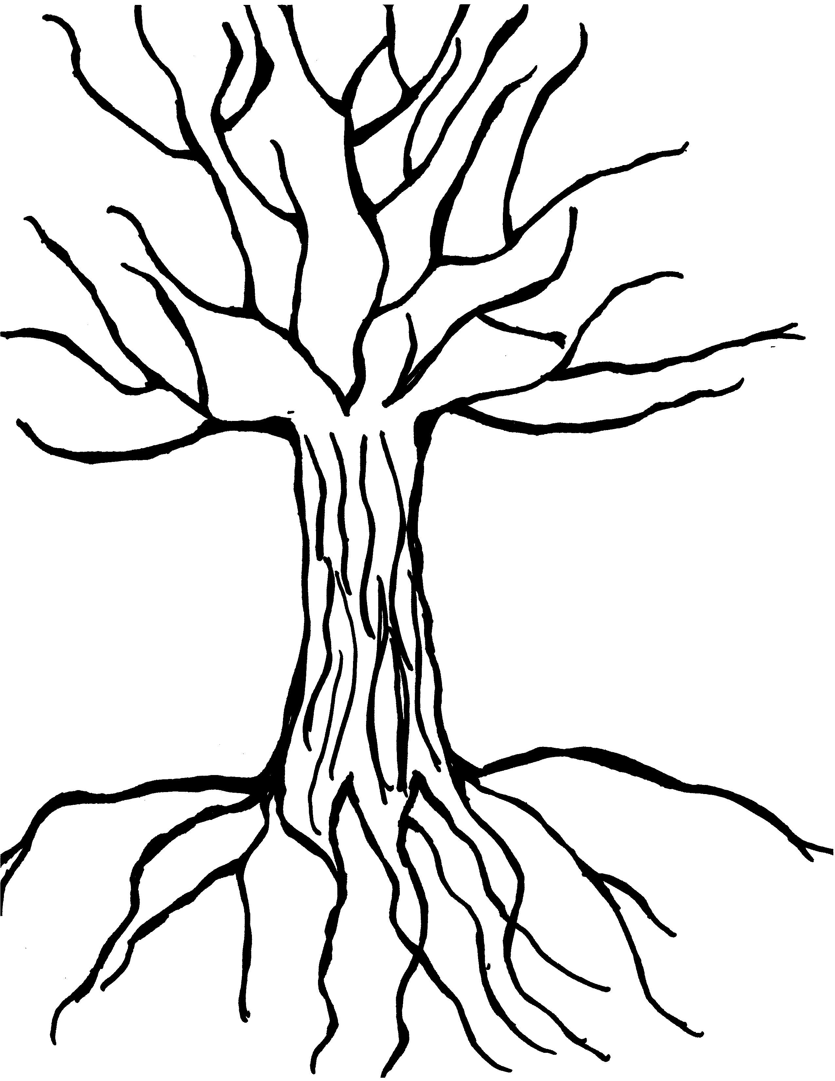

# Maintaining Balance

**Sense of Purpose**

* Spiritual Connectedness
* Optimism
* Goals

**Autonomy**

* Sense of Identity
* Self-Awareness
* Adaptive Distancing
* Task Mastery

**Social Competence**

* Cultural Flexibility
* Sense of Humor
* Caring

**Problem Solving**

* Planning
* Critical Thinking
* Help Seeking

*Source:* HeavyRunner PrettyPaint, I., *Cultural Resilience: Pisatsikamotaan: Finding Hope from the Inside Out* (2012) and *Miracle Survivors: Promoting Resilience in Indian Students* (2003).

# Coming From a Place of Purpose

Video available at: <https://youtu.be/ZQQzq4nQ0Is>.

How can the seven grandfather teachings or your own cultural values be applied to your shared purpose?

# Defining Tribal Child Welfare Success Through Shared Purpose

In the summer, you drafted a definition of success in tribal child welfare. Now, we want you to further develop your definition with the lens of a shared purpose. Use the space below to write your definition.

# Telling Your Story

This video is available at: <https://youtu.be/KZ76AlpXiT8>.

* When you think of a leader, what is their story in your mind?
* How would you tell your leadership story?

# What Will Your Leadership Story Be?

Think about a leadership moment when you felt the most confident. This is a time you felt powerful and alive. Your senses were heightened, and you felt on top of the world. You were filled with excitement. You were so alive you did not care what anyone else thought. Where are you? What are you doing? Who is around you? How are you impacting them? Now write down all the thoughts and feelings that arose for you.

# Case Study: Applying Margaret’s Story

This video is available at: <https://youtu.be/tX-a05RbKu8>.

* Where is your program, and where do you want it to be?
* What purpose will your leadership provide to your coworkers, your families, your community, and your tribe?
* What ripple effects will your leadership story have?
* Where do you want your community to be in seven generations?

# Mobilizing Resources

Tribal Information Exchange: <https://tribalinformationexchange.org/>

Capacity Building Center for Tribes: <https://capacity.childwelfare.gov/tribes>

# Adaptive Leadership

*As you have learned about adaptive leadership over the first two days, we are providing a space here for you to start writing down what challenges you are currently facing in your program.*

*Challenges you are currently facing:*

*________________________________________________________________________________________________*

*________________________________________________________________________________________________*

*________________________________________________________________________________________________*

*________________________________________________________________________________________________*

*________________________________________________________________________________________________*

*________________________________________________________________________________________________*

*________________________________________________________________________________________________*

*________________________________________________________________________________________________*

*Now that you have listed out some of your current challenges, put them into columns of “technical” and “adaptive.” This can allow you to begin determining how you might want to address these challenges as you learn more about adaptive leadership in the next two days.*

|  |  |
| --- | --- |
| **Technical** | **Adaptive** |
|  |  |
|  |  |
|  |  |
|  |  |
|  |  |