Tribal Child Welfare Leadership Academy

Session 4

Winter

This product was developed by the National Capacity Building Center for Tribes, which is funded by the Children’s Bureau through cooperative agreement number FAIN #90CZ0028.

# Acknowledgment

Welcome to the Tribal Child Welfare Leadership Academy (TCWLA). This curriculum was adapted from the National Child Welfare Workforce Institute’s (NCWWI) Leadership Academy for Middle Managers (LAMM) using federal dollars. You will see the curriculum has been divided into 4 modules reflecting a seasonal approach. Module 1 begins in the spring, and module 4 ends in the winter. The examples provided throughout the curriculum reflect specific tribal values for some tribes, but we respect that all tribes are not the same and each unique community has values, customs, and practices of their own. The full curriculum is free to the public and can be adapted by your tribal child welfare organization to meet the needs of your staff and your own cultural values.

We are grateful to the Children’s Bureau for funding this project and hope you will find it relevant to your own tribal child welfare leadership needs. When using the curriculum or its materials, we ask that you make attributions to the Capacity Building Center for Tribes and the Children’s Bureau.

***Recommended citation:***

Capacity Building Center for Tribes. (2024). *Tribal Child Welfare Leadership Academy*. Denver, CO: Author.

© 2024, Capacity Building Center for Tribes, Butler Institute for Families, Graduate School of Social Work, University of Denver

This document may be reproduced in whole or part without restriction as long as the Capacity Building Center for Tribes is credited for the work.

The contents of this document are solely the responsibility of the Capacity Building Center for Tribes and do not necessarily represent the official views of the Children’s Bureau.

Table of Contents

Acknowledgment 2

Training Materials 4

Room Setup 4

Training Design 4

Welcome and Introductions 5

Open in a Good Way 5

Tribal Child Welfare Leadership Academy: Winter 6

Respecting Our Time Together 6

Note of Caution 7

Foundation of the Tribal Child Welfare Leadership Training 7

Today’s Agenda 8

Storytelling Bingo Activity 9

Indigenous Circles of Leading: An Eagle’s View 9

Winter – Reflection and Giving Thanks 10

Supporting Cultural Practice: Sharing and Caring 11

Guiding Principles of Spiritual Orientation 12

Our Connection to the Great Tree of Life 13

The Great Tree of Life 14

Maintaining Balance 16

Coming From a Place of Purpose 17

An Eagle’s View of Your Leadership Journey 18

Telling Your Story 18

What Will Your Leadership Story Be? 19

Completing Margaret’s Story 20

Case Study: Applying Margaret’s Story 20

Winter is Ending, and the Cycle of Seasons Continues 21

Mobilizing Resources: Tribal Information Exchange 21

Capacity Building Center for Tribes 22

The Eagle’s View 23

Closing: Ending Our Time Together 23

Thankful and Blessed 24

# Training Materials

For the in-person training days, you will need the following materials:

* Printed participant workbooks, which are also emailed to participants ahead of time
* Flip chart paper
* Markers
* Paper
* Pens
* Post-Its

# Room Setup

When setting up the in-person classroom, these configurations are best for open discussion:

* Circle tables
* Four to six chairs per table
* Tables set up in a circle
* Drink/snack station in the back of the room

# Training Design

This complete training is 24 hours of training. The breaks are not included in this time frame because those will be tailored to the participants’ needs and the length of each day of training.

**Facilitator Note:** While this training is broken out into 4, 6-hour training days, the delivery of the training can be changed to accommodate program needs—for example, 6, 4-hour days. Depending on the size and engagement of the participants, some sections can take longer than others, so you will want to adjust your timing and breaks accordingly. You will want to work several breaks into the day, such as a 10-minute break at the end of each hour. You can find timers to share on screen that will keep track of the time left in breaks on YouTube. Search the internet for “YouTube” timers for timers, like this 10-minute example: <https://youtu.be/yxu0qHbG_2c>.

**Facilitator Note:** As people come into the room, you can play gentle music. The PowerPoint slides don’t start until after the “Welcome,” “Introductions,” and “Open in a Good Way.”

Welcome and Introductions

10 minutes

Virtual Delivery: You can adapt all the activities in this curriculum for virtual delivery, and we have found that the discussions and engagement can be successful in an online environment through using chat, creating breakout groups, and asking people to come off mute.

Do:

Acknowledge any dignitaries, leadership, and elders who have joined the group.

Recognize Children’s Bureau and the Capacity Building Center for Tribes for creating this training.

Introduce the facilitators, including relevant info that you are comfortable sharing, and then provide detailed intro after blessing.

Offer a land acknowledgment—if in person, for land of the venue, and if virtual, then each facilitator for land they are joining from.

Open in a Good Way

15 minutes

**Facilitator Note:** Make sure you have arranged blessing ahead of time with tribal programs and considered cultural protocols. Try to bring in a tribal elder of the tribes you are training. Find out what the protocol is for gifts and blessing supplies and provide culturally relevant introductions. If virtual, determine if the blessing will be on screen or just audio.

Say:

* As we begin this time together, we want to start our time together in a good way.

Do:

Introduce blessing provider.

Offer thanks.

Once blessing is done, bring the PowerPoint slide deck up after the “Welcome” and “Open in a Good Way.”

Virtual Delivery: When using Zoom as your sharing platform, make sure you click the two radio buttons in bottom left to share sound and optimize video for clips. The person who shares their screen will need to have good bandwidth and the ability to play videos without lagging.

Slide 1:

Tribal Child Welfare Leadership Academy: Winter

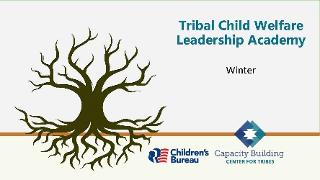

5 minutes

Say:

* Thank you for joining us for this last day of training. As always, we are so grateful to have you with us as we continue along our leadership journey.

Do:

Reintroduce tech support, so they know who to send questions to if they have any issues; if any issues came up in the previous days, let the participants know the solutions.

**Tech Tip:** When you introduce yourself, discuss all the housekeeping pieces that you need participants to discuss. You will want to help facilitators keep track of time so that breaks are worked into the day.

Slide 2:

Respecting Our Time Together

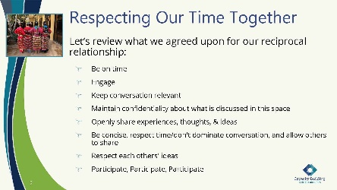

5 minutes

**Facilitator Note:** If new participants have joined the group, allow for them to contribute to the agreements as you see fit. Remind participants how breaks will occur so that they will know when breaks will happen.

Say:

* Let’s revisit the agreements we have established over the past days of training. We formed these so that we could mutually respect our time together.

Do:

Read the content on the slide.

Ask:

Does anyone have anything they want to add?

Say:

* Thank you to everyone for reciprocating this respect for our time together.

Slide 3:

Note of Caution

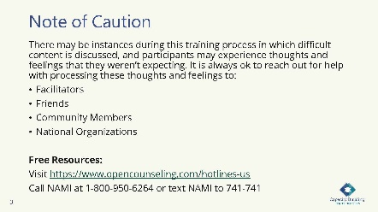

5 minutes

Say:

We want to remind you to take care of yourself and reach out for help if needed. This slide notes some available resources, and we are always here to talk if needed.

Ask:

Are there any other mental health or community resources that you would like to share?

Slide 4:

Foundation of the Tribal Child Welfare Leadership Training

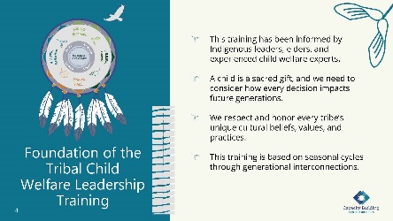

5 minutes

Say:

This is our last opportunity to revisit the foundation of this training. Review what is on the slide and let me know if you have any questions.

**Facilitator Note:** This is what is on the slide. You can pick a topic from below to discuss:

How you lead and the choices you make can have ripple effects. We can achieve success in tribal child welfare programs when tribal child welfare leaders, tribal leaders, and the community work together and know children are sacred gifts who need to be connected to kin, community, and their environment. These collaborations provide a collective vision to honor the rights of Indigenous children for the next seven generations.

The intention of this training is to help you build upon your Indigenous leadership skills to create more strength and resiliency for your program. Our hope is that you will find universal connections to your own nation’s cultural beliefs and that you will bring your unique perspective to our conversations, so we can all work together to build upon tribal sovereignty.

Tribes who want to implement the training locally can use their own cultural beliefs, practices, and values. No landscape is the same, and all seeds need special conditions to successfully grow. What you can grow may be limited by the resources you have available. Or you may need to change your environment to grow what is needed to serve your people. We honor and respect all the landscapes you are bringing together in this room, and we hope you can find universal truths in the material we provide.

Throughout this training, we will explore the historical events that shaped our current realities and consider the future of our tribal nations for the next seven generations.

Slide 5:

Today’s Agenda

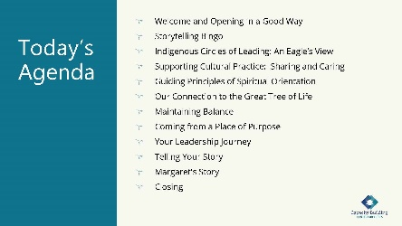

5 minutes

Do:

Review the day’s agenda:

* + Welcome and Opening in a Good Way
  + Storytelling Bingo
  + Indigenous Circles of Leading: An Eagle’s View
  + Supporting Cultural Practice:  Sharing and Caring
  + Guiding Principles of Spiritual Orientation
  + Our Connection to the Great Tree of Life
  + Maintaining Balance
  + Coming from a Place of Purpose
  + Your Leadership Journey
  + Telling Your Story
  + Margaret's Story
  + Closing

Do:

Remind everyone that they received a participant workbook that they will be using.

Slide 6:

Storytelling Bingo Activity

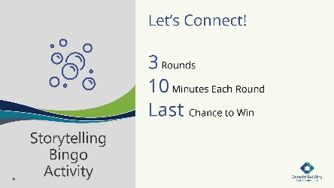

35 minutes

Say:

It is so hard to believe that we are on our final day of training! For one last time, we will engage in our bingo game that we started during our first session. Who is going to win this morning?

**Facilitator Note:** Here are the bingo instructions to refresh your memory.

Tell your story and ask others for their story. Break into a group of three for 10 minutes and choose a topic in a square; then each of you share a story. Write in **their** answers below the topic. We will do three rounds of interaction each morning. Throughout the next few days of training, you will have additional opportunities to fill in your squares. The object of “Storytelling Bingo” is to fill in each square for “Blackout Bingo” (every square to be filled).

Virtual Delivery: This mingle can be done via Zoom by using breakout rooms. For this breakout, randomly assign three participants into each breakout group. Remind people that the bingo template is in their training workbook

**Tech Help**: Keep track of time and let people know when it is time to rotate.

Slide 7:

Indigenous Circles of Leading: An Eagle’s View

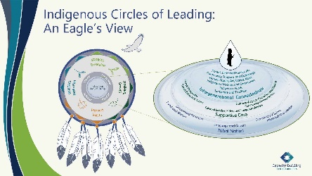

10 minutes

Say:

* As we move into our final session, let’s take a quick review of the “Indigenous Circles of Leading” model as it represents the purpose for all things. We’ve gone through the cycle of seasons, and the last is the winter season—a time for reflection of work being accomplished, what worked and what didn’t work. Many teams come together and give thanks for the successes while also sharing lessons learned. As we come into the time of rest, we can begin strategic planning for the future through cultural restorative practice. The “Intergenerational Circles of Care” is a guide for inclusion of these protective supports as we are all in this together.

Ask:

Does anyone have any questions or comments before we move into our last season?

Do:

Provide space for a few responses.

Slide 8:

Winter – Reflection and Giving Thanks

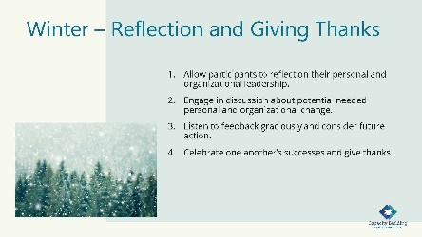

10 minutes

Say:

* We are now moving into winter, a time of reflection, giving thanks, and planning. As we’ve gone through each season in the leadership journey for the past three days, it’s been great to be a part of such rich discussion, building relationships and learning from each other. Take a deep breath. Know this is the last day, but it will be a good one!
* In winter, the weather is changing, and nature begins to sleep. Many plants, animals, and insects are hibernating, and we begin to stay inside more and treasure the warmth. Traditional practices included giving thanks by sharing with others. Elders would begin storytelling and reflection in those long winter nights. Families would gather and share meals. Reflection from the seasons before would lead to planning for the future, as spring would soon be arriving. All life occurs within the circle of the seasons, including an interconnectedness with all things.

Slide 9:

Supporting Cultural Practice: Sharing and Caring

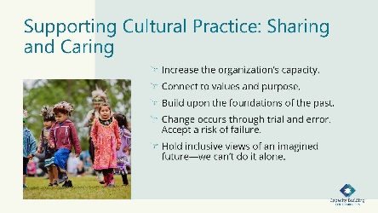

20 minutes

Say:

* In the fall season, we explored mobilizing our resources, understanding adaptive leadership, and addressing immunity to change. As a tribal organization, your culture and values are your strength, and the “Intergenerational Protective Circles of Care” is a basis for tribal sovereignty. Cultural restorative practice increases an organization’s capacity, connects value and purpose, builds upon foundations from the past, occurs through trial and error, accepts the risk of failure, and holds inclusive views of an imagined future—knowing we can’t do it alone. These descriptions are the basis of sharing and caring.

Ask:

When looking at the bullet points on this slide, we want you to consider you these questions:

* + What does cultural restorative practice look like in an Indigenous adaptive leadership approach?
  + What resources can you mobilize for adaptive change?

Say:

* In this scenario, we continue our leadership journey in mobilizing our resources for adaptive change. We will share a story of a tribal organization that has the shared purpose of cultural family preservation. This is available in your workbook if you would like to follow along.

Do:

Tell the following story.

Say:

* A tribal organization was concerned about high out-of-home placement of children in their community. The organization hired a new director who had a clear vision for using “Indigenous Circles of Leading” and “Intergenerational Connectedness” concepts in the program. She engaged other staff with similar ideas to create a climate of family preservation rather than removal. Challenges included some staff leaving, but the organization trained new hires in the new model of “caring for our relatives.” A practice model that supported family and cultural preservation was designed with input from staff and community. Cultural activities were incorporated in daily practice at the program, including regular prayer, smudging, and increased use of tribal language. The tribe’s values were posted in the front entryway, so anyone coming into the building could see the beliefs and conduct in working with families. They began to reach out to other community partners, such as law enforcement, and they developed a child welfare law enforcement position and moved him into the child welfare building to allow for natural interactions with child welfare staff.
* The community gifted the program a traditional pipe to use for staff self-care and with family members. The program named itself in their traditional language, “uplifting our relatives,” and had new signs made in their language. Staff felt empowered to share traditional teachings, language, and practices. The program brought in Indigenous trainers to train in ways consistent with Indigenous intergenerational approaches. Workers felt empowered, and morale increased. Soon, word spread, and people reached out to work there. Families started to trust workers to assist them rather than remove their children. Over a few years, the whole program had changed its image in the community, and people started coming to them for help without fear of child removal. This positive transformation started when someone decided to take on the adaptive challenge of shifting practice.

Do:

Conduct a group reflection. As participants share their answers, write the suggestions on a piece of flip chart paper.

Ask:

Can anyone share additional ways to integrate cultural practices within the work, whether within your own program or within the story we just shared?

Slide 10:

Guiding Principles of Spiritual Orientation

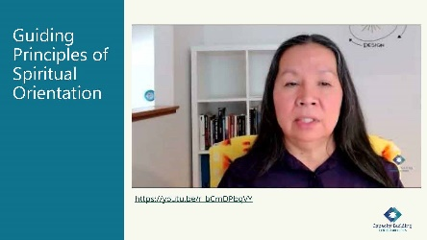

10 minutes

**Tech Help:** You will play the video embedded in this PPT slide during the next section, which is also available at: <https://youtu.be/r_bCmDPbqVY>.

Say:

* Nancy Bordeaux is a Sicangu Lakota from Rosebud, South Dakota. Nancy is a highly skilled, interactive trainer and facilitator. She believes tradition and values guide positive change and transformation for Indigenous peoples. Nancy’s work focuses on intergenerational healing. Her knowledge of trauma has been instrumental in creating cultural and holistic practices that support healing. She is a practitioner of her ceremonies and integrates science and culture in her unique style of work.

Say:

* When watching this video, please think about your own cultural values and lifeways, and consider how you can bring those to your workplace. Exploring our cultural values and beliefs is a unique path for every person, for every tribal nation, and for those we serve.

Do:

Play the video embedded in the PowerPoint slide, which is 4:19 minutes and also available at <https://youtu.be/r_bCmDPbqVY>.

Slide 11:

Our Connection to the Great Tree of Life

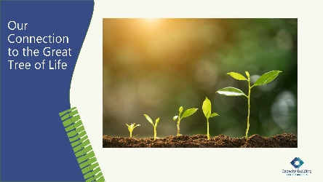

15 minutes

Say:

The video provided an Indigenous way of knowing from the Lakota beliefs and is a way to understand our connection with another living organism in relation to our own grounding and potential growth.

The video narrated the tree as an iconic symbol of our Indigenous lifeways. This lesson is a reflected self-exploration of our life since time immemorial. It is often envisioned as a mature tree standing in full bloom with the roots and branches extending robustly into both the earth and sky. We call this image the Great Tree of Life and to understand the life of the tree, we start at the beginning.

Let’s begin by considering the planting of the tree seed. After it has been planted in the earth, the seed’s hard coat will soon break open and fall off. This signifies the birth of the tree, and the primary root will quickly form and emerge. Once this root appears, it becomes open to nutrients and water from the earth and sky. Soon after, other companion roots appear and begin to anchor in place the newly established tree. Accompanying the early growth of the first roots, the plant stem forms and grows upward. Over time, a mature tree trunk forms from this stem. It supports the weight of the crown. It pipes water and nutrients from the roots upward. The leaves at the top manufacture food from light energy and then transport it back down the trunk to the roots and branches.

As a tree grows, buds are produced at the top and on either side of the trunk. New leaves grow from these buds. They grow and lengthen into branches. In turn, new buds appear on these branches, turn into leaves, and grow into branches. A new branch grows out of the axis of each leaf. In this manner, branches continue to divide to create a wide crown of branches. The branches become centers of indefinite growth and development as life energy is transported through the trunk to the roots. It’s a cyclical process to induce growth.

Do:

Break out into pairs for 10 minutes.

Ask:

We want each person to share a positive and uplifting story in their life that involved a tree. The following questions help guide your discussion:

* + What was the situation?
  + What is memorable about it?
  + What stands out for you?

Do:

Reconvene the groups and ask for volunteers to share their stories.

Thank them for sharing. In your own words, validate their story and elaborate on how closely connected and related we are to nature, particularly the Tree Nations.

Slide 12:

The Great Tree of Life

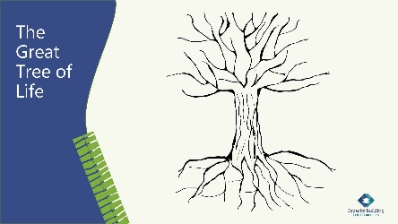

40 minutes

Say:

* Let’s consider the Great Tree of Life as we consider our values and beliefs. In this graphic, you will see an example of values in the tree roots, which grounds us in our personal and professional lives. These values aren’t seen but manifest through our behaviors and actions. Indigenous values are taught from our ancestors and motivate us to conduct ourselves in good and desirable ways.
* The tree trunk is symbolic of our body. It is the conduit to support and channel energy and nutrients to promote growth through maturity. The flow of nutrients from the soil, light, and water is transported through the tree trunk. As we walk through life, we are encouraged to heal and grow through positive behavioral change and transformation into a better person each day. The rings in our trunk show how we have evolved through each season of our life.
* The tree branches are the manifestations of growth and energy and symbolic of our behavior and activities. The roots, or our values, are channeled upward to proliferate life-enhancing growth. The branches are the growth extending outward into the world that is visual and illustrate the activities formed from your values.
* Now let’s consider future growth and possibilities. The branches are now beginning to form buds and leaves. These leaves are continual new growth and become an intricate part of the tree. The landscape supports the new growth and brings light energy to the tree.

Do:

Break out into pairs for 15 minutes.

Say:

Step 1: Completing Their Own Great Tree of Life

* + Please find the blank tree handout that is in your workbook.
  + What values do you feel would nourish your tree? Write your values into the roots of the tree. The values you select in this process will serve as the grounding of your traditional values and beliefs.
  + The tree trunk becomes the center of indefinite growth and development. Write your name and description of who you are in the trunk. Your description of yourself is defined as positive and one of strength.
  + Consider your values and the activities you have in your life that are inspirational and positive. Write these activities on the branches.
  + What activities would you like to include to promote positive change and continued healing? Write these in as your leaves. These leaves become new growth for rejuvenation.

Do:

Ask the group to share their thoughts of this process and how identifying their own values and beliefs can be a healing process that leads to healthier lifeways, both personally and professionally.

Say:

Step 2: Visioning Your Future

* + Now, imagine yourself in the next 15 years. Much change has happened over the years. The love, care, and attention that you gave to the tree you planted has resulted in a fully grown and maturing Great Tree of Life. It has transformed you and placed you in new surroundings, in a beautiful landscape, beyond your wildest dreams.
  + Take 10 minutes and write down the answers to these questions.

Ask:

Which values would you say most nourished your Great Tree of Life?

What decisions and care enabled your great tree to grow so glorious and healthy?

What did you do that helped your tree become so inspirational for you?

Say:

Step 3: Summarize

* + In summary, let’s view the image of your fully-grown tree diagram in front of you. It is important to note that this process in which you have engaged is about bringing the future into the present. It’s about taking an affirmative, strength-based approach to expanding and understanding the alternative capacities you possess to transcend seemingly insurmountable challenges in your life. It’s the Great Tree of Life. In your work in child welfare, the tree of life is a teaching from the Lakota and a significant way to envision how our values, conduct, and activities guide us to live in a good way.

Slide 13:

Maintaining Balance

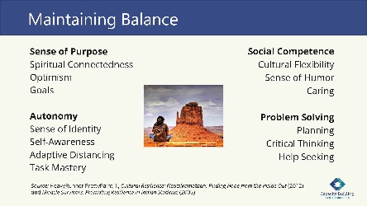

5 minutes

Say:

* As we work to envision our future, it is important that we pay attention to how we stay in balance. On this slide, we list traditional teachings in maintaining balance and resilience from a tribal perspective. This perspective is from Dr. Iris HeavyRunner Pretty Pain’s work from two sources: 1) *Cultural Resilience: Pisatsikamotaan: Finding Hope from the Inside Out* (2012) and *Miracle Survivors: Promoting Resilience in Indian Students* (2003). Resilience, according to Pretty Paint, is a relatively new word with an old meaning. In the winter season of reflection, we are considering what resiliency factors can support our leadership practice to continue our shared purpose.

Do:

Have someone read the list that is on the screen.

Slide 14:

Coming From a Place of Purpose

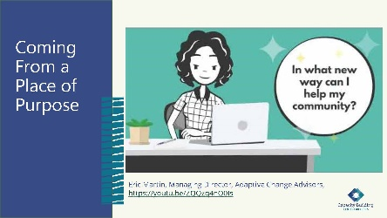

10 minutes

**Tech Help:** This slide has the embedded video of Eric Martin’s closing thoughts, which is 2:19 minutes and available online at: <https://youtu.be/ZQQzq4nQ0Is>.

Say:

* As you start considering everything you know about leadership, you begin to realize what you don’t know.Eric mentioned humility, which is also one of the seven grandfather teachings.
* Another thing that Eric mentioned was being proactive and not reactive, which is difficult in child welfare because there are continual priorities and responses needed.Eric encourages us to step outside of the pressures to be more in tune with our shared purpose.We should always take time to consider better choices that will support our purpose for a more beautiful world. We know in our hearts that this is possible.

Ask:

How can the seven grandfather teachings or your own cultural values be applied to your shared purpose?

**Facilitator Note:** You can refer to the seven grandfather values after participants share what it means to them.

**• Love** – Embrace peace and have unconditional regard for others.

**• Bravery** – Act with integrity even when fearful.

**• Honesty** – Keep one’s word and behave in an honorable way.

**• Humility** – Know your place in the larger picture, and do not put yourself above the Great Spirit, animals, plants, or other life.

**• Truth** – Be honest with yourself and others

**• Respect** – Treat others in a caring manner and with dignity.

**• Wisdom** – Value knowledge and learning throughout one’s life.

Slide 15:

An Eagle’s View of Your Leadership Journey

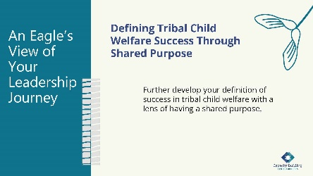

30 minutes

**Facilitator Note:** The participants gave you their definitions in the summer module, so you will need to provide them with those original definitions at this time or ask them to find them in their summer workbook.

Say:

* As you work toward a shared purpose while engaging in leadership moments, you will need a way to ground your leadership and measure your progress toward that shared purpose.Creating a definition of tribal child welfare success for your program can provide that grounding and measurement.
* In the summer, you drafted a definition of success in tribal child welfare. Now, we want you to further develop your definition with the lens of a shared purpose.

Do:

Give participants about 15 minutes to work on their definitions. They can work individually, in pairs, or small groups—whatever feels comfortable for them.

**Facilitator Note**:Provide flip chart paper on the wall so that participants can brainstorm for their definitions.They can create it visually or use narrative.

Do:

Provide 10 minutes at the end for participants to share their definitions.

Slide 16:

Telling Your Story

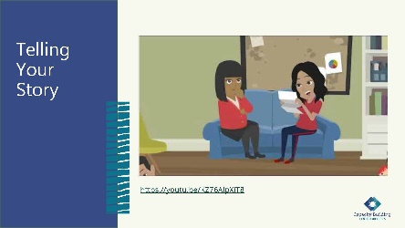

10 minutes

Say:

* In historical times, people used buffalo robes to keep a record of events as they occurred over time. Winter storytellers shared these for all to hear. Here, we introduce Suzanne Delap, who worked as an evaluator for the Capacity Building Center for Tribes. In this video, you will hear how storytelling can be a way of advocating and bringing together intergenerational wisdom, reclaiming identity, and validating experience. Sharing stories centers on Indigenous voices and epistemologies and emphasizes respect, responsibility, and reciprocity.
* As you listen to this video, consider these questions, which are also available in your workbook:
  + When you think of a leader, what is their story in your mind?
  + How would you tell your leadership story?

**Tech Help:** Play the 2:50 minutes video, which is also available at: <https://youtu.be/KZ76AlpXiT8>.

Do:

Play the embedded video, which is 2:50 minutes.

After the video, provide space for people to debrief and talk about what stories mean in their communities.

Slide 17:

What Will Your Leadership Story Be?

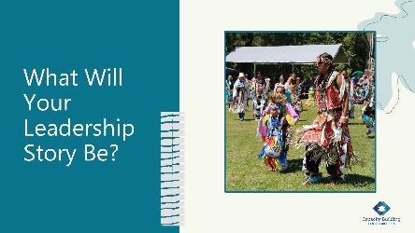

15 minutes

Do:

Welcome everyone to enter a personal reflection space in whatever way is comfortable for them.

Say:

* Let’s engage in a reflection and cataloging-of-thoughts activity. These reflections can help you create your leadership story. We will first read the reflection prompt to you. You can close your eyes and listen, or you can follow along in your workbook. Let’s get started:
  + Think about a leadership moment when you felt the most confident. (Pause) This is a time you felt powerful and alive. (Pause) Your senses were heightened, and you felt on top of the world. (Pause) You were filled with excitement. (Pause) You were so alive you did not care what anyone else thought. (Pause) Where are you? (Pause) What are you doing? (Pause) Who is around you? (Pause) How are you impacting them? (Pause) Now, in your workbook, write down all the thoughts and feelings that arose for you.

Do:

Provide 10 minutes for participants to write down their ideas.

Slide 18:

Completing Margaret’s Story

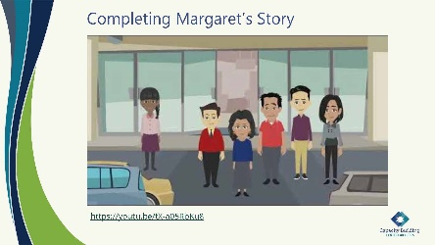

10 minutes

Say:

* Let’s hear the end of Margaret’s leadership story. While you watch this video, consider these two questions:
  + What did an eagle’s view provide for Margaret?
  + What was the shared purpose of her agency?

**Tech Help:** Play the video embedded in the PowerPoint slide, which is 3:35 minutes. It is also available at: <https://youtu.be/tX-a05RbKu8>.

Do:

Play “Margaret’s Story” embedded in the PowerPoint slide.

Slide 19:

Case Study: Applying Margaret’s Story

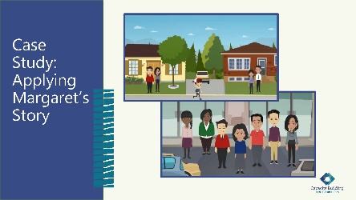

35 minutes

Say:

* We are now going to ask you to break out into your case study groups for one final activity. In your groups, we want you to think about Margaret’s journey and what she was able to create in relation to where you want your program to grow.
* Think about:
  + Where is your program, and where do you want it to be?
  + What purpose will your leadership provide to your coworkers, your families, your community, and your tribe?
  + What ripple effects will your leadership story have?
  + Where do you want your community to be in seven generations?

Do:

Break participants into their case study groups for 20 minutes.

Be available for questions.

Provide them a five-minute warning.

Pull the groups back together.

Provide 10 minutes for a debrief and discussion about the answers to the questions.

Slide 20:

Winter is Ending, and the Cycle of Seasons Continues

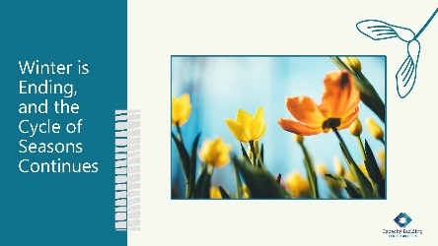

5 minutes

Say:

* Tribal child welfare leadership training does not end today. We’ve learned in each session that adaptive leadership is part of your overall leadership. Adaptive leadership requires you to take leadership moments when needed and to connect to a shared purpose. Indigenous ways of being and interconnectedness with all things reminds us to take time for culture and seek to restore culture in ourselves, our families, our organizations, and our communities to honor the last seven generations as well as sustain the next seven generations. “The Indigenous Circles of Leading” model and the “Intergenerational Protective Circles of Care” can be your guide in your leadership moments going forward and inform how you create change within your tribal program.

Slide 21:

Mobilizing Resources: Tribal Information Exchange

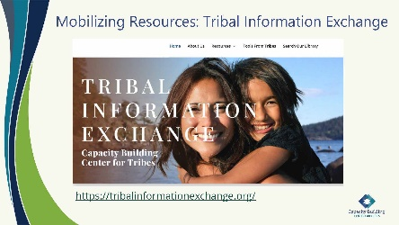

10 minutes

Say:

* The Capacity Building Center for Tribes’ website, the Tribal Information Exchange, offers resources for further learning.

Do:

Pull up the website on the screen.

Ask:

Does anyone have any questions about the TIE?

**Facilitator Notes:** The Tribal Information Exchange—operated by the Capacity Building Center for Tribes—is a website with many resources, including those found under the About Us, Resources, Tools for Tribes, and Search Our Library pull-down menus on the site.

Slide 22:

Capacity Building Center for Tribes

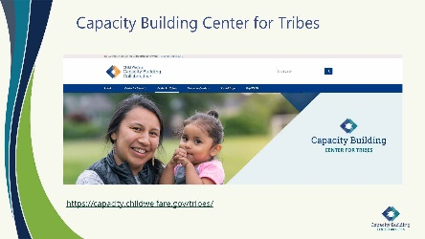

10 minutes

Say:

* The Capacity Building Center for Tribes is part of the Capacity Building Collaborative, which is operated by the Children’s Bureau and includes the Center for States and Center for Courts. You can also go to this page to access the entire collaborative and to drill down to the Capacity Building Center for Tribes. A link to our Tribal Information Exchange is also available on this page. Please note that on the bottom of the Center for Tribes page is another opportunity to sign up on our email listserv.
* The Capacity Building Center for Tribes has additional ways to engage with you: tailored services projects, peer groups, peer-to-peer engagements, and a “Tribal Child Welfare Practice Path” worker training. For more information about these opportunities, please contact us at 1-800-871-8702 or [info@cbc4tribes.org](mailto:info@cbc4tribes.org), or check out our latest news and information on the Tribal Information Exchange.

**Facilitator Note:** Share that the Center for Tribes is part of a partnering collaborative funded by the Children’s Bureau. The Center’s array of services includes:

Universal – TIE resource information and webinars.

Tailored – On-site services for tribal child welfare program enhancement.

Targeted – Workforce development, Title IV-E groups, peer-to-peer engagements, and peer groups.

Highlight that the Center for Tribes team is continuing our approach to a collaborative supportive circle of care for all tribes who are federally recognized and receiving Title IV-B funds.

If there are other resources that you feel would be useful for the group, provide them here.

Slide 23:

The Eagle’s View



10 minutes

Say:

* As you think about today’s content, remember that every one of us has multiple leadership moments each day. During these moments, try to take an eagle’s view.
* Sovereignty begins with each of us. Remember that as we take our eagle’s view, we are making decisions for the next seven generations.
* I also remind you that effective leadership is active and reflective. Taking a view from above the fray provides a holistic approach to see patterns, relationships, contexts, and visionary practices. This view is especially valuable during the winter when we are resting to empower our next phase of growth because it will allow us to see where we need to focus our energy in the spring.

Ask:

What can you do in the next few weeks to remind yourself to take an eagle’s view? How do you think it will help guide your leadership?

Slide 24:

Closing: Ending Our Time Together

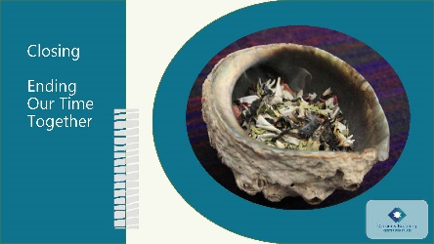

10 minutes

Say:

* As we close out our training day, we are grateful for the sharing and engagement from this group. Each of us believes deeply in this training, and we are honored to be the ones to share it with you.

Ask:

Is there anything that anyone would like to discuss before we end our time together?

Do:

Provide a few minutes for participants to say their final thoughts.

Slide 25:

Thankful and Blessed

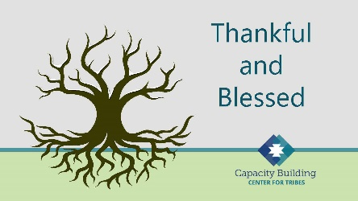

10 minutes

Do:

Each facilitator gives thanks to the group.

Ask participants to share their way of saying, “See ya later.”

Tribal Child Welfare Leadership Academy Curriculum Team

This curriculum is the collaborative effort of many individuals and agencies working together to create the Tribal Child Welfare Leadership Academy training, an adaptation of the NCWWI Leadership Academy for Middle Managers. We acknowledge the many tribal leaders, formal, informal, and hereditary, who provided input and guidance to the process and outcome. The core curriculum team includes:

**Carolyn Benard**

Logistical Coordination. Butler Institute for Families, University of Denver. Grant and Project Coordinator for Capacity Building Center for Tribes. Denver, CO.

**Tabitha Carver-Roberts**

Curriculum Revision Editor. Senior Program Associate, Butler Institute for Families, University of Denver.

**Jackie Crowshoe,** Turtle Mountain Band of Chippewa

Resource Coordination and Culture Bearer. Capacity Building Center for Tribes, University of Southern Maine, Muskie School of Public Service. Tribal Child Welfare Policy Associate.

**Anne Comstock**

Project Management and Logistical Coordination. Tribal Law and Policy Institute/Center for Tribes Consultant.

**Emily Iron Cloud-Koenen,** Oglala Lakota

Lead Coaching Coordinator and Culture Bearer. Former Executive Director of Lakota Oyate Wakaneia Owicakiyapi, which is located on the Pine Ridge Reservation in South Dakota. Consultant for the Capacity Building Center for Tribes.

**Priscilla Day,** Anishinaabe and an enrolled tribal member of the Leech Lake Reservation

Lead Curriculum Writer and Culture Bearer. Director, Center for Regional and Tribal Child Welfare Studies and a tenured full professor at the Department of Social Work at the University of Minnesota Duluth, where she has taught since 1993. Advisory Board Member and Consultant for the Capacity Building Center for Tribes.

**Kathy Deserly**

Project Advisor and Co-Director, Tribal Law and Policy Institute/Center for Tribes. Worked in the field of child welfare for Native communities since 1974. Has provided extensive training and technical assistance to Native and non-Native programs. Became a founding board member of the Indian Child and Family Resource Center in Helena, MT. Served as the Associate Director for the National Child Welfare Resource Center for Tribes.

**Rachel Fore,** Cherokee

Curriculum Writer and Culture Bearer. Administrative Operations Leader with Cherokee Nation Indian Child Welfare in Oklahoma. Her work involves managing the administrative, financial, and support service programs for her agency. Rachel came to work for Cherokee Nation in 2009.

**Rita Hart,** Jicarilla Apache and Choctaw

Curriculum Writer and Culture Bearer, Project Senior Associate, Butler Institute/Center for Tribes. Extensive experience in the field of state child welfare, Indian child welfare, and Bureau of Indian Affairs.

**Robin Leake**

Principal Investigator and Co-Director, Capacity Building Center for Tribes. Research Associate Professor, Butler Institute for Families, University of Denver.

**Tom Lidot,** Chilkat Tlingit

Facilitator, Curriculum Writer and Culture Bearer. Tribal STAR Program Leader. Academy for Professional Excellence, San Diego State University, School of Social Work. Consultant Advisor Center for Tribes.

**Bob Lindecamp**

Project Advisor. ICF International. Senior Consultant to the Children’s Bureau for Capacity Building Center for Tribes and the National Child Welfare Workforce Institute. Selbyville, Delaware.

**Betty Nez,** Navajo

Coaching Advisor and Culture Bearer. Director of Zuni Tribal Social Services. Manages the Indian Child Welfare Act (ICWA) program, the Child Protective Services program, case management services, and the Foster Care and Family Preservation program. She has been working for Zuni Tribal Social Services for nine years.

**Rose-Margaret Orrantia,** Yaqui

Coaching Advisor and Culture Bearer. Previously worked at the Institute of American Indian Arts in Santa Fe, NM, for 18 years. Returning to San Diego, she served as the Executive Director of Indian Child and Family Services (ICFS), a state licensed foster family and adoption agency serving the American Indian population in San Diego and Riverside Counties.

**Deborah Reed**

Project Advisor. Assistant Professor of Practice/Project Leader. Leadership Academy for Middle Leaders, Center for Improvement of Child and Family Services-CWP. School of Social Work, Portland State University.

**Tribal Content Experts**

**Brenda Gilman Bagwill**

Tribal Patient/Liaison and ICWA Advocate  
Sycuan Band of Kumeyaay Nation

**Sunni Dominguez**

Council member  
Community Liaison for Tribal STAR  
Iipay Nation of Santa Ysabel

**Season Goodpasture**

Director of Social Services for Pala Band of Mission Indians  
Maidu and Paiute of the Susanville Rancheria  
**Jahari Harrison**

Southern Indian Health Council  
Indian Child Social Services  
Carib-Kalinago

**Karan Kolb**

Indian Health Council  
Director of Social Services  
Rincon Band of Luiseno

**Melvin Lewis**

Director of Social Services  
Ft Mojave Indian Tribe

**Carolina Manzano**

CEO Southern Indian Health Council  
Alpine, CA

**Linda Ruis**

Director of Tribal Social Services  
Iipay Nation of Santa Ysabel